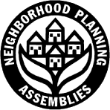 | Neighborhood Planning Assembly Attendees  NPA (choose one) Wards 1 & 8 Wards 2 & 3 Wards 4 & 7 Ward 5 Ward 6  Date of Assembly :_________________ Location:___________________________  Please return to your convenor, _________________________,  or email to cedofd@burlingtonvt.gov

1 |  | 21
2 |  | 22
3 |  | 23
4 |  | 24
5 |  | 25
6 |  | 26
7 |  | 27
8 |  | 28
9 |  | 29
10 |  | 30
11 |  | 31
12 |  | 32
13 |  | 33
14 |  | 34
15 |  | 35
16 |  | 36
17 |  | 37
18 |  | 38
19 |  | 39
20 |  | 40

