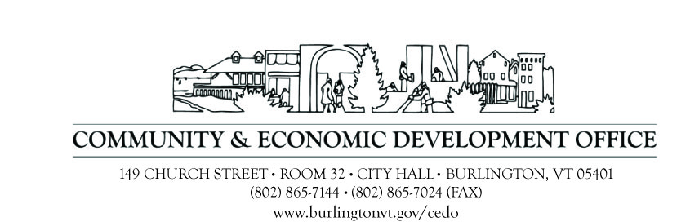

REQUEST FOR PROPOSALS (RFP)

Grant Writing Services for U.S. Department of Housing and Urban Development
2017 Lead Hazard Control Notice of Funding Availability
for the
City of Burlington
Community & Economic Development Office
Burlington Lead Program

Response Date: January 6, 2017

- Purpose

The Burlington Lead Program (BLP), which is administered by the City of Burlington Community & Economic Development Office (CEDO), issues this RFP to obtain grant writing services to prepare an application under the U.S. Department of Housing & Urban Development’s (HUD’s) Fiscal Year 2017 Notice of Funding Availability (NOFA) for the Lead-Based Paint Hazard Control Grant Program (LHC). The funding for this RFP comes from a non-federal source.

CEDO seeks a consultant prepared and uniquely qualified to provide comprehensive Lead Hazard Control grant application development and writing services in response to the above-referenced NOFA.

- Proposal Requirements

Proposals must be received before the Response Date and include the following:

- Background information of the company making the proposal, focusing on past experience with writing successful HUD LHC grant proposals.

- Background information of the key personnel working on the project, focusing on past experience with writing successful HUD LHC grant proposals.

- Proposed contract services and a breakdown of individual(s) that will be responsible for each aspect of the project.

- Detailed timeline for meeting expected NOFA deadline based on previous HUD LHC NOFAs. [CEDO understands that the NOFA may not have been released as of the date of this RFP. Nevertheless, proposals must still give a detailed timeline of benchmarks starting with the release of the NOFA and ending with completed application submission.]

- Demonstrated an understanding of how the City of Burlington can compete with larger municipalities for LHC grant awards.

- Cost for providing consulting services.

- Evaluation and Selection

While cost is a consideration in the RFP evaluation process, CEDO is not required to select the lowest cost proposal. A history of successful HUD LHC applications will be the main factor when evaluating and selecting the winning proposal. Submittals should sufficiently demonstrate how the consultant is uniquely qualified for such an undertaking and will be reviewed and evaluated by the Burlington Lead Program Coordinator and Program Director.

This RFP does not commit CEDO to pay any costs incurred by any proposer in the submission of a proposal. The proposer is responsible for all cost associated with the response to this RFP. The City reserves the right to reject any and all proposals at any time with no penalty, to negotiate with any qualified source, to waive any formality or to cancel the RFP in part or in its entirety if it is in the best interest of the City of Burlington. This solicitation of proposals in no way obligates the City of Burlington to award a contract.

Proposals are due by 4:30 p.m., Friday, January 6, 2017 Please submit your proposal by email to jtanguay@burlingtonvt.gov For further information on this RFP, please contact Jeff Tanguay at 802-865-7598.



EQUAL HOUSING OPPORTUNITY

