SNOW AND ICE CONTROL PLAN
The purpose of this plan is to define the operational procedures and best management practices (BMP’s) for storing and utilizing snow and ice control materials, and for performing winter maintenance activities. It defines the level of service that Burlington Public Works will strive to provide on our 95 miles of streets and 127 miles of sidewalks.
Since storms vary dramatically and occur during a variety of traffic conditions, this Snow and Ice Control Plan is intended to be flexible. It is a guide structured to fit average conditions, but able to accommodate the wide variety of conditions that will be encountered by maintenance crews who are working to maintain safe roads and conditions.
STORM WARNING NOTIFICATION
The Department of Public Works Right of Way uses the online weather service MxVision Weather Sentry Online. The service provides up to the hour weather predications and forecasts up to 15 days out. DPW will issue storm related public service announcements via the local media, Facebook, Twitter, and Front Porch Forum. Sign up for an email or text by going to:
Email listserve: https://groups.yahoo.com/neo/groups/Burlingtonparkingban/info
Text messages: GovDelivery https://public.govdelivery.com/accounts/VTBURLINGTON/subscriber/new
Facebook: https://www.facebook.com/BTVDPW
Twitter: @btvdpw
Phone: 802-658-SNOW

PERSONNEL SCHEDULING
Our Right of Way crew of (18) full time Street Maintenance and (2) seasonal employees maintain the streets and sidewalks. Large storms may require around the clock coverage. This will require help from outside work groups and departments. The Street Maintenance Foreman will find volunteers during the normal workday and create a plan based on the available manpower and weather conditions. The plan will be reviewed by the Assistant Director of Right of Way before implementing.

MOBILIZATION
When the decision has been made to react to a storm, the Right of Way Foreman will mobilize the crew. Since all trucks, tractors and routes are assigned, all the employees need is the call to deploy. If a storm event is predicted after normal business hours, the personnel will be put “on-call” per the union contract. All on-call employees will make themselves available by telephone.
While DPW Right of Way is tasked specifically with the staffing snow and ice control operations, the employees of the Equipment Maintenance group have a responsibility to assist with equipment repairs. Once the decision has been made to respond to a storm event, during normal working hours the Right of Way Foreman will notify the Fleet Manager. The Fleet Manager will then schedule his employees to provide maintenance assistance. After normal working hours, if the foreman in charge determines that the streets and sidewalks need to be plowed he will call the “on-call” maintenance team.

SNOW AND ICE CONTROL MATERIALS
Road salt (NaCl) is the primary snow and ice control material. The salt is purchased under the State of Vermont contract. FY15 the contract was awarded to Cargill, the local distributor is Barrett’s Trucking in Burlington @ 863-1311. DPW uses approximately 3500 tons of road salt per year. The Street Maintenance Foreman is responsible for the ordering and inventory of the salt. The entire salt inventory is stored at 645 Pine Street. Liquids like magnesium chloride (MgCl2) are being used on a small scale until we further understand their benefits. Safety Data Sheets (SDS) are available in a binder in every truck and in the SDS binder located in the Street Maintenance area.

EQUIPMENT INSPECTION
All City equipment; to include all plow trucks, loaders, and sidewalk tractors will be operator level inspected before any snow operations. Immediately following a storm on the next regular business day, all equipment will be cleaned, greased, fluids levels checked, and a proper preventive maintenance check per the manufactures operator manual. All deficiencies will be reported immediately to DPW Fleet Services.

EQUIPMENT CALIBRATION
Every November, all truck spreaders and computerized spreader controls will be calibrated with salt (NaCl) per the manufactures operation manual. After every storm event, each truck will have the mileage and pounds per lane mile recorded. This task will be assigned to a working foreman and one other street maintenance worker.

TRAINING OF PERSONNEL
Training is a key part to our snow plans success. All operators are properly trained before using any equipment utilizing operator manuals, manufacturers trainers, our in house trained employees, and on the job training. All employees will be able to properly operate, and maintain the equipment before actually plowing snow. Before the first snow storm, all operators will drive their route, getting familiar with obstacles such as high manholes, trees, narrow roads, mailboxes, etc. Any reported obstructions will be reported to the Right of Way Inspector for further action. Every truck has a binder with all route maps, bike routes, CCTA emergency routes, and the list of dead end roads.

SNOW ROUTE ASSIGNMENT
All operators will be assigned a route, whether it is in a truck or a sidewalk tractor. Continuity is important in assigning routes and equipment. Operators will learn the best way to battle snow and ice if they are doing the same streets every storm and will know areas that need special attention such as bridges, on and off ramps, hills, curves, and school zones. The same with the equipment, the operators in the same truck or tractor will know how it handles and what the vehicles limits are.
The sizes of the routes are designed for the City’s fleet of trucks and tractors. There are 10 large trucks, 1 small truck for dead ends and narrow streets, and 11 tractors. Of the 10 large trucks, 1 is a spare in case of a break down. With the 11 tractors, 2 are spares. Depending on the accumulation of snow, it could take an operator with a large truck approximately 5-7 hours to plow their route once. An operator on a sidewalk route will take approximately 6 hours to plow their route, if they are salting at the same time it will take 8-9 hours to complete once.

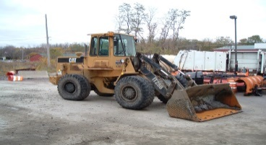 LOADING PROCEDURES
The loading of salt in all trucks will be by the oldest available loader in the fleet. The operation will be conducted by qualified City employees only. The trucks will be loaded to their max GVWR and not overloaded. A scale is located in the loader and will be calibrated before the winter season. The loader will have operator level preventive maintenance after every storm event and all loading procedures will be supervised by an assigned working foreman.

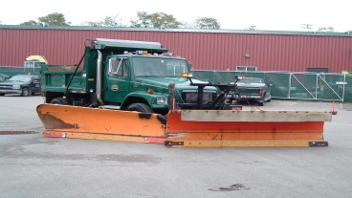 SPREADING AND PLOWING PROCEDURES
Salting Operations
Streets will be salted during light storms where minor accumulations of snow are expected. This requires the use of 6 large trucks that will salt the primary streets with priorities going to the routes coming into and exiting the City, primary roads leading into neighborhoods, school zones, downtown, and intersections. Not every street is salted unless there is a prediction of ice.
Plowing Operations
Plowing of the streets is the same regardless of the amount of snow predicted. The City owns (10) large plow trucks with (1) being used as a spare in case of break down and (1) small truck for dead ends and narrow streets. We can add plows to our (2) front end loaders for additional help in major storms.
The (9) large plow trucks are assigned a route and each route starts with its primary street, leading to its secondary main, and then into the neighborhood streets. (Truck route maps appendix B.) The (1) small plow truck is assigned a list of narrow and dead end streets. (Narrow and dead street list appendix C.)

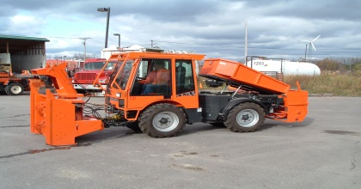 Sidewalk Plowing and salting
There are (9) sidewalk routes and are plowed during the day concurrently with street plowing. Extra attention is given to the downtown, Old North End, areas around schools and school crossing guard locations.
During a night time snow push back or any night time plowing operation, sidewalk plowing usually starts around 3 a.m. so that the sidewalks are open when school begins. This time could vary depending on the size of the storm.
If the storm exceeds 12” of snow and there are snow banks along the sidewalk, we will have to snow blow every sidewalk. This will take considerable time and manpower. This operation could take up to 24 hours or more. Again the priorities are downtown, Old North End, and school zones. We normally have many equipment failures while snow blowing, so having fleet services available is key.
We routinely plow, scrape, and sometimes salt the sidewalks during the day to maintain a safe environment.

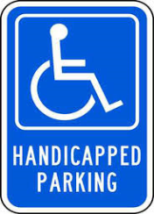 Accessibility (Handicapped) Parking Spaces
Burlington has a large amount of handicapped parking spaces that must be cleared of snow. This will take place once the streets and sidewalks have been cleared. After the storm, the department will start clearing the spaces starting from the downtown, working their way to the outskirts of the city. With the limited amount of manpower available it may take many days before all spaces can be cleared of snow. If a resident has a particular handicap parking space that needs immediate attention, please call DPW Customer Service @ 863-9094.
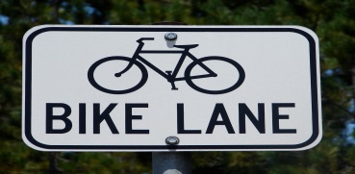 Bike lanes
Burlington has 7.75 miles of dedicated bike lanes throughout the City. They are all on major truck routes and the lane will be plowed to the curb. After the roads and sidewalks are cleared, DPW will dispatch a sidewalk tractor and clean the bike lane free of snow. (Appendix A)
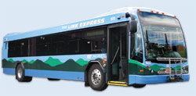 CCTA Bus Routes
Burlington is a major hub for public transportation. Many of the priority routes are also major routes for the CCTA public transportation system. The operators are familiar with their routes and understand the importance of the public transportation system. We routinely review the routes with the DPW Drivers.

Performance Capabilities
As stated earlier, Burlington has 95 miles of roads and 127 miles of sidewalks. During the average year we receive 80 inches of snow. Of course this is only an average and what really matters is when it falls, and how many snow events we have to deal with. Generally speaking, the length of the storm rather than the amount of snow determines how we deal with it. Our plans are built around these capabilities.
Street plowing routes | 10
Hours to plow every street once | 5 to 7
Hours to salt all streets @ 500 lbs. mile | 4
Sidewalk plow routes | 9
Hours to plow every sidewalk once | 8
Hours to snow blow every sidewalk once | 24
Hours to salt every sidewalk | 12

SNOW STORAGE
Snow removed from the City streets, greenbelts, parking lots, and parking meter spaces will be stored at 702 Lake Street in Burlington. This area is for the storage of City removed snow and not for any private contractor, unless contracted by a City department. This site is a former oil tank farm near the waterfront and has been an ideal storage area as the berm keeps contaminants from reaching the lake. This storage area will be cleaned of any trash and debris every spring.

SNOW OPERATION DAMAGES
- Mailboxes and other structures within the Right-of-Way
Occasionally mailboxes and other property may be damaged by snow plowing operations due to poor visibility, the mailbox being buried in a snow bank or the weight /volume of snow being plowed. The damage is not deliberate and in most cases unavoidable. Burlington Public Works is not responsible for damage and does not repair, replace or re-erect mailboxes that are located within the right-of-way unless physically struck by a DPW plow truck. In these cases, the property owner shall submit a claim to the City for reimbursement. All mailboxes must be installed to the USPS standards.

Many residents have basketball nets in the right of way, these not only interfere with plowing to the curb, but during inclement weather the plow operator may not see the basketball net and damage the basketball net and City equipment. The City will not be responsible for any damages to basketball nets within the right of way. If any basketball nets are found in the right of way, the DPW Right of Way inspector will be notified and will have it removed.

While removing the snow from the sidewalks we find many fences, borders and decorative landscaping close to the sidewalk. This presents quite a challenge for the department to operate the tractors safely. We ask that all landscaping be built at least 12” from the sidewalk in order to minimize damage to private and city property. Burlington Public Works will not be responsible for any damages to landscaping or fences that are within 12” of the sidewalk. All reported damage will be inspected by our Right of Way Inspector, and if the inspection finds the City responsible, an insurance claim will be made with our agent.

- Plantings in the right of way
Snow removal from the streets and sidewalks are a challenging task and there are many obstacles that the operators have to maneuver around, and the major items being trees and shrubs. While great care is taken not to damage the tree or shrubbery, the property owner must maintain the vegetation so it does not impeded the right of way. While the City equipment may damage the vegetation, the trees and shrubbery may also damage the equipment. The department will not be responsible for any damage to any plantings encroaching on the right of way.

- Accident Protocol
Plowing snow in a large truck with a wing plow takes a special skill. Public Works employees are highly skilled and properly trained before they operate any commercial vehicle. Vehicle accidents will happen, and when they do, the following must happen:
- Stop vehicle in a safe area.
- Check all people involved for injuries. Call 911 if needed.
- The DPW employee will call their supervisor either by cell phone or by 2-way radio and inform him of the situation.
- Supervisor will call the Burlington Police Department. A police report will be taken, the DPW employee will receive a copy of the report, if the report is not available, you are required to obtain the incident number.
- If the vehicle is able to be driven, it must report to DPW Fleet Services for an evaluation before continuing on with snow plow operations.
- All accidents must be reported to the Right of Way Assistant Director and the insurance company. The Foreman or Assistant Director will report all the proper information on the Travelers Insurance Portal.

 PARKING LIMITATIONS
Burlington does not have a seasonal parking ban like most towns in our region. It is the responsibility of the Public Works Director to declare a winter parking ban. Parking bans are declared on a case by case basis. Criteria for a parking ban include length of storm, amount of snow during the storm and how much snow is already on the streets and has not been plowed to the curb. By City ordinance 20-56 the ban must be declared by 3p.m. in order to be in effect by 10 p.m. that evening until 7 a.m. the following morning.
Parking Ban Notification
Parking bans are warned in the following manner:
1. Using the City maintenance light system
2. Sending a press release to all local radio and television stations, and the Burlington Free Press
3. Posting alerts on social media, such as Facebook, Twitter, and Front Porch Forum.
4. Sending out text messages and e-mails via GovDelivery
5. An up to date recording on 658-SNOW
Once the Director calls a ban, the street maintenance foreman will notify the parking enforcement supervisor, who is responsible for the enforcement of the winter parking ban. Second, he will activate up to 90 plus flashing parking ban lights. These lights are located at the entrances of the City, important intersections, and throughout the City’s neighborhoods. They are a visual warning to the residents that a parking ban is in effect.
The DPW foreman in charge of the plowing crew will meet with the parking enforcement crew at 9:30 p.m. at the police department to review and cover any last details.
Vehicles must be off of the streets during these hours if a ban is declared or they will be towed. While parking bans make it easier to plow snow, it is difficult for some people to find alternative parking. DPW does offer free parking in the City owned parking garages as an option. Parking is available in the Marketplace Garage and the Macy’s Garage on the lower decks only. Vehicles must be removed by 7:30 am or they will be charged the full day's rate. Additional information can be found at http://www.burlingtonvt.gov/.
While a winter parking ban is not called for every storm, if residents have access to off street parking, we urge them to use it. Additional information can be found at http://www.burlingtonvt.gov/Police/Winter-Parking.
The City has 4 designated tow areas.
Lake St. boat launch: Vehicles towed from the Old North End and west of Willard St. from Pearl St. to Maple St.
Grove St. Shamanski Park parking lot: Vehicles towed east of Willard St. from Maple St. to the New North End.
Gosse Court, North Ave to the end: Vehicles towed from the New North End.
Oakledge Park parking lot: Vehicles towed from the south end and west of Willard St. from Maple St. south.
When the lots are full, vehicles found on the street could also be towed to the nearest street the Public Works Department designates as a drop-off point. This would be a street that has been cleared of snow. For car owners to find their vehicle, please call (802) 540-2380.

AFTER STORM RESPONSIBILITIES

It is expected that 12 hours after a snow storm that every City street will have been plowed. The Street Maintenance Foreman will inspect every City street to ensure that the streets are cleared and passable. The department will continue to patrol the streets and maintain them to be safe and passible. It is possible that the downtown and some narrow streets may have to have the snow removed. If this service is needed, it will happen approximately 2-3 days after the storm using City owned equipment. Snow removal downtown usually happens in the early morning hours. For the narrow and dead end streets, we will post the streets for “no parking” and remove the snow during the day.

SNOW RELATED CITY ORDINANCES

27-84 Throwing snow into street prohibited.
No person shall throw or put, or cause to be thrown or put, snow or ice in the part of the street known as the travel portion nor on a sidewalk of a street.
(Rev. Ords. 1962, § 4303; 1969 Cum. Supp., § 4303)

27-2 Enclosing highway; erecting fence or encroachment; nuisance.
No person shall enclose a part of the highway or street, or erect a fence, building or other encroachment, or make obstructions, or create a nuisance on a highway or street, or continue such enclosure, fence, building, encroachment or nuisance on a highway or street.
(Rev. Ords. 1962, § 4209)

Appendix A - Bike Lanes

1. South Winooski Ave. 6’- West side, Maple St. to Howard St.- 2250 Linear Ft.

2. Pine Street – West side, Flynn Ave. to Maple Street. – 5750 Linear Ft.

3. South Union Street 6’ lane - East side, Main Street to Pearl Street. – 11440 Linear Ft.

4. North Union Street 6’ lane - East side, Pearl Street to North Winooski Ave. – 1980 Linear Ft

5. North Winooski Ave. 7’ lane - West Side, Decatur Street to North Street - 700 Linear Ft.

6. North Winooski Ave. - 7’ lane - West side – North St. to Pearl St. 1380 Linear Ft.

7. South Willard Street – East side, Main Street to Pearl Street. – 1500 Linear Ft.

8. North Willard Street – East side, Pearl Street to North Street. – 1260 Linear Ft.

9. Mansfield Ave. – East side, Colchester Ave. to North Street. – 1440 Linear Ft.

10. East Ave. 4’– West side, Colchester Ave. to Carrigan Drive. – 2260 Linear Ft.

11. Main Street – South side, University Hts. to City line. – 1421 Linear FT.

12. Main Street – North side, City line to University Hts. – 1421 Linear Ft.

13. North Ave. – East side, North Street to Institute Road. – 4600 Linear Ft.

14. North Ave. – West side, Institute Road to Berry Street. – 3300 Linear Ft.

Appendix B – Truck Routes

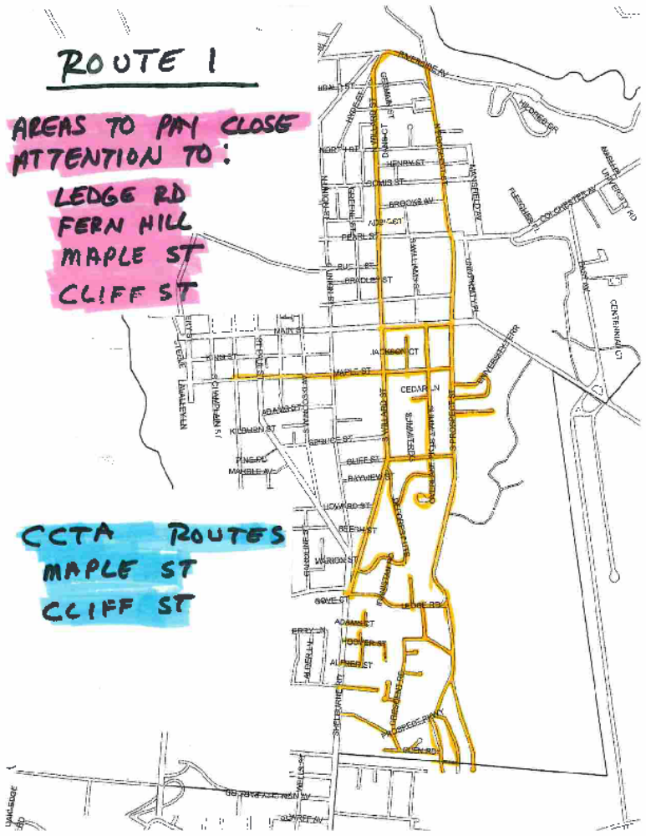

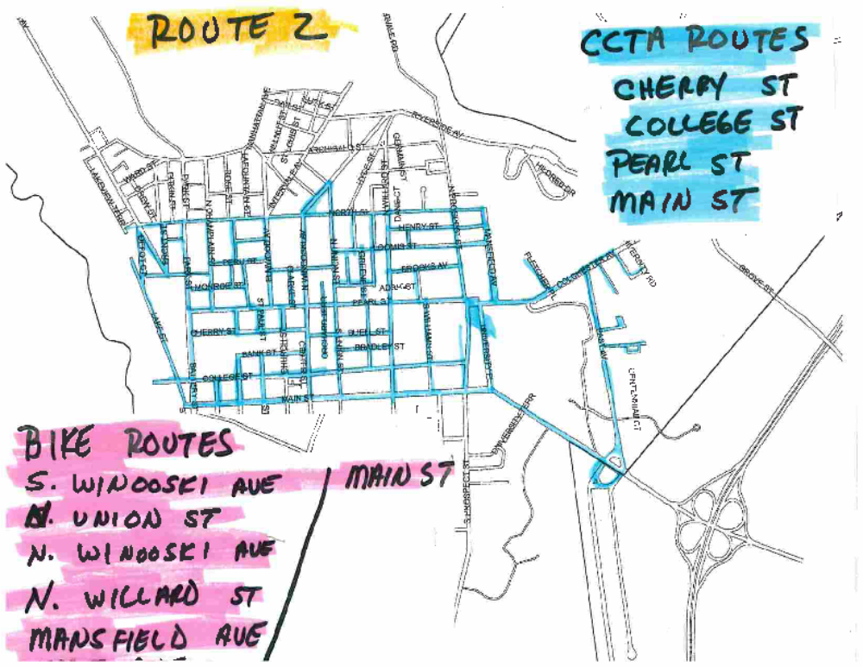

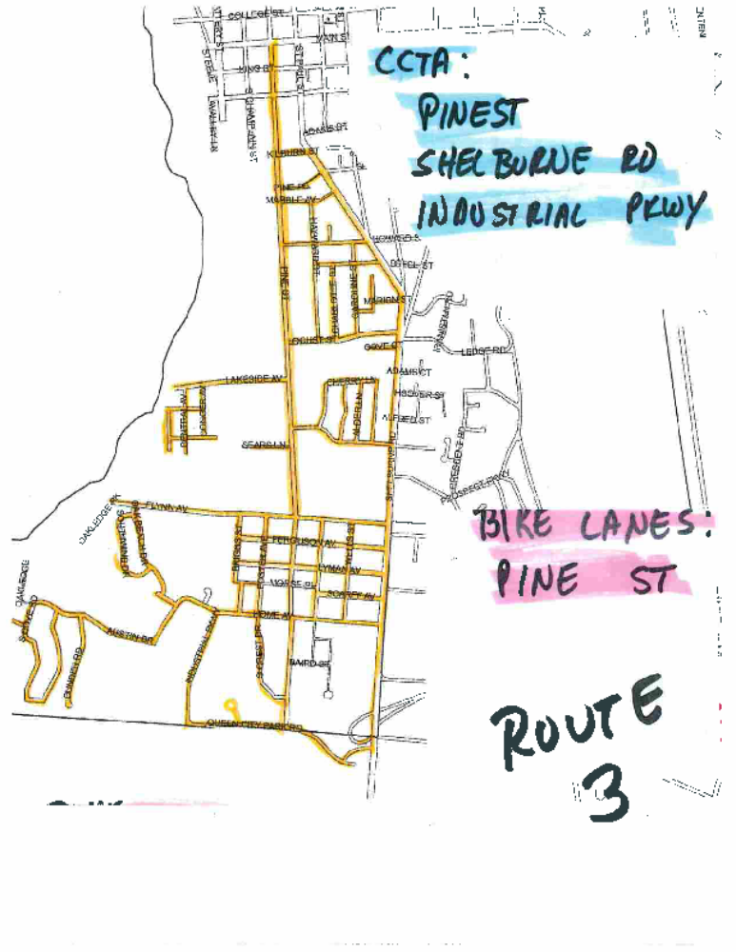

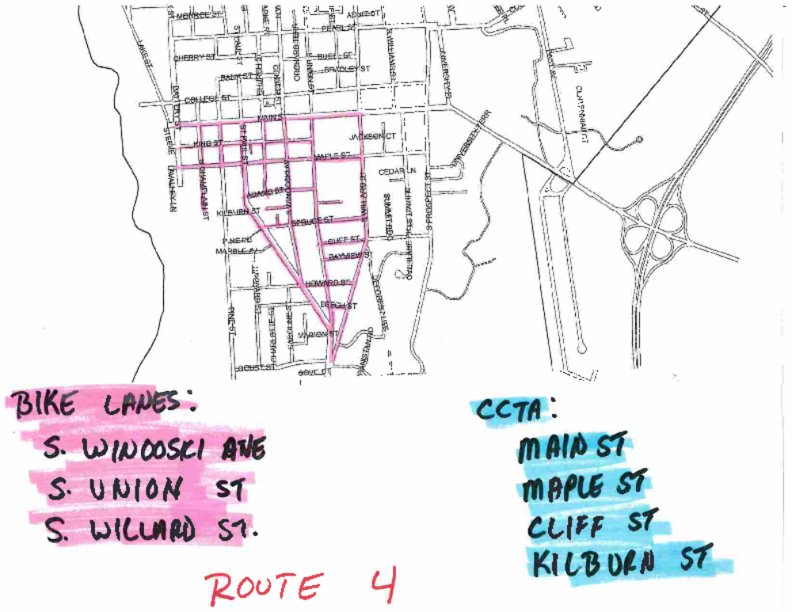

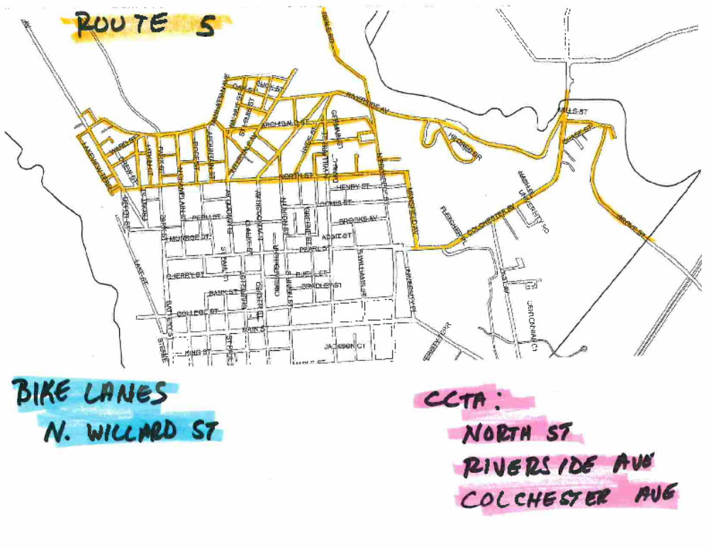

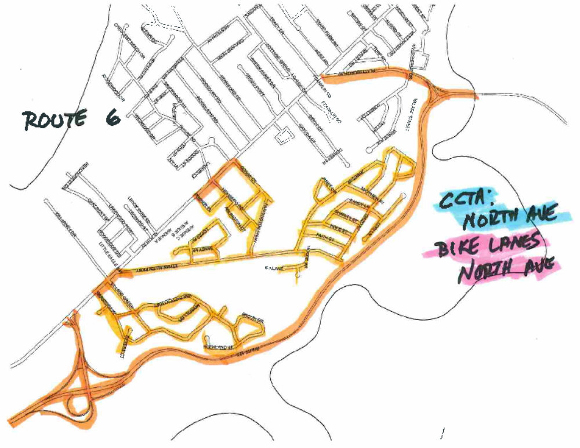

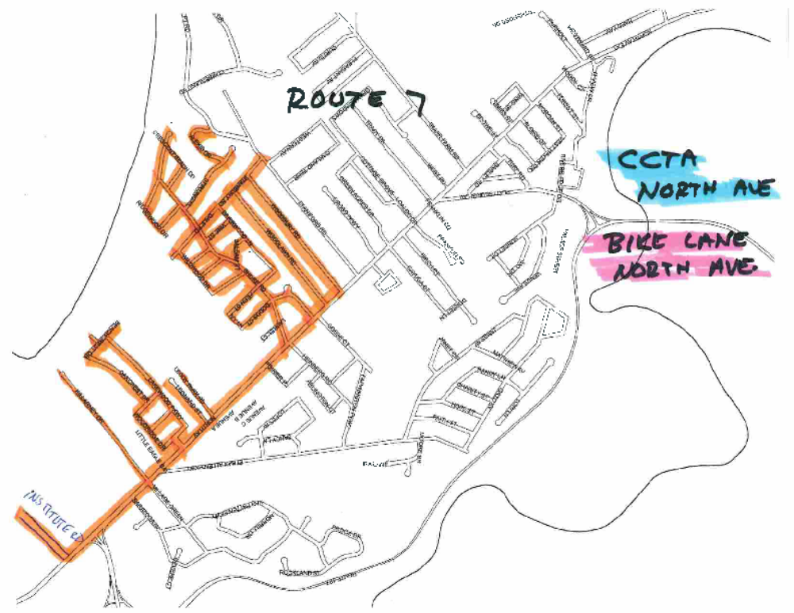

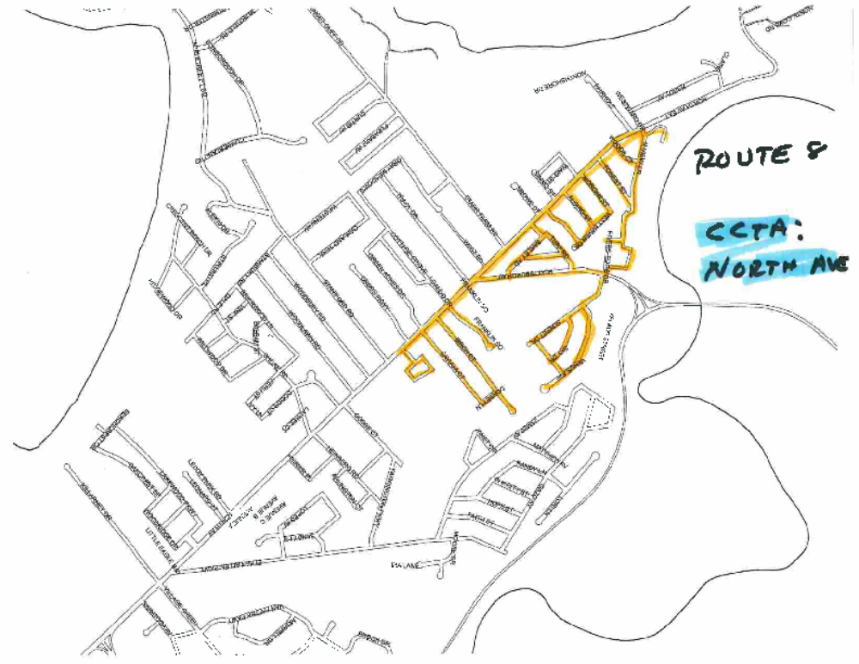

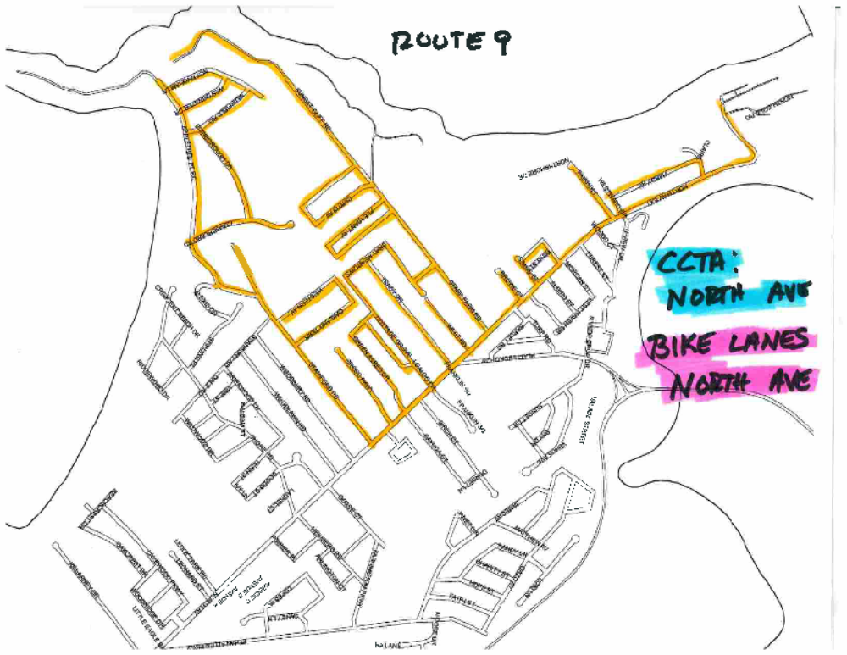

Appendix C – Narrow and Dead End Street List
DEAD END AND NARROW STREETS
MAIN ST AND SOUTH END CROSS ROAD AND SPECIAL DIRECTIONS
ADAMS CT SHELBURNE RD, AT LEFT TURN, CLEAN RIGHT SIDE DRIVEWAY ENTRANCE
LUDWIG CT HOOVER ST, BACKDRAG AND PLOW ACROSS HOOVER ST
REDSTONE TERR HOOVER ST
ALFRED ST SHELBURNE RD
PEROTTA PL HOOVER ST
GOVE CT SHELBURNE RD
GOLDEN PL HOWARD ST
SPRUCE CT SPRUCE ST
ELM TERR S. WINOOSKI AVE
BROWNS CT KING ST
BEECH ST WILLARD AND SOUTH UNION
KINGSLAND TERR SOUTH UNION
UNIVERSITY TERR MAIN ST, BACKDRAG AND PLOW OUT
PINE PLACE PINE ST, NO SIDEWALK, SALT AND CLEAN WELL
LEDGEMERE ST MARIAN ST
CATHERINE ST LOCUST AND ST. PAUL

MAIN ST TO MANHATTEN DR

THIBAULT PKWY COLCHESTER AVE
NASH PLACE COLCHESTER AVE
LATHAM COURT COLCHESTER AVE
CALARCO CT COLCHESTER AVE
COLCHESTER CT COLCHESTER AVE
CHASE LANE CHASE ST
RUMSEY LANE CHASE ST
CHASE ST BARRETT ST, BACK DRAG END OF ST.
VERMONT PARK HILLSIDE TERR, RIVERSIDE AVE
HYDE ST ARCHIBALD ST
GERMAIN ST ARCHIBALD ST
CHARLES ST NORTH WILLARD
RUSSELL ST NORTH WILLARD
CONVERSE COURT HICKOK PL
LAFAYETTE PL PEARL ST
ORCHARD TERR BUELL ST
CLOAREC CT INTRVALE AVE
ALLEN ST ELMWOOD AVE
MYTRLE ST PARK ST
POPLAR ST NORTH CHAMPLAIN ST
CROWLEY ST NORTH AVE
SUNSET CT NORTH AVE
VOLTZ ST MANHATTEN DR OVER →

NEW NORTH END CROSS ROADS AND SPECIAL INSTRUCTIONS

POIRIER PL NORTH AVE, BACK DRAG END OF STREET AND PLOW OUT
PLATTSBURG AVE EXT (GRIT PIT RD) PLATTSBURG AVE, PLOW PAST THE LAST HOUSE
RIVERVIEW DR (CAMP DAISY RD) NOTHVIEW DR
NORTH COVE ROADS (2) NORTH AVE EXTENSION, RIGHT BRANCH OF ROAD NEEDS TO
PLOWED OUT
APPLETREE PT ROAD DIRT ROAD, PLOW TO THE END
SUNSET CLIFF RD DIRT ROAD, PLOW TO END
LORI LANE ONLY PLOW ROTARY ON LEFT SIDE
WEST ST NORTH AVE

ALL STREETS ON THIS LIST WILL BE INSPECTED BY THE STREET MAINTENCE FORMAN AFTER THE STORM.



