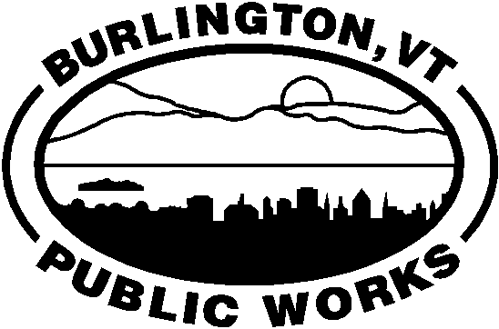 | ENV  15 |  | CITY OF BURLINGTON ● DEPARTMENT OF PUBLIC WORKS  SOLID WASTE GENERATION TAX RETURN  INFORMATION RETURN FOR USE BY COLLECTORS OF SOLID WASTE IN DETERMINING LIABIILITY AND TAXES DUE UNDER SEC. 14-14 OF THE BURLINGTON CODE OF ORDINANCES (SEE INSTRUCTIONS ON BACK BEFORE COMPLETING).

IDENTIFICATION |  |  | MONTHLY RETURN |  | AMENDED RETURN |  |  | FINAL RETURN
PERIOD BEGINNING |  |  | PERIOD ENDING |  |  |  |  |  | DUE DATE
FEDERAL EIN |  |  |  | ACCOUNT ID |  |  | TRADE NAME (DBA, etc.)
LEGAL NAME |  |  |  |  |  |  |  |  |  |  | BUSINESS TELEPHONE NUMBER
BUSINESS ADDRESS |  |  |  |  |  |  | CITY/TOWN |  |  |  | STATE |  | ZIP CODE

COMPUTATION
1 | Enter Number of Burlington Residential Dwelling Units (RDUs) Served This Period:
2 | Tax Due |  | A. Multiply Line 1 x 3.70  And Enter Number Here:
B. Enter the Amount of
Any Credits Here:
3 | Subtract Line 2b from 2a and Enter Here;  This is Your Tax Due This Period: |  |  |  |  |  |  |  |  | $
4 | Enter Any Penalty Due This Period ($13.00 or 1% of Line 3, whichever is greater): |  |  |  |  |  |  |  |  | $
5 | Total Amount Liable for Interest This Period (Line 3 + Line 4): |  |  |  |  |  |  |  |  | $
6 | Interest Due |  | A. Multiply Line 5 x 1%  And Enter Number Here:
B. Enter the Number
of Months Late:
 | C. Multiply Line 6a by Line 6b and Enter here;  This is the Total Interest Due This Period: |  |  |  |  |  |  |  |  | $
7 | Total Taxes, Penalties and Interest Due This Period (Line 3 or Line 5 + Line 6c): |  |  |  |  |  |  |  |  | $

I certify that this return has been examined by me, and is, to the best of my knowledge and belief, true, correct, and complete.

SIGN HERE ►
 | Signature |  | Title |  | Date

ENV-15 (2/14) After you complete this form, mail it to: Solid Waste Taxes, DPW, PO Box 849, Burlington, VT 05402-0849
ENV-15 INSTRUCTIONS Page 2

The purpose of Form ENV-15, Solid Waste Generation Tax Return, is to provide a method for you to calculate your tax liability each month to the City of Burlington under Sec. 14-14, Code of Ordinances.

The tax is imposed on every hauler licensed by the Public Works Commission to collect, remove and dispose of solid waste within the City Limits of Burlington.

The tax is assessed at a rate of $3.35 per residential dwelling unit per month

Returns are due on or before the last day of the month after the end of the previous month. Even if no tax is due, a return must be filed with the Department.

Payments are due with the return, and must be made in U.S. dollars drawn on a U.S. bank. Checks should be made payable to: CITY OF BURLINGTON.

PENALTIES:

If you fail to file a return by the due date, add to the tax (less any payments made on or before the due date) $13 or 1% of the total tax due, whichever is greater, for the reporting period.

To avoid the imposition of penalties, your return must be filed with your remittance in full for the amount of the tax due and postmarked by the due date.

INTEREST:

If the tax is not paid on or before the due date, interest must be paid on the amount of the tax due and any penalties.

REQUIRED SCHEDULES:

A licensed collector of solid waste must provide the Department a list of customer additions and deletions each month. This information should be entered on Schedule A and attached behind the return.

Every quarter, a licensed collector must provide the Department with a complete customer list in addition to the list of monthly additions and deletions. This information should be entered on Schedule B and attached behind the return after Schedule A.

In the IDENTIFICATION section, enter your:

FEDERAL EIN: This is your Federal Employer’s Identification Number used for tax and record-keeping purposes.

ACCOUNT ID: This is your Department of Public Works identifying number, and appears on your Return of Solid Waste Generation Tax.

TRADE NAME: This is the name that you use in conducting your normal day-to-day business operation.

LEGAL NAME: Your legal name is the name under which your business owns assets or incurs debts. For sole proprietorships, it is the name of the proprietor; for corporations, it is the name filed with the Vermont Secretary of State; and for partnerships, it is the legal name used in the partnership agreement.

BUSINESS ADDRESS: The address where your major business activity is physically located.

BUSINESS TELEPHONE NUMBER: The telephone number where you can usually be reached during normal business hours.

After completing the COMPUTATION part of the return, be sure to sign your name, and enter your title and the date in the space provided. Send your completed form to:

RECYCLING COORDINATOR
DEPARTMENT of PUBLIC WORKS
POST OFFICE BOX 849
BURLINGTON, VT 05402-0849

PRIVACY ACT NOTIFICATION

The Federal Privacy Act of 1974, as amended, requires all agencies requesting identifying numbers to inform individuals from whom they seek information why the request is being made and how the information is used. The disclosure of identifying numbers, including Social Security Numbers, is required by Section 14-14 of Burlington Code of Ordinances. Such numbers which are disclosed on any reports or return are used for tax administration purposes, and as may be required by law, or when the taxpayer gives written authorization to this department for another department, person, agency or entity to have access (limited or otherwise) to the information contained in his/her return.

