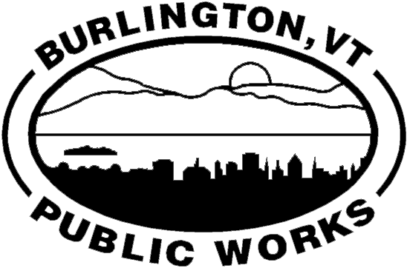 |  | CITY OF BURLINGTON  DEPARTMENT OF PUBLIC WORKS  WATER RESOURCES DIVISION  235 Penny Lane | P O Box 878 | Burlington, VT 05402  P 802.863.4501 | F 802.864.8233  water-resources@burlingtonvt.gov | www.burlingtonvt.gov/dpw/water
Tenant Agreement Form

ONLY PROPERTY OWNERS ARE AUTHORIZED TO FILL OUT AND SIGN THIS FORM

Property Owner(s) Name: Click here to enter text.

Full Mailing Address: Click here to enter text.

Phone #: Click here to enter text. Email Address: Click here to enter text.

Water Account #: Click here to enter text. Service Location: Click here to enter text.

We have received a request to put the Water Resources bill into the name of a tenant(s) for the above listed
property. Please be aware that the Burlington City Ordinances (section 31-19) state "Although another person
may pay the service rate, the owner of the premises shall be held responsible for such rate." This means if
your tenant fails to pay the bill then we will hold you liable for the balance.

- As the property owner your name will remain on the bill at all times and the tenant is listed as a care of (c/o). You will only receive statements concerning this account if the tenant(s) fails to pay the bill, interest is assessed and the delinquency is $200 or higher. Please sign up for our online account monitoring, so you can stay informed about your property.
- This form in no way relieves you of responsibility for unpaid balances; see City Ordinance section 31-19.
- This form must be completed and returned before we can make any related changes to the bill.
- The tenant(s) will remain on the account until we receive notice (verbal or written) that they are leaving. We will accept move out information from either party.
- We will not approve a new tenant form or make the necessary updates if there is a balance owed. Your completed form will be held as pending until the balance is zero.
- If no current tenant form is on file then the mailing address reverts back to you.
- We do not provide final bills upon termination of tenant(s) leases. It is the responsibility of the property owner to inquire about any unpaid balances and we strongly encourage verifying account status prior to returning a security deposit.

PROPERTY OWNER: I HAVE READ THE ABOVE AGREEMENT AND UNDERSTAND THAT THE WATER
RESOURCES BILL WILL REMAIN MY RESPONSIBILITY IN THE EVENT THAT MY TENANT(S) DOES NOT PAY.

Owner(s) E-Signature: Click here to enter text. Date: Click here to enter a date.

I would like the bill to go to: Click here to enter text.

At the following mailing address: Click here to enter text.

Tenant Email: Click here to enter text. Tenant move in date: Click here to enter a date.

