REQUEST FOR PROPOSALS (RFP)
CONSULTANT SERVICES

_______PARC System RFP Production AND VENDOR SELECTION_

Date of Issuance: 26 August 2016

Issued by: City of Burlington—Department of Public Works & Burlington International Airport

Due Date for Questions: 2 September 2016 by 5:00PM EST (must be in writing)
(responses will be posted on 8 September, 2016 by 5:00PM EST)

Due Date for Proposals: 19 September 2016 by 2:00PM EST

Issuing Points of Contact:
Patrick J. Cashman, Assistant Director for Traffic and Parking, Burlington Public Works
AND
Marie Friedman, Airport Financial Advisor, Burlington International Airport
c/o Patrick J. Cashman
645 Pine Street, Burlington, VT 05401
(802)863-0460
pcashman@burlingtonvt.gov

INTRODUCTION AND GENERAL SCOPE OF WORK
The City of Burlington is seeking proposals from qualified firms to develop, write, and submit for the City’s approval a Request For Proposals (RFP) for a Parking and Revenue Control (PARC) system. The current PARC system servicing all City owned and operated garages is, in its current configuration, outdated, labor intensive, and does not support a wide variety of customer options for daily, weekly, or monthly parking. The City is seeking expert assistance in defining current and future needs from the perspectives of efficient City operations, an exemplary and tailorable customer experience, and establishing the capability to expand services and/or evolve services as new technologies become available and appropriate. The selected provider is expected to also apply an understanding of the City of Burlington’s ordinances, transportation environment, demands, limitations and opportunities in order to draft a unique, tailored RFP for a PARC system that is the best fit for the City.

A general scope of work could include, but not be limited to:

- Review and incorporate relevant City plans and prior relevant studies. Linkages between existing City plans and references to the proposed PARC system RFP must be cited and are foundational to the proposed RFP.
- Survey relevant City and partner management and incorporate suggestions, concerns, needs, etc. into the proposed RFP.
- Survey Public Works and Airport front line garage personnel and incorporate suggestions, concerns, needs, etc. into the proposed RFP.
- Survey five (5) key stakeholder groups and incorporate suggestions, concerns, needs, etc. into the proposed RFP.
- Define and recommend target system startup and maintenance costs appropriate for the City of Burlington, with costs broken down by City Department to assist in source selection and the development of out-year budgeting.
- Define, evaluate and recommend purchase, lease, lease-to-purchase or other available financing arrangements that have demonstrated success in the industry and that may be of benefit to the City of Burlington.
- Develop and recommend grading criteria for use in source selection.
- Write and provide to the City of Burlington a proposed system RFP to best meet the current and future City needs of both downtown garages and at the Burlington International Airport, based on identified requirements and industry best practices
- Collect, organize and make recommendations regarding the comments received during the review of the proposed RFP.
- Attend, brief, and justify proposed RFP at five (5) meetings of the authorities needed to approve the project, including but not limited to the Public Works Commission, Airport Commission, Board of Finance, and City Council.
- Identify recommend groups and providers to receive the RFP.
- Provide written expert review and assessment of responses received, focused on the degree to which the proposed system meets the need defined in the RFP, the appropriateness of the proposed solution to the unique demands and opportunities of the Burlington International Airport, the City of Burlington and its parking management district, and the maturity of the technologies proposed.
- Coordinate, script, and attend system demonstrations from proposing firms.
- Provide expertise and assistance with negotiations and agreement with preferred system vendor.
- Provide hourly rate for resident technical engineer services in supervision of installation by preferred vendor.

CITY SUPPLIED DATA/EFFORT (a link to a drop box folder containing all this data will be emailed separately of this RFP)
- Plan BTV Downtown and Waterfront. June 2013
- Downtown Parking and Transportation Management Plan. December 21, 2015.
- Moving Forward Together: Transportation Plan for the City of Burlington. March 2011
- Plan BTV Transportation Study. October 2011

DEADLINE FOR RECEIPT OF PROPOSALS
All replies and proposals in response to the Request for Proposal must be received in a sealed envelope clearly marked “PARC System RFP Production”, sent to the points of contact at the address stated above no later than 2:00 p.m. on the due date stated above, at which time all submitted proposals will be publicly opened and recorded. Late proposals will not be accepted. Electronic proposals are preferred as long as they are received by the points of contact by the required deadline.

ANSWERS TO QUESTIONS AND REVISIONS TO REQUEST FOR PROPOSAL
Any revisions, addendums and answers to questions received by the due date for questions will be sent to consultants who directly received this proposal via email. In addition, revisions will be posted on the City’s RFP web page http://burlingtonvt.gov/RFP/. It is advised that consultants sign up for the GovDelivery notification so that they will be notified of any changes to the RFP page.

SITE VISIT
There will be no formal pre-proposal site visit. Individual visits can be scheduled through the points of contact above.

PARTNERSHIPS
Consultants may team up with other firms, local or otherwise, in order to provide whatever diversity is deemed necessary for completing the project tasks.

PROPOSAL FORMAT
Consultants are encouraged to be concise. All proposals must include, but are not limited to the following:

- Letter of Transmittal and three (3) copies of the proposal (preferably double-sided) if sent through the mail. If sent electronically, all documents shall be in pdf format.
- Proposed scope of work.
- Lump sum bid price, total time required to complete project addressing items 1-14 of the General Scope of Work with items 12-14 being on call following submission of RFP.
- A brief description of your firm’s history and experience with parking management and consulting.
- A work history of up to three (3) related projects involving the assessment of municipal needs and recommendation of material solutions showing for each:
  - Name, address and phone number for each client.
  - Brief project description.
  - Statement as to whether project was completed on time and within budget.
- Location of the office from which the management of the project will take place.
- Proposed project schedule

PROPOSAL EVALUATION
Proposals will be reviewed and evaluated by City and partner staff based on the information provided in the proposal. Additional information may be requested prior to final selection. It is anticipated that a decision will be made within 10 days of the due date. The selected consultant shall be willing to enter into an agreement with the Owner similar to the Draft Agreement Example provided in Attachment A.

CONTRACT REQUIREMENTS
Consultants are advised to review the Draft Agreement example (Attachment A), standard Burlington Consultant Contract Provisions (Attachment B), and the Livable Wage, Outsourcing Policy, and Union Deterrence Ordinances (Attachment C) in advance of submitting a proposal. The City of Burlington reserves the right to alter or amend any or all of these provisions in the project contract.

INDEMNIFICATION
The Consultant will act in an independent capacity and not as officers or employees of the Municipality. The Consultant shall indemnify, defend and hold harmless the Municipality and its officers and employees from liability and any claims, suits, expenses, losses, judgments, and damages arising as a result of the Consultant’s acts and/or omissions in the performance of this contract.

The Municipality is responsible for its own actions. The Consultant is not obligated to indemnify the Municipality or its officers, agents and employees for any liability of the Municipality, its officers, agents and employees attributable to its, or their own, negligent acts, errors or omissions.

LIMITATIONS OF LIABILITY
The City of Burlington, Vermont assumes no responsibility and liability for costs incurred by parties responding to this RFP or responding to any further requests for interviews, additional data, etc., prior to the issuance of the contract.

REJECTION OF PROPOSALS
The City of Burlington reserves the right to reject any or all proposals, to negotiate with one or more parties, or to award the contract in the City’s best interests, including proposed contractor’s schedule. The City reserves the right to re-advertise for additional proposals and to extend the deadline for submission of the proposals.

OWNERSHIP OF DOCUMENTS
Proposals, plans, specifications, basis of designs, electronic data, designs and reports prepared under any agreement between the selected contractor or consultant and the city shall become the property of the City. Records shall be furnished to the City by the Contractor upon request at any time, however the Contractor or Consultant may retain copies of the original documents.

APPENDIX A – DRAFT AGREEMENT
BURLINGTON PUBLIC WORKS / BURLINGTON INTERNATIONAL AIRPORT
AGREEMENT FOR CONSULTING SERVICES FOR
PARC SYSTEM RFP PRODUCTION

1. Parties: This is an Agreement for services between the City of Burlington, (hereinafter called “CITY”) and __________, with its principal place of business at ______, VT (hereinafter called “CONSULTANT”).

2. Subject Matter: The subject matter of this Agreement is assistance with the development of Request for Proposals for a Parking And Revenue Control system at City garages. Detailed services are described in the Consultant’s proposal.

3. Maximum Amount: In consideration of the services to be performed by Consultant, City agrees to pay Consultant a sum not to exceed $______.

4. Agreement Term: The period of Consultant’s performance shall begin upon this ______ day of , 2016 and end on ______, 2016.

5. Source of Funds: Burlington Department of Public Works / Burlington International Airport.

- Attachments: The Consultant agrees to perform the work in compliance with the following attachments, all of which are incorporated herein and made part of this Agreement:

Attachment A – Proposal Scope of Work and Expected Deliverables
Attachment B – Schedule
Attachment C – Cost Proposal and Payment Procedures
Attachment D – Additional Contract Provisions
Attachment E – City’s Livable Wage Ordinance, Ch 21. Article VI
Attachment F – City’s Outsourcing Ordinance, Ch. 21, Article VII
Attachment G – City’s Union Deterrence, Ch. 21, Article VIII

- Entire Agreement and Amendments:
The parties acknowledge that this Agreement is the entire agreement between the parties and that there are no representations, inducements, arrangements, promises, or agreements outstanding between them, either oral or in writing, other than those. No provision of this Agreement shall be changed or modified except by a written instrument executed by both parties hereto.

8. Binding Nature:
This Agreement shall be binding upon and inure to the benefit of the parties, their respective successors, and permitted assigns.

IN WITNESS WHEREOF, the parties hereto have caused this Agreement to be executed as of the day and year first above written.

BURLINGTON DPW BURLINGTON INTERNATIONAL AIRPORT

Signature: _________________________ Signature: _________________________
Name: Chapin Spencer Name: Eugene Richards
Title: Director of Public Works Title: Airport Director
Date: _______________________, 2016 Date: _______________________, 201

CONSULTANT
Signature:__________________________
Name:_____________________________
Title:_______________________________
Date:_________________, 2016

ATTACHMENT D - BURLINGTON STANDARD CONTRACT CONDITIONS

Wherever used, abbreviations may be used in place of a word or phrase and definitions may be used to interpret statements for the meaning of words phrases or expressions. The intent and meaning for abbreviations and definitions shall be interpreted as herein set forth:

AASHTO American Association of State Highway and Transportation Officials
AGC Associated General Contractors of America
ANR Agency of Natural Resources
ANSI American National Standards Institute
ASCE American Society of Civil Engineers
AWWA American Water Works Association
CADD Computer Aided Drafting and Design
CES Contractor Engineering Services
CFR Code of Federal Regulations
DOT United States Department of Transportation
EEO Equal Employment Opportunity
EIS Environmental Impact Statement
EDM Electronic Data Media
FHWA Federal Highway Administration, U.S. Department of Transportation
FSS Federal Specifications and Standards
FTA Federal Transit Administration
IBC International Building Code
IPC International Plumbing Code
NEC National Electrical Code
SIR Self Insured Retention
USC United States Code
USEPA United States Environmental Protection Agency
VAOT Vermont Agency of Transportation
VOSHA Vermont Occupational Safety and Health Act
VSA Vermont Statutes Annotated
WEF Water Environment Association

- INDEMNIFICATION:
The CONSULTANT will act in an independent capacity and not as officers or employees of the CITY. The CONSULTANT shall indemnify, defend and hold harmless the CITY and its officers and employees from liability and any claims, suits, expenses, losses, judgments, and damages arising as a result of the CONSULTANT’s negligent acts and/or omissions in the performance of this contract.

The CONSULTANT will act in an independent capacity and not as officers or employees of the CITY. The CONSULTANT shall indemnify, defend and hold harmless the CITY and its officers and employees from liability and any claims, suits, expenses, losses, judgments, and damages arising as a result of the CONSULTANT’s negligent acts and/or omissions in the performance of this contract.

- RELATIONSHIP:
The parties agree that the CONSULTANT is an independent CONSULTANT. To that end, the CONSULTANT shall determine the method, details, and means of performing the work, but will comply with all legal requirements in doing so. City shall provide the CONSULTANT with no specific instructions or training in how to provide the required services, except to the extent required by law or regulation. The CONSULTANT shall provide its own tools, materials or equipment. The parties agree that neither the CONSULTANT nor its Principal is an employee of City or any of its departments, agencies, or related entities. The parties also agree that neither the CONSULTANT nor its Principal is entitled to any employee benefits from City. CONSULTANT understands and agrees that it and its Principal have no right to claim any benefits under the Burlington Employee Retirement System, City’s worker’s compensation benefits, health insurance, dental insurance, life insurance or any other employee benefit plan offered by City. The CONSULTANT agrees to execute any certifications or other documents and provide any certificates of insurance required by City and understands that this contract is conditioned on its doing so, if requested.

The CONSULTANT understands and agrees that it is responsible for the payment of all taxes on the above sums and that City will not withhold or pay for Social Security, Medicare, or other taxes or benefits or be responsible for any unemployment benefits.

- INSURANCE:
Prior to beginning any work the CONSULTANT shall obtain the following insurance coverage from an insurance company registered and licensed to do business in the State of Vermont and having an A.M. Best insurance rating of at least A-, financial size category VII or greater (www.ambest.com). The certificate of insurance coverage shall be documented on forms acceptable to the CITY. Evidence of compliance with minimum limits and coverages, evidenced by a certificate of insurance showing policies and carriers that are acceptable to the CITY, must be received prior to the effective date of the Agreement. The insurance policies shall provide that insurance coverage cannot be canceled or revised without thirty (30) days prior notice to the CITY. In the event that this Contract extends to greater than one year, evidence of continuing coverage must be submitted to the CITY on an annual basis. Certified copies of any insurance policies may be required. Each policy (with the exception of professional liability and workers compensation) shall name the CITY as an additional insured for the possible liabilities resulting from the CONSULTANT’s actions or omissions. It is agreed that the liability insurance furnished by the CONSULTANT is primary and non-contributory for all the additional insureds.

The CONSULTANT is responsible to verify and confirm in writing to the CITY that:

(a) All SUB-CONSULTANTs, agents or workers meet the minimum coverages and limits plus maintain current certificates of coverage for all SUB-CONSULTANTs, agents or workers. SUB-CONSULTANTs must comply with the same insurance requirements as the CONSULTANT.

(b) All coverages shall include adequate protection for activities involving hazardous materials.

(c) All work activities related to the agreement shall meet minimum coverages and limits.

No warranty is made that the coverages and limits listed herein are adequate to cover and protect the interests of the CONSULTANT for the CONSULTANT's operations. These are solely minimums that have been developed and must be met to protect the interests of the CITY.

GENERAL LIABILITY AND PROPERTY DAMAGE:

With respect to all operations performed by the CONSULTANT, SUB-CONSULTANTs, agents or workers, it is the CONSULTANT's responsibility to insure that general liability insurance coverage, on an occurrence form, provides all major divisions of coverage including, but not limited to and with limits not less than:

1. Premises Operations
2. Independent CONSULTANT’s Protective
3. Products and Completed Operations
4. Personal Injury Liability
5. Contractual Liability
6. Broad Form Property Damage
7. Medical Expenses
8. Collapse, Underground and Explosion Hazards

 |  | 1. General Aggregate |  |  |  |  | $2,000,000
 |  | 2. Products-Completed/Operations Aggregate |  |  |  |  | $2,000,000
 |  | 3. Personal & Advertising Injury |  |  |  |  | $1,000,000
 |  | 4. Each Occurrence |  |  |  |  | $1,000,000
 |  | 5. Fire Damage (Any one fire) |  |  |  |  | $ 250,000
 |  | 6. Med. Expense (Any one person) |  |  |  |  | $ 5,000

WORKERS' COMPENSATION: With respect to all operations performed, the CONSULTANT shall carry workers compensation insurance in accordance with the laws of the State of Vermont and ensure that all SUB-CONSULTANTs and subCONSULTANTs carry the same workers’ compensation insurance for all work performed by them under this contract. Minimum limits for Employer's Liability:

(a) Bodily Injury by Accident: $500,000 each accident
(b) Bodily Injury by Disease: $500,000 policy limit, $500,000 each employee

PROFESSIONAL LIABILITY INSURANCE:

(a) General. The CONSULTANT shall carry architects/engineers/professional liability insurance covering errors and omissions made during their performance of contractile duties with the following minimum limits:

$3,000,000 - Annual Aggregate
$1,000,000 - Per Occurrence

(b) Deductibles. The CONSULTANT is responsible for any and all deductibles.

(c) Coverage. Prior to performing any work, the CONSULTANT agrees to provide evidence of E&O insurance coverage defined under this Section. In addition, the CONSULTANT agrees to attempt to maintain continuous professional liability coverage for the period of the agreement and whenever applicable any construction work related to this agreement, and for a period of five years following substantial completion, if such coverage is reasonably available at commercially affordable premiums.

VALUABLE PAPERS INSURANCE: The Consultant shall carry valuable papers insurance in a form and amount sufficient to ensure the restoration or replacement of any plans, drawings, field notes, or other data relating to the work, whether supplied by the Municipality or developed by the Consultant, subconsultant, worker or agent, in the event of loss, impairment or destruction of these documents. Such coverage shall remain in force until the final plans, and all related materials, have been delivered by the Consultant to, and accepted by, the Municipality.

The policy shall provide coverage on an each occurrence basis with limits not less than:

Valuable Papers $10,000
Electronic Data Media $10,000

AUTOMOBILE LIABILITY: The CONSULTANT shall carry commercial automobile liability insurance covering all motor vehicles, including owned, non-owned and hired, used in connection with the agreement. Each policy shall provide coverage with a limit not less than: $1,000,000 - Combined Single Limit for each occurrence.

UMBRELLA LIABILITY:
$1,000,000 Each Event Limit
$1,000,000 General Aggregate Limit

COMPLIANCE WITH LAWS

- GENERAL COMPLIANCE WITH LAWS
The CONSULTANT shall comply with all applicable Federal, State and local laws, including but not limited to the Burlington Livable Wage Ordinance, the Non-Outsourcing Ordinance and the Union-Deterrence Ordinance and shall provide the required certifications attesting to compliance with these ordinances (see attached ordinances and certifications).

Provisions of the Agreement shall be interpreted and implemented in a manner consistent with each other and using procedures that will achieve the intent of both parties. If, for any reason, a provision in the Agreement is unenforceable or invalid, that provision shall be deemed severed from the Agreement, and the remaining provisions shall be carried out with the same force and effect as if the severed provisions had never been a part of the Agreement.
- CIVIL RIGHTS and EQUAL EMPLOYMENT OPPORTUNITY
During performance of the Agreement, the CONSULTANT will not discriminate against any employee or applicant for employment because of race, age, color, religion, sex, sexual orientation, gender identity, marital status, veteran status, disability, HIV positive status or genetic information.

The CONSULTANT shall comply with the applicable provisions of Title VI of the Civil Rights Act of 1964 as amended, Executive Order 11246 as amended by Executive Order 11375 and as supplemented by the Department of Labor regulations (41 CFR Part 60). The CONSULTANT shall also comply with the rules, regulations and relevant orders of the Secretary of Labor, Nondiscrimination regulations 49 CFR § 21 through Appendix C, and Regulations under 23 CFR§710.405 (b). Accordingly, all subcontracts shall include reference to the above. The CONSULTANT shall comply with all the requirements of Title 21, VSA, Chapter 5, Subchapter 6 and 7, relating to fair employment practices to the extent applicable. A similar provision shall be included in any and all subcontracts.

- CHILD SUPPORT PAYMENTS
By signing the Contract the CONSULTANT certifies, as of the date of signing the Agreement, that they are (a) not under an obligation to pay child support; or (b) is under such an obligation and is in good standing with respect to that obligation; or (c) has agreed to a payment plan with the Vermont Office of Child Support Services and is in full compliance with that plan. If the CONSULTANT is a sole proprietorship, the CONSULTANT’s statement applies only to the proprietor. If the CONSULTANT is a partnership, the CONSULTANT's statement applies to all general partners with a permanent residence in Vermont. If the CONSULTANT is a corporation, this provision does not apply.

- TAX REQUIREMENTS: By signing the Agreement, the CONSULTANT certifies, as required by law under 32 VSA, Section 3113, that under the pains and penalties of perjury, he/she is in good standing with respect to payment, or in full compliance with a plan to pay, any and all taxes due the State of Vermont as of the date of signature on the Agreement

CONTRACTUAL AGREEMENTS

- REGISTRATION: The CONSULTANT agrees to be registered with the Vermont Secretary of State’s office as a business entity doing business in the State of Vermont at all times this contract is effective. This registration must be complete prior to contract execution.

- PERSONNEL REQUIREMENTS AND CONDITIONS: A CONSULTANT shall employ only qualified personnel, for responsible authority to supervise the work. The CITY shall have the right to approve or disapprove key personnel assigned to administer activities related to the Agreement.

Except with the approval of the CITY, during the life of the Agreement, the CONSULTANT shall not employ:

(a) Personnel on the payroll of the CITY who are directly involved with the awarding, administration, monitoring, or performance of the Agreement or any project(s) that are the subjects of the Agreement.

(b) Any person so involved within one (1) year of termination of employment with the CITY.

The CONSULTANT warrants that no company or person has been employed or retained, other than a bonafide employee working solely for the CONSULTANT, to solicit or secure this Agreement, and that no company or person has been paid or has an agreement with the CONSULTANT to be paid, other than a bonafide employee working solely for the CONSULTANT, any fee, commission, percentage, brokerage fee, gift, or any other consideration, contingent upon or resulting from the award or making of the Agreement. For breach or violation of this warranty, the CITY shall have the right to annul the Agreement, without liability to the CITY, and to regain all costs incurred by the CITY in the performance of the Agreement.

The CITY reserves the right to require removal of any person employed by a CONSULTANT, from work related to the Agreement, for misconduct, incompetence, or negligence, in the opinion of the CITY in the due and proper performance of its duties, or who neglects or refuses to comply with the requirements of the Agreement.

- TRANSFERS, SUBLETTING, ETC: A CONSULTANT shall not assign, sublet, or transfer any interest in the work, covered by an Agreement, without prior written consent of the CITY and further, if any SUB-CONSULTANT participates in any work involving additional services, the estimated extent and cost of the contemplated work must receive prior written consent of the CITY. The approval or consent to assign or sublet any portion of the work, shall in no way relieve the CONSULTANT of responsibility for the performance of that portion of the work so transferred. The form of the SUB-CONSULTANT's agreement shall be as developed by the CONSULTANT and approved by the CITY. The CONSULTANT shall ensure that insurance coverage exists for any operations to be performed by any SUB-CONSULTANT as specified in the insurance requirements section of this agreement.

The services of the CONSULTANT, to be performed under the Agreement, are personal and shall not be transferred without written authorization of the CITY. Any authorized subagreements shall contain all of the same provisions for and attached to the original agreement with the CITY.

- CONTINUING OBLIGATIONS: The CONSULTANT agrees that if, because of death or other occurrences, it becomes impossible to effectively perform its services in compliance with the Agreement, neither the CONSULTANT nor its surviving members shall be relieved of their obligations to complete the Agreement. However, the CITY may terminate the Agreement if it considers a death or incapacity of any members to be a loss of such magnitude that it would affect the firm's ability to satisfactorily execute the Agreement.

- OWNERSHIP OF THE WORK: The CONSULTANT agrees that the ownership of all studies, data sheets, survey notes, subsoil information, drawings, tracings, estimates, specifications, proposals, diagrams, calculations, EDM and other material prepared or collected by the Consultants, hereafter referred to as "instruments of professional service", shall become the property of the CITY as they are prepared and/or developed during execution of the Agreement. The CONSULTANT agrees to allow access to all “instruments of professional service” at any time. The CONSULTANT shall not copyright any material originating under the Agreement without prior written approval of the CITY. No publications or publicity of the work, in part or in total, shall be made without the agreement of the CITY, except that Consultants may in general terms use previously developed instruments of professional service to describe its abilities for a project in promotional materials.

- PROPRIETARY RIGHTS: The parties under the Agreement hereby mutually agree that, if patentable discoveries or inventions should result from work performed under the Agreement, all rights accruing from such discoveries or inventions shall be the sole property of the CONSULTANT. The CONSULTANT, however, agrees to and does hereby grant to the CITY, the State of Vermont and the United States Government an irrevocable, nonexclusive, non-transferable, and royalty-free license to practice each invention in the manufacture, use, and disposition, according to law, of any article or material or use of method that may be developed, as a part of the work under the Agreement.

- Public Records
Any and all records submitted to the city, whether electronic, paper, or otherwise recorded, are subject to the Vermont Public Records Act. The determination of how those records must be handled is solely within the purview of city. All records considered to be trade secrets, as that term is defined by subsection 317(c)(9) of the Vermont Public Records Act, shall be identified, as shall all other records considered to be exempt under the act. It is not sufficient to merely state generally that the proposal is proprietary or a trade secret or is otherwise exempt. Particular records, pages or section which are believed to be exempt must be specifically identified as such and must be separated from other records with a convincing explanation and rationale sufficient to justify each exemption from release consistent with section 317 of title 1 of the Vermont Statutes Annotated.

- ReCORDS Retention
The CONSULTANT agrees to retain, in its files, and to produce to City within the time periods requested, all books, documents, EDM, accounting records, and other evidence related to City, at any time during this Agreement and for a period of at least three (3) years after its termination. The CONSULTANT further agrees that the CITY shall have access to all the above information for the purpose of reviewing and audit during the Agreement period and anytime within the aforementioned retention period. Copies of all of the above referenced information shall be provided to the CITY if requested. CONSULTANT, SUB-CONSULTANTs, or any representatives performing work related to the Agreement, are responsible to insure that all data and information created or stored on EDM is secure and can be duplicated if the EDM mechanism is subjected to power outage or damage.

- APPEARANCES:
- Hearings and Conferences. The CONSULTANT shall provide professional services required by the CITY and necessary for furtherance of any work covered under the Agreement. Professional services shall include appropriate representation at design conferences, public gatherings and hearings, and appearances before any legislative body, commission, board, or court, to justify, explain and defend its contractual services covered under the Agreement.

The CONSULTANT shall perform any liaison that the CITY deems necessary for the furtherance of the work and participate in conferences with the CITY, at any reasonable time, concerning interpretation and evaluation of all aspects covered under the Agreement.

The CONSULTANT further agrees to participate in meetings with the CITY and any other interested or affected participant, for the purpose of review or resolution of any conflicts pertaining to the Agreement.

The CONSULTANT shall be equitably paid for such services and for any reasonable expenses incurred in relation thereto in accordance with the Contract document.

- Appearance as Witness. If and when required by the CITY, a CONSULTANT, or an appropriate representative, shall prepare and appear for any litigation concerning any relevant project or related Agreement, on behalf of the CITY. The CONSULTANT shall be equitably paid for such services and for any reasonable expenses incurred in relation thereto, in accordance with the Contract document.

- CHANGES AND AMENDMENTS: No changes or amendments of the Agreement shall be effective unless documented in writing and signed by authorized representatives of the CITY and the CONSULTANT.

- APPENDICES: The CITY may attach, to these specifications, appendices containing various forms and typical sample sheets for guidance and assistance to the CONSULTANT in the performance of the work. It is understood, however, that such forms and samples may be modified, altered, and augmented from time to time by the CITY as occasions may require. It is the responsibility of the CONSULTANT to ensure that they have the latest versions applicable to the Agreement.

- EXTENSION OF TIME: The CONSULTANT agrees to prosecute the work continuously and diligently and no charges or claims for damages shall be made by the CONSULTANT for delays or hindrances, from any cause whatsoever, during the progress of any portion of services specified in the Agreement. Such delays or hindrances, if any, may be compensated for by an extension of time for such reasonable period as the CITY may decide. Time extensions shall be granted by amendment, only for excusable delays, such as delays beyond the control of the CONSULTANT and without the fault or negligence of the CONSULTANT.

- SETTLEMENTS OF MISUNDERSTANDINGS: In order to prevent misunderstandings and litigation, it is mutually agreed by all parties that the Directors of Public Works and Burlington International Airport shall act as referees on all questions arising under the terms of an Agreement and that the decision of this governing body in such cases shall be binding upon both parties.

In agreements subjecting costs to final audit, an administrative review regarding the audit will be sent to the CONSULTANT. Any dispute arising from an administrative decision shall be appealed in writing within thirty (30) days of receipt.

- FAILURE TO COMPLY WITH TIME SCHEDULE: It is mutually understood and agreed to, that neither party hereto shall be held responsible for delay in performing the work encompassed herein, when such delay is due to unforeseeable causes such as acts of God, or a public enemy, fire, strikes, floods, or legal acts of public authorities. In the event that any such causes for delay are of such magnitude as to prevent the complete performance of the Agreement within two (2) years of the originally scheduled completion date, either party may by written notice request to amend or terminate the Agreement.

- CITY'S OPTION TO TERMINATE: The Agreement may be terminated in accordance with the following provisions, which are not exclusive:

(a) Breach of Contract. Administrative remedies - the CITY reserves the right to terminate a Contract for breach of Contract agreements. Termination for breach of Contract will be without further compensation to the CONSULTANT.

(b) Termination for Cause. The CITY reserves the right, upon written notice to the CONSULTANT, to terminate the Agreement, as of a date to be specified by the CITY, if the CONSULTANT fails to complete the designated work to the satisfaction of the CITY, within the time schedule agreed upon. The CONSULTANT shall be compensated on the basis of the work performed and accepted by the CITY at the date of final acceptance of the Agreement.

(c) Termination for Convenience. In addition to its rights and options to terminate an Agreement as provided herein, the CITY may, at any time prior to completion of services specified under an Agreement, terminate the Agreement by submitting written notice to a CONSULTANT, within not less than fifteen (15) days prior to the effective date, via certified or registered mail, of its intention to do so. If the termination is for the CITY's convenience, payment to the CONSULTANT will be made promptly for the amount of any fees earned to the date of the notice of termination, less any payments previously made. However, if a notice of termination is given to a CONSULTANT prior to completion of twenty (20) percent of the estimated services, as set forth in the approved Work Schedule and Progress Report, the CONSULTANT will be reimbursed for that portion of any reasonable and necessary expenses incurred to date of the notice of termination, that are in excess of the amount earned under its approved fee to the date of said termination. Such requests for reimbursement shall be supported with factual data and shall be subject to the CITY's approval. The CONSULTANT shall make no claim for additional compensation against the CITY by reason of such termination.

- ACKNOWLEDGEMENTS
Acknowledgment of the City of Burlington’s support must be included in any and all publications, renderings and project publicity, including audio/visual materials developed under this contract.

OPERATIONAL STANDARDS

- RESPONSIBILITY FOR SUPERVISION: The CONSULTANT shall assume primary responsibility for general supervision of CONSULTANT employees and his/her or their subCONSULTANTs for all work performed under the Contract and shall be solely responsible for all procedures, methods of analysis, interpretation, conclusions and contents of work performed under the Agreement.

- INDEPENDENCE: The CONSULTANT shall act in an independent capacity and not as officers or employees of the CITY.

- UTILITIES: Whenever a facility or component of a private, public, or cooperatively-owned utility will be affected by any proposed construction, the CONSULTANT will counsel with the CITY, plus achieve any necessary contacts and discussions with the affected owners, regarding any requirement necessary for revisions of facilities or existing installations, both above and below ground. Any such installations must be completely and accurately exhibited on any detail sheets or plans. The CONSULTANT shall inform the CITY, in writing, of any such contacts and the results thereof.

- PUBLIC RELATIONS: Whenever it is necessary to perform work in the field, particularly with respect to reconnaissance, the CONSULTANT will endeavor to maintain good relations with the public and any affected property owners. Personnel employed by or representing the CONSULTANT shall conduct themselves with propriety. The CONSULTANT agrees to inform property owners and/or tenants, in a timely manner, if there is need for entering upon private property as an agent of the CITY, in accordance with VSA Title 19 § 35 and §503, in order to accomplish the work under the Agreement. The CONSULTANT agrees that any work will be done with minimum damage to the land and disturbance to the owner. Upon request of the CONSULTANT, the CITY shall furnish a letter of introduction to property owners soliciting their cooperation and explaining that the CONSULTANT is acting as an agent of the CITY.

- INSPECTION OF WORK:
The CITY shall, at all times, have access to the CONSULTANT's work for the purposes of inspection, accounting, and auditing, and the CONSULTANT shall provide whatever access is considered necessary to accomplish such inspections. At any time, the CONSULTANT shall permit the CITY or representative for the CITY the opportunity to inspect any plans, drawings, estimates, specifications, or other materials prepared or undertaken by the CONSULTANT pursuant to execution of the Agreement.

Conferences, visits to a site, or an inspection of the work, may be held at the request of any involved party or by representatives of the CITY.

- RETURN OF MATERIALS. CONSULTANT agrees that at the termination of this Agreement, it shall return to City all materials provided to it during its engagement on behalf of City.

PROJECT DEVELOPMENT AND STANDARDS

- PLANS RECORDS AND AVAILABLE DATA:
The CITY agrees to make available, at no charge, for the CONSULTANT's use all available data related to the Agreement including any preliminary plans, maps, drawings, photographs, reports, traffic data, calculations, EDM, valuable papers, topographic survey, utility location plats, or any other pertinent public records.

- DESIGN STANDARDS: Unless otherwise specifically provided for in the Agreement, or directed in writing, CONSULTANT services, studies or designs, that include or make reference to plans, specifications, special provisions, computations, estimates, or other data necessary for construction of a designed facility, shall be in conformance with applicable portions of the following specifications, manuals, codes or regulations, including supplements to or revisions thereof, adopted and in effect prior to award of the Agreement:

(a) VAOT’S latest edition of the Standard Specifications for Construction.
(b) VAOT’S Bridge Design Manual.
(c) All applicable AASHTO roadway, traffic, bridge, bicycle and pedestrian policies, guides and manuals.
(d) VAOT’S Manual on Survey.
(e) VAOT’S Right-of-Way Manual.
(f) The Highway Capacity Manual - Special Report 209.
(g) The ANSI/AASHTO/AWS D-1.5, Bridge Welding code.
(h) The MUTCD and Vermont Supplement requirements.
(i) The Standard Specifications for Structural Supports for Highway Signs, Luminaries and Traffic Signals
(j) Other CITY directives and guidelines current at the time of the Agreement and as may be issued by the CITY during the progress of the design.

In case of any conflict with the guidelines referenced, the CONSULTANT is responsible to identify and follow any course of direction provided by the CITY.

- REVIEWS AND ACCEPTANCES: All preliminary and detailed designs, plans, specifications, estimates or other documents prepared by the CONSULTANT, shall be subject to review and endorsement by the CITY.

Approval for any inspections or sequences of progress of work shall be documented by letters, memoranda or other appropriate written means.

A frequency for formal reviews shall be set forth in the Agreement. Informal reviews, conducted by the CITY will be performed as deemed necessary. The CONSULTANT shall respond to all official comments regardless of their source. The CONSULTANT shall supply the CITY with written copies of all correspondence relating to formal and informal reviews.

No acceptance shall relieve a CONSULTANT of their professional obligation to correct any defects or errors in their work at their own expense.

- BINDING NATURE AND JURISDICTION
This agreement shall be binding upon and shall inure to the benefit of the parties hereto, their successors or heirs and representatives, and assigns. This agreement shall be governed by Vermont law, and the CONSULTANT expressly agrees to submit to the jurisdiction of the courts of the State of Vermont.

PAYMENT FOR SERVICES RENDERED:

- PAYMENT PROCEDURES: The CITY shall pay, or cause to be paid to the CONSULTANT or the CONSULTANT’s legal representative, payments in accordance with the Agreement. When applicable, for the type of payment specified in the Agreement, the progress report shall summarize actual costs and any earned portion of fixed fee.

All invoices and correspondence shall indicate the applicable project name, project number and the Agreement number. When relevant, the invoice shall further be broken down in detail between projects.

When applicable, for the type of payment specified in the Agreement, expenses for meals and travel shall be limited to the current approved in-state rates, as determined by the State of Vermont’s labor contract, and need not be receipted. All other expenses are subject to approval by the CITY and must be accompanied with documentation to substantiate their charges.

No approval given or payment made under an Agreement, shall be conclusive evidence of the performance of said Agreement, either wholly or in part thereof, and no payment shall be construed to be acceptance of defective work or improper materials.

The CITY agrees to pay the CONSULTANT and the CONSULTANT agrees to accept, as full compensation, for performance of all services rendered and expenses encompassed in conformance therewith, the type of fee specified in the Agreement.

Upon completion of all services covered under the Agreement and payment of the agreed upon fee, the Agreement with its mutual obligations shall be terminated.

- PAYMENT FOR ADDITIONS OR DELETIONS: The CITY may, upon written notice, and without invalidating the Agreement, require any changes to, additions to, or deletions from, the originally contemplated extent of the work, prior to completion of the Agreement by means of an amendment to the original Agreement. Any adjustments of this nature shall be executed under the appropriate fee established in the Agreement, based on the adjusted quantity of work, except that any claim for extension of time caused thereby shall be adjusted at the time of ordering such addition or deletion.

- PAYMENT FOR EXTRA WORK, ADDITIONAL SERVICES OR CHANGES: The CITY may, upon written notice, and without invalidating the Agreement, require changes resulting from revision or abandonment of work already performed by the CONSULTANT or changes in the scope of work.

The value of such changes, to the extent not reflected in other payments to the CONSULTANT, shall be incorporated in an amendment and be determined by mutual agreement, by one or more of the following:

(a) Fixed Price. By a price that is not subject to any adjustment on the basis of the CONSULTANT's expenses experienced in performing the work. The CONSULTANT is fully responsible for all costs and resulting profit or loss.

(b) Rate Schedule. By unit prices designated in the Agreement, or by unit prices covered under any subsequent Agreements.

(c) Actual Cost. By amounts determined on the basis of actual costs incurred, as distinguished from forecasted expenditures.

No changes, for which additional fee payment is claimed, shall be made unless pursuant to a written order from the CITY, and no claim shall be valid unless so ordered.

The CONSULTANT agrees to maintain complete and accurate records, in a form satisfactory to the CITY for all time devoted directly to same by CONSULTANT employees. The CITY reserves the right to audit the records of the CONSULTANT related to any extra work or additional services. Any such services rendered shall be subject, in all other respects, to the terms of the Agreement. When changes are so ordered, no additional work shall be performed by the CONSULTANT until an Agreement amendment has been fully executed, unless written notice to proceed is issued by the CITY. Any claim for extension of time, which may be necessitated as a result of extra work or additional services and changes, shall be given consideration and evaluated insofar as it directly relates to the change.

ATTACHMENT C – BURLINGTON ORDINANCE REQUIREMENTS
NOTE: This ordinance only applies for contracts over $15,000.
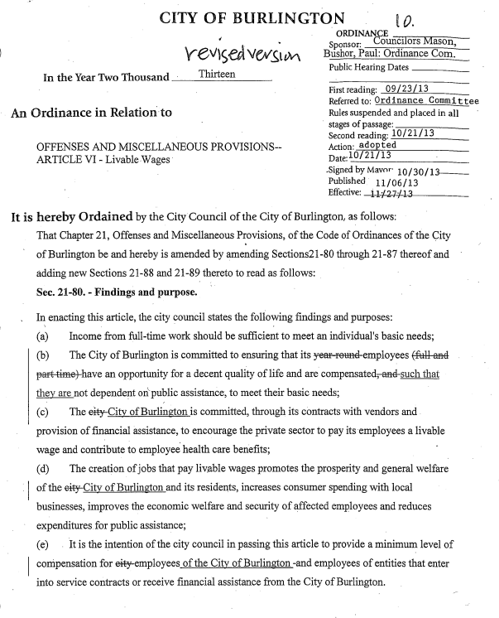

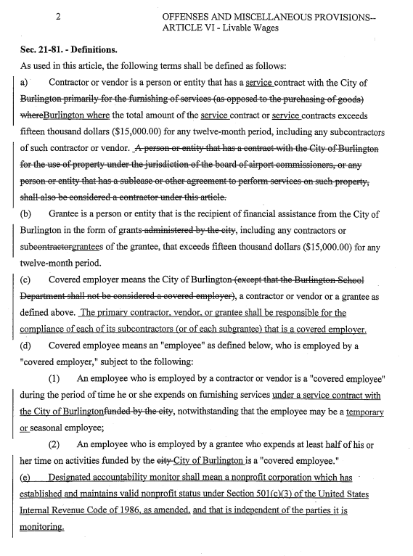
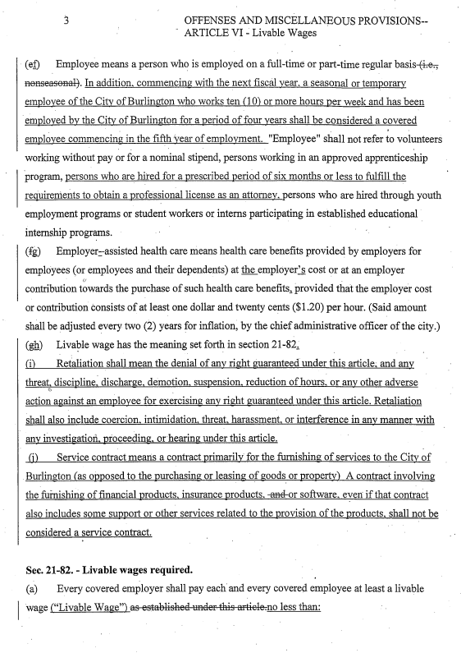
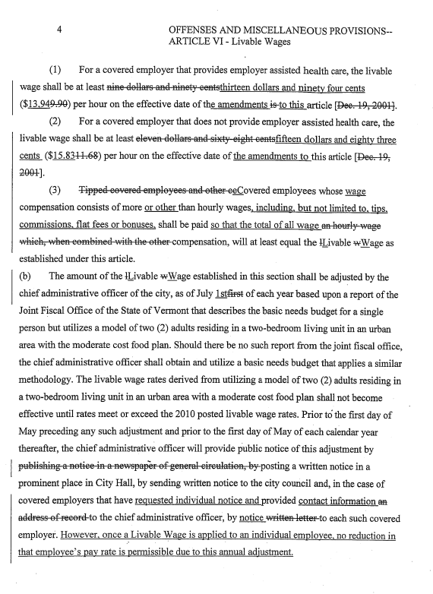

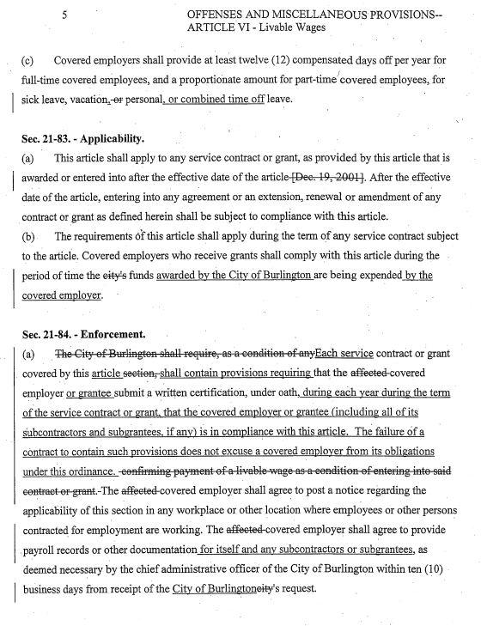

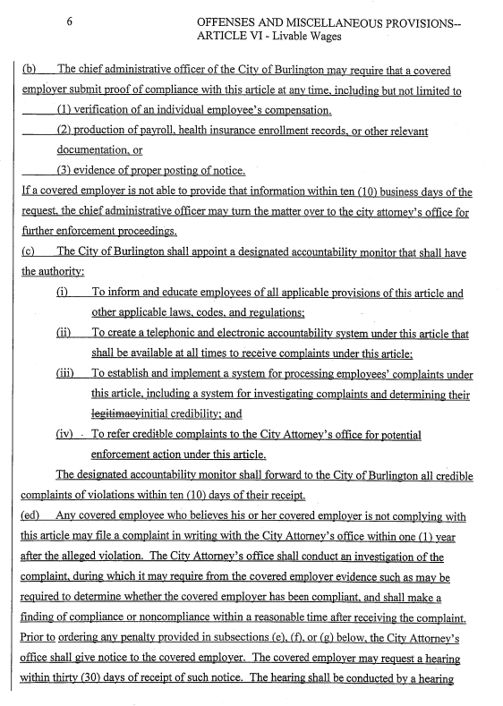
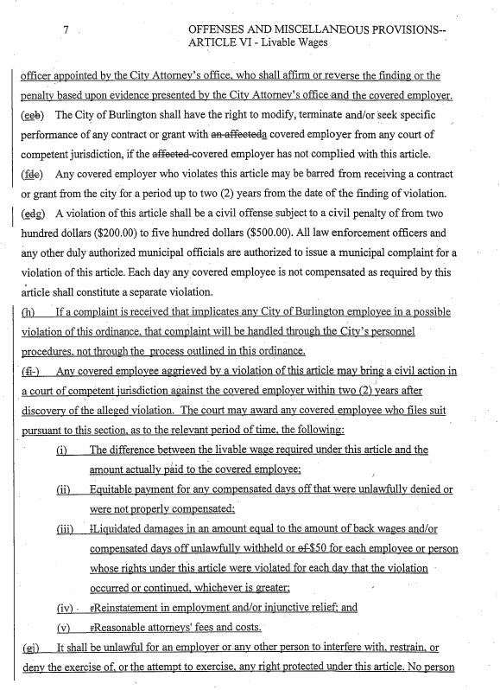
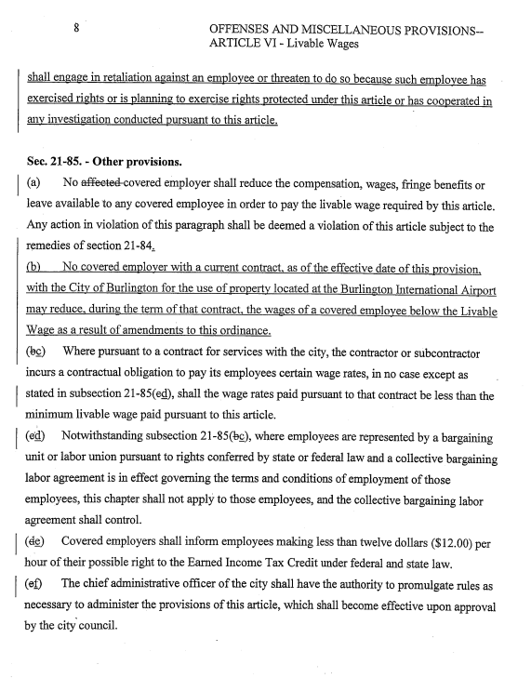
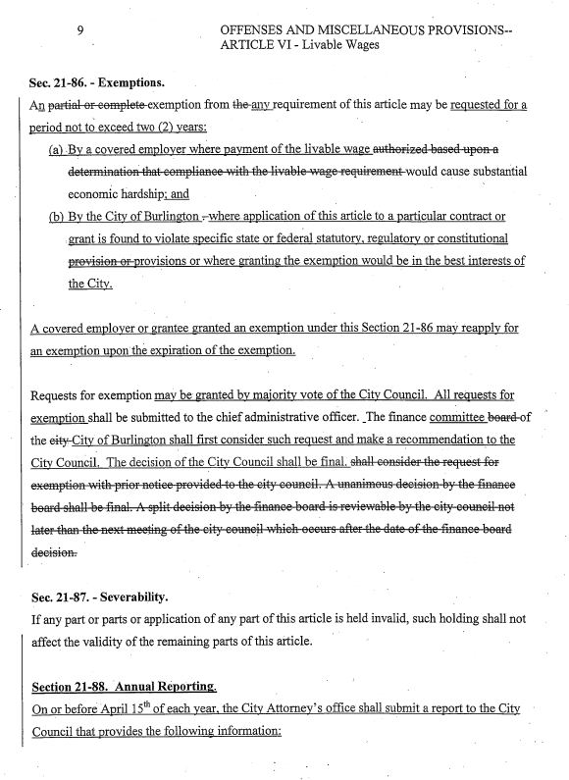
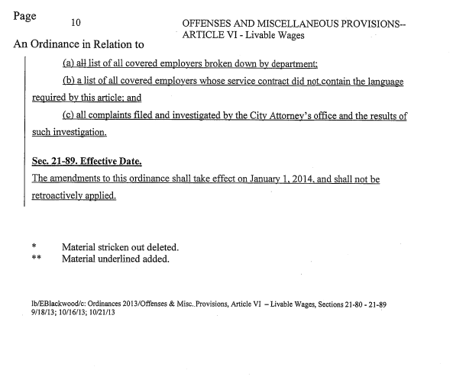
Certification of Compliance with the City of Burlington’s Livable Wage Ordinance
I, ________________________________, on behalf of ___________________________________ (Contractor/Consultant) and in connection with the _________________________________(project), hereby certify under oath that (1) Contractor shall comply with the City of Burlington’s Livable Wage Ordinance; (2) as a condition of entering into this contract or grant, Contractor confirms that all covered employees, as defined by Burlington’s Livable Wage Ordinance, shall be paid a livable wage for the term of the contract as determined and adjusted annually by the City of Burlington’s Chief Administrative Officer, (3) a notice regarding the applicability of the Livable Wage Ordinance shall be posted in the workplace or other location where covered employees work, and (4) payroll records or other documentation, as deemed necessary by the Chief Administrative Officer, shall be provided within ten (10) business days from receipt of the City's request.
Dated at _____________________, Vermont this ____ day of __________________, 2016.

By:_______________________________________________
Duly Authorized Agent

Subscribed and sworn to before me: _______________________________
Notary

BURLINGTON’S OUTSOURCING ORDINANCE

ARTICLE VII. OUTSOURCING

21-90 Policy.
It is the policy of the City of Burlington to let service contracts to contractors, subcontractors and vendors who perform work in the United States.
(Ord. of 11-21-05/12-21-05)

21-91 Definitions.
(a) Contractor or vendor. A person or entity that has a contract with the City of Burlington primarily for the furnishing of services (as opposed to the purchasing of goods), including any subcontractors of such contractor or vendor.
(b) Government funded project. Any contract for services which involves any city funds and the total amount of the contract is fifty thousand dollars ($50,000.00) or more. Burlington School Department contracts shall not be considered government funded projects under this article.
(c) Outsourcing. The assigning or reassigning, directly, or indirectly through subcontracting, of services under a government funded project to workers performing the work outside of the United States.
(Ord. of 11-21-05/12-21-05)

21-92 Implementation.
(a) No contract for a government funded project shall be let to any contractor, subcontractor, or vendor who is outsourcing, or causing the work to be performed outside of the United States or Canada.
(b) Prior to the commencement of work on a government funded project a contractor, subcontractor or vendor shall provide written certification that the services provided under the contract will be performed in the United States or Canada.
(Ord. of 11-21-05/12-21-05)

21-93 Exemption.
An exemption from requirements of this article may be authorized by the chief administrative officer based upon a determination that the services to be performed for the government funded project are not available in the United States or Canada at a reasonable cost. Any such exemption decision by the chief administrative officer shall be reported to the board of finance in writing within five (5) days. The board of finance may, if it should vote to do so, override the exemption decision if such vote occurs within fourteen (14) days of the date of the chief administrative officer’s communication to such board.
(Ord. of 11-21-05/12-21-05)

21-94 Enforcement.
(a) Any contractor, subcontractor or vendor who files false or materially misleading information in connection with an application, certification or request for information pursuant to the provisions of this article or outsources work on a government funded project shall be deemed to be in violation of this article.
(b) A violation of this article shall be a civil offense subject to a civil penalty of from one hundred dollars ($100.00) to five hundred ($500.00). All law enforcement officers and any other duly authorized municipal officials are authorized to issue a municipal complaint for a violation of this article. Each day any violation of any provision of this article shall continue shall constitute a separate violation.
(c) The City of Burlington shall have the right to modify, terminate and or seek specific performance of any contract for a government funded project if the contractor, subcontractor or vendor has not complied with this article.
(Ord. of 11-21-05/12-21-05)

21-95—21-99 Reserved.
Certification of Compliance with the City of Burlington’s Outsourcing Ordinance
I, __________________________________, on behalf of __________________________________ (Contractor) and in connection with the ________________________________________________________________________________________[project], hereby certify under oath that (1) Contractor shall comply with the City of Burlington’s Outsourcing Ordinance (Ordinance §§ 21-90 – 21-93); (2) as a condition of entering into this contract or grant, Contractor confirms that the services provided under the above-referenced contract will be performed in the United States or Canada.
Dated at ________________________, Vermont this ____ day of __________________, 2016.

By:_______________________________________________
Duly Authorized Agent

Subscribed and sworn to before me: _______________________________
Notary

BURLINGTON’S UNION DETERRENCE ORDINANCE

ARTICLE VIII. UNION DETERRENCE

21-100 Policy.
It is the policy of the City of Burlington to limit letting contracts to organizations that provide union deterrence services to other companies.
(Ord. of 3-27-06/4-26-06)

21-101 Definitions.
(a) Contractor or vendor. A person or entity that has a contract with the City of Burlington primarily for the furnishing of services (as opposed to the purchasing of goods), including any subcontractors of such contractor or vendor.
(b) Government funded project. Any contract for services which involves any City funds and the total amount of the contract is fifteen thousand dollars ($15,000.00) or more. Burlington School Department contracts shall not be considered government funded projects under this article.
(c) Union deterrence services. Services provided by a contractor, subcontractor or vendor that are not restricted to advice concerning what activities by an employer are prohibited and permitted by applicable laws and regulations, but extend beyond such legal advice to encouraging an employer to do any of the following:
1) Hold captive audience, (i.e., mandatory) meetings with employees encouraging employees to vote against the union;
2) Have supervisors force workers to meet individually with them to discuss the union;
3) Imply to employees, whether through written or oral communication, that their employer may have to shut down or lay people off if the union wins the election;
4) Discipline or fire workers for union activity;
5) Train managers on how to dissuade employees from supporting the union.
(d) Substantial portion of income. For the purposes of this article, substantial portion of income shall mean greater than ten (10) percent of annual gross revenues or one hundred thousand dollars ($100,000.00), whichever is less.
(Ord. of 3-27-06/4-26-06)

21-102 Implementation.
(a) No contract for a government funded project shall be let to any contractor, subcontractor, or vendor who
1) Advises or has advised an employer to conduct any illegal activity in its dealings with a union.
2) Advertises union deterrence services as specialty services;
3) Earns a substantial portion of its income by providing union deterrence services to other companies in order to defeat union organizing efforts.
(b) Prior to the commencement of work on a government funded project a contractor, subcontractor or vendor shall provide written certification that it has not advised the conduct of any illegal activity, it does not currently, nor will it over the life of the contract provide union deterrence services in violation of this article.
(Ord. of 3-27-06/4-26-06)

21-103 Enforcement.
(a) Any contractor, subcontractor or vendor who files false or materially misleading information in connection with an application, certification or request for information pursuant to the provisions of this article or provided union deterrence services during the life of a contract for a government funded project shall be deemed to be in violation of this article.
(b) The City of Burlington shall have the right to modify, terminate and or seek specific performance of any contract for a government funded project if the contractor, subcontractor or vendor has not complied with this article.
(Ord. of 3-27-06/4-26-06)

21-104—21-110 Reserved.

Certification of Compliance with the City of Burlington’s
Union Deterrence Ordinance

I, __________________________, on behalf of _____________________________ (Contractor) and in connection with ________________________________ (City contract/project/grant), hereby certify under oath that _____________________________ (Contractor) has not advised the conduct of any illegal activity, and it does not currently, nor will it over the life of the contract advertise or provide union deterrence services in violation of the City’s union deterrence ordinance.
Dated at _____________________, Vermont this ____ day of __________________, 2016.

By:_______________________________________________
Duly Authorized Agent

