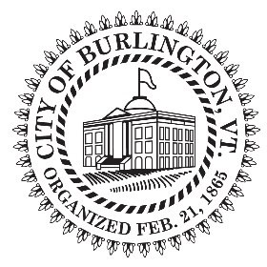HUMAN RESOURCES DEPARTMENT
CITY OF BURLINGTON
200 Church Street, Suite 102, Burlington, VT 05401
Phone: (802) 865-7145
Fax (802) 864-1777
Vermont Relay: 7-1-1 or 800-253-0191

CITY OF BURLINGTON HOLIDAYS 2022

New Year’s Day (observed) | Friday, December 31, 2021 (actual date, Saturday, January 1st)
Martin Luther King, Jr. Day | Monday, January 17, 2022
Presidents’ Day | Monday, February 21, 2022
Town Meeting Day | Tuesday, March 1, 2022
Memorial Day | Monday, May 30, 2022
Independence Day | Monday, July 4, 2022
Bennington Battle Day | Tuesday, August 16, 2022
Labor Day | Monday, September 5, 2022
Indigenous Peoples’ Day | Monday, October 10, 2022
Veterans Day | Friday, November 11, 2022
Thanksgiving Day | Thursday, November 24, 2022
Christmas Day (observed) | Monday, December 26th, 2022 (actual date, Sunday, December 25)

IN ADDITION:

• One Floating Holiday Per Fiscal Year.
• The day after Thanksgiving shall be a Limited Service Day. A Limited Service Day shall be defined as a day that all City offices are open and all City services are provided. Department Heads shall ensure
minimum staffing is available to carry out necessary functions. Employees required to work a Limited Service Day shall be entitled to another day off, which shall be taken during the fiscal year in which it is earned or it will be forfeited.

The City of Burlington will not tolerate unlawful harassment or discrimination on the basis of political or religious affiliation, race, color, national origin, place of birth, ancestry, age, sex, sexual orientation, gender identity, marital status, veteran status, disability, HIV positive status, crime victim status or genetic information. The City is also committed to providing proper access to services, facilities, and employment opportunities.
For accessibility information or alternative formats, please contact Human Resources Department at (802) 540-2505.

