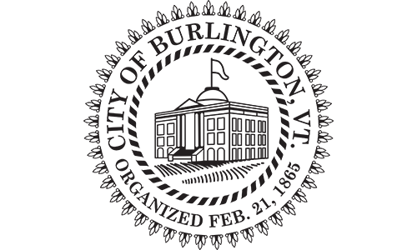
CITY OF BURLINGTON
Request for Proposals
City of Burlington, Vermont
Issued: January 1st, 2020
Due: January 31st, 2020

The City of Burlington, Vermont (population 42,650), invites qualified insurance carriers, third-party administrators, and ancillary benefit services (MBM and PBM) to submit proposals for the City of Burlington's employee group health insurance plan and other ancillary benefits that have a renewal date of July 1, 2020.

The City of Burlington has four unions that have approved the current benefits structure. Your proposal must allow for the complete current in-force benefits structure in order to be considered. Your proposal must incorporate this statement, “Our proposal duplicates the in-force benefits exactly, as agreed upon by the City’s unions.”

The City desires to make a selection no later than March 15, 2020. Depending upon the proposal(s) selected and any necessary transition, the City understands that the above referenced timeframe may need to be adjusted by mutual consent. Important proposal parameters are contained in section XI “General Information for Presenters” and throughout this request. Please review the request in detail and prepare to communicate your questions by the date specified in section XI.

You are invited to bid on required services or services individually.

Ancillary Benefit Services
      - Medical Benefits Manager (MBM) (not TPA)
      - Pharmacy Benefits Manager (PBM)
        - Rebates
        - Manage specialty drugs for better outcomes, IE J Code blocking

Third Party Administrator (TPA) Services
- Stand-alone claim processing
- Bundled or un-bundled stop-loss
- Network access
- Coordinated MBM and PBM relationships
- Streamlined arbitration
Fully Insured
- Coordinated MBM and PBM relationships
- Local network access
Details and proposal parameters can be found in section XI General Information for Presenters. Presenter-RFP Manager communications will be governed by the rule stated in section XI #6.

