Planning Commission
Ordinance Com.

Ten

COMPREHENSIVE DEVELOPMENT ORDINANCE--
Neighborhood Mixed-Use (NMU) District Expansion and Modification
#ZA 10-07

That Appendix A, Comprehensive Development Ordinance, of the Code of Ordinances of the City of Burlington be and hereby is amended by amending Maps 4.4.2-1 and 4.3.1-1, Sec. 4.4.2(d)(4), Tables 4.4.2-1 and 4.4.2-2, and the pertinent parts of Appendix A – Use Table, thereof to read as follows:

Sec. 4.4.2 Neighborhood Mixed use districts
(a) Purpose. As written.
Map 4.4.2-1 Neighborhood Mixed Use Districts
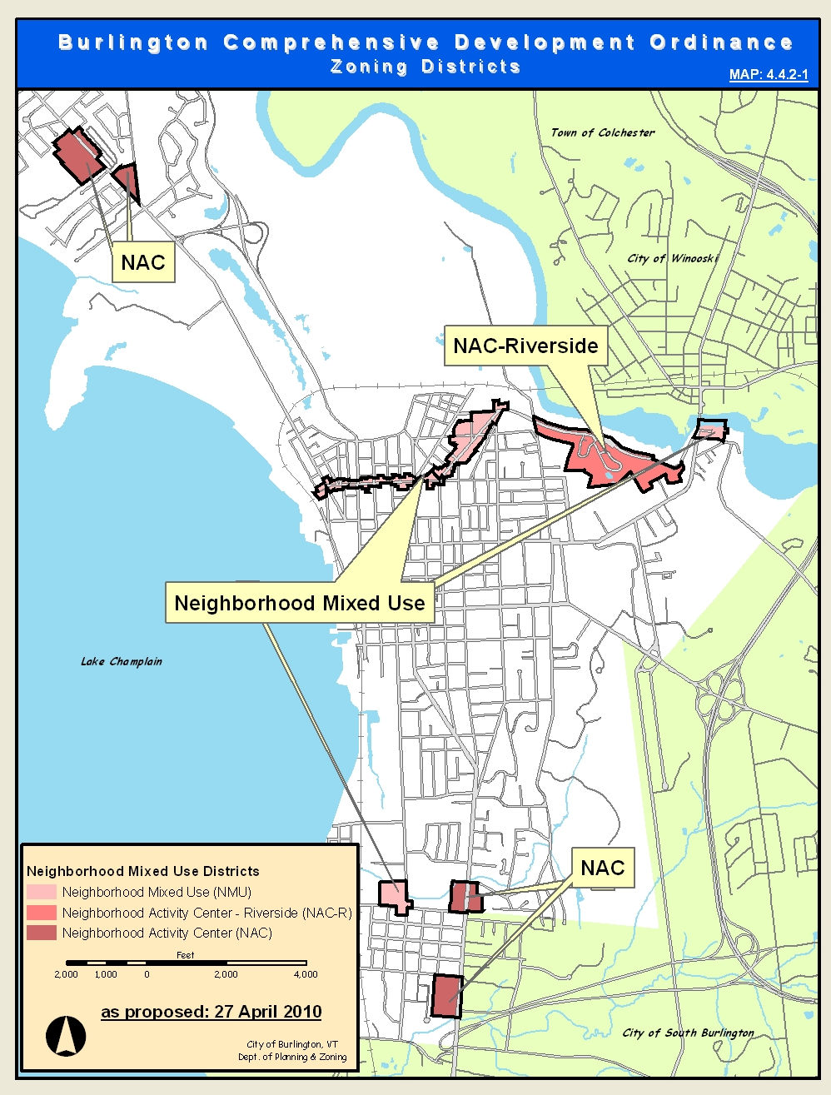
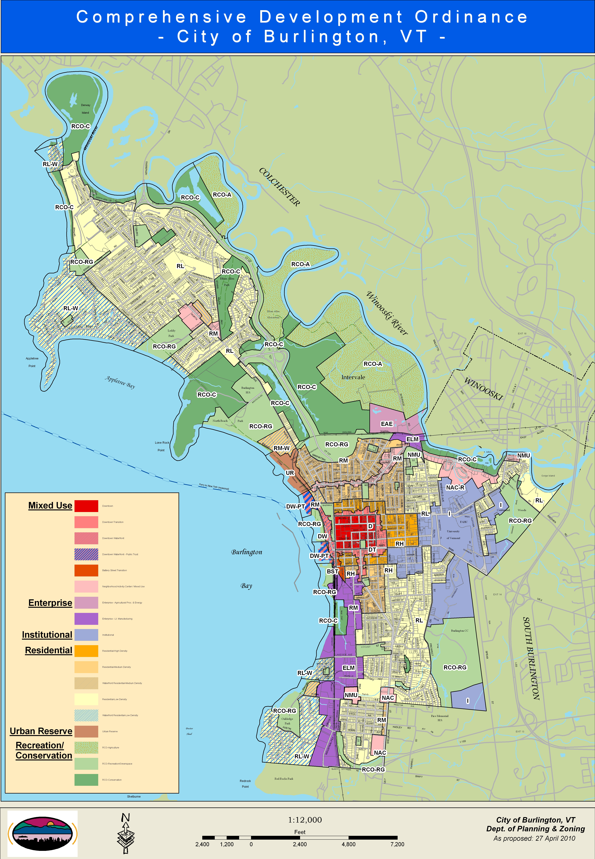
Map 4.3.1-1
2

COMPREHENSIVE DEVELOPMENT ORDINANCE--
Neighborhood Mixed-Use (NMU) District Expansion and Modification
#ZA 10-07

(b) Dimensional Standards and Density

The density and intensity of development, dimensions of building lots, the heights of buildings and their setbacks from property boundary lines, and the limits on lot coverage shall be governed by the following standards:

Table 4.4.2 -1 Dimensional Standards and Density
Districts | Max. Intensity  (floor area ratio¹) | Max. Lot Coverage | Minimum Building Setbacks (feet)  Front⁵ Side² Rear² |  |  | Height³  (feet)
NAC | 2.0 FAR | 80%⁶ | 0 | 0 | 0 | Min: 20⁴  Max: 35
NMU | 2.0 FAR | 80% | 0⁷ | 0 | 0 5 | Min: 20  Max: 35
NAC-Riverside | 2.0 FAR | 80% | 0 | 0 | 0 | Min: 20  Max: 35
- Floor area ratio is defined in Art. 13 and described in Art 5. Actual maximum build out potential may be reduced by site plan and architectural design considerations of Art 6.
- Structures shall be setback a minimum of 15-feet along any property line that abuts a residential zoning district.
- Minimum building height shall be 20-feet and 2 stories. Measurement of and exceptions to height standards are found in Art 5. Bonuses for additional building height are described in section (d)4 below.
- See exception for grocery stores >10,000 gross square feet in (d)2 below.
- All structures shall be setback 12-feet from the curb on a public street.
- Exceptions to minimum lot coverage are provided in (d)3.
- Not withstanding footnote 5 the NMU district at the intersection of Pine St. and Flynn Avenue shall have a minimum front yard setback of 10 feet.
- Permitted and Conditional Uses: (As written)

(d) District Specific Regulations:

1. Ground Floor Residential Uses Restricted As written.

2. Exception to Minimum Building Height in NAC District As written.

3. Exception to Maximum Lot Coverage in NAC District As written.

4. Development Bonuses/Additional Allowances
The following exceptions to maximum allowable base building height and FAR in Table 4.4.2-1 above may be approved in any combination subject to the maximum limits set forth in Table
3

COMPREHENSIVE DEVELOPMENT ORDINANCE--
Neighborhood Mixed-Use (NMU) District Expansion and Modification
#ZA 10-07

4.4.2-2 below at the discretion of the DRB. The additional FAR allowed shall correspond to the proportion of the additional building height granted to the maximum available.

A. Inclusionary Housing:
Inclusionary housing units shall be provided, with applicable additional coverage and density exceptions, in accordance with the provisions of Article 9, Part 1. An additional allowance in all Neighborhood Mixed Use NAC and NAC-Riverside districts may be permitted at the discretion of the DRB for the provision of additional onsite inclusionary housing units.
A maximum of an additional 10 feet of building height, and corresponding FAR, may be permitted at the discretion of the DRB for an additional 5% inclusionary housing units provided onsite in excess of the requirements of Article 9, Part 1. The total gross floor area dedicated to the additional inclusionary housing shall be equivalent to the gross floor area resulting from the additional allowance.

B. Senior Housing:
A maximum of an additional 10-feet of building height, and corresponding FAR, may be permitted at the discretion of the DRB in all Neighborhood Mixed Use NAC and NAC-Riverside districts where no less than twenty-five per cent (25%) of the total number of onsite units are reserved for low-moderate income senior households as defined by state or federal guidelines, including no less than ten percent (10%) reserved for low-income households. The total gross floor area dedicated to the senior housing shall be equivalent to the gross floor area resulting from the additional allowance.

C. Maximum Bonus:
In no case shall any development bonuses or allowances granted, either individually or in combination, enable a building to exceed the maximum FAR and maximum building height permitted in any district as defined below:

Table 4.4.2 -2: Maximum FAR and Building Heights with Bonuses
 | Maximum  FAR | Maximum  Height
NAC | 3.0 FAR | 45 feet
NMU | 3.0 FAR | 45 feet
NAC-Riverside | 3.0 FAR | 45 feet

4

COMPREHENSIVE DEVELOPMENT ORDINANCE--
Neighborhood Mixed-Use (NMU) District Expansion and Modification
#ZA 10-07

Appendix A - USE TABLE:
Legend:
Y | Permitted Use in this district
CU | Conditional Use in this district
N | Use not permitted in this district
USES | NMU
RESIDENTIAL SPECIAL USES | NMU
Dormitory⁵ | CU N²⁵
NON-RESIDENTIAL USES | NMU
Amusement Arcade | CUN
Appliance Sales/Service | Y²⁴
Auction House | YN
Bakery - Wholesale | YN
Boat Repair/Service | CUN
Boat Storage | CUN
Cinema | YCU¹⁴
Dry Cleaning Service | Y²⁴¹⁴
Film Studio | CUN
Garden Supply Store | CU²⁴¹⁴
Health Club | YCU
Micro-Brewery/Winery | YCU
Pet Store¹⁰ | YCU
Public Transit Terminal | CUN
Recreational Facility - Indoor | CUN

5 COMPREHENSIVE DEVELOPMENT ORDINANCE
Neighborhood Mixed-Use (NMU) District Expansion and Modification
ZA #10-07

- Residential uses are not permitted except only as an accessory use to an agricultural use.
- Duplexes may be constructed, or a single unit may be converted into a duplex, on lots existing as of January 1, 2007 and which meet the minimum lot size of 10,000 square feet.
- Duplexes shall only be allowed as a result of a conversion of an existing single family home. New duplexes are prohibited.
- No more than 5 rooms permitted to be let in any district where bed and breakfast is a conditional use. No more than 3 rooms permitted to be let in the RL district.
- An existing fraternity, sorority, or other institutional use may be converted to dormitory use subject to conditional use approval by the DRB.
- Must be owner-occupied.
- Must be located on a major street.
- Allowed only on the ground floor level of structures in the district.
- Automobile sales not permitted as an accessory use.
- Exterior storage and display not permitted.
- All repairs must be contained within an enclosed structure.
- No fuel pumps shall be allowed.
- Permitted hours of operation 5:30 a.m. to 11:00 p.m.
- Such uses not to exceed ten thousand (10,000) square feet per establishment.
- Excludes storage of uncured hides, explosives, and oil and gas products.
- See Sec. 4.4.1(d) 2 for more explicit language regarding permitted and conditional uses in the Downtown Waterfront – Public Trust District.
- Allowed only as an accessory use.
- A permitted use in the Shelburne Rd Plaza and Ethan Allen Shopping Center.
- Cafes not permitted as an accessory use. Retail sales and tasting are permitted as an accessory use.
- Accepted agricultural and silvicultural practices, including the construction of farm structures, as those practices are defined by the secretary of agriculture, food and markets or the commissioner of forests, parks and recreation, respectively, under 10 VSA §1021(f) and 1259(f) and 6 VSA §4810 are exempt from regulation under local zoning.
- See Sec. 4.4.7 (c) for specific allowances and restrictions regarding uses in the Urban Reserve District.
- See Sec. 4.4.5 (d) 6 for specific allowances and restrictions regarding Neighborhood Commercial Uses in Residential districts.
23. Allowed only on properties with frontage on Pine Street. (pending re: ZA-10-06)
24. Such uses shall not exceed 4,000 square feet in size.
25. Dormitories are only allowed on properties contiguous to a school existing as of January 1, 2010.

* Material stricken out deleted.
** Material underlined added.

lb/emb/c: Ordinances 2010/Zoning Amendment #ZA 10-07 Neighborhood Mixed-Use (NMU) Expansion (Sec. 4.4.2 & Table & App. A Table)
6/23/10

