City of Burlington
February 2014
FINANCIAL STATEMENTS

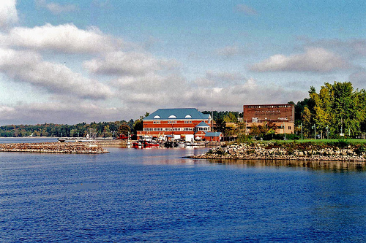

Community and Economic Development Office
The majority of CEDO funding is from reimbursable grants. While currently our revenues are well below the projected amount for this time of year, expenditures are tied to project completion and expenses and are not evenly distributed throughout the calendar year. We have identified shortfalls in projected revenue in the areas of new revenue sources and an indirect cost transfers. We are actively working with the CAO to identify and address these issues in a timely manner.
Department of Public Works
The Department of Public Works has six General Fund divisions (seven with the Central Maintenance Facility). The six include: Administration, Streets (Right of Way), Trades, Engineering, Equipment Maintenance, and Recycling. To stay brief our summary will only review significant highlights.
The year to date budget concerns rests primarily with the Streets budget. The winter has contributed to overages for both overtime and salt. Overtime for snow this year is running $70,000 more than the same time last year. Salt is $109,000 more this year with the winter still not over. The harsh winter with deep frost will also lead to a late start for spring work that this group does to earn revenue for sidewalk installation for the Capital Street Program. That work is further complicated by the type of sidewalk work being programmed in Streets as “long” runs with an actual need now for “short” runs. Many sidewalk problems are being logged in “See Click Fix”. Streets has year to date completed $183,844 of $815,000 budgeted for concrete, i.e. sidewalk replacement. The net for Streets at this time is $1.18 million in General Fund support, compared to a budget for the year of $417,769.
The Trades group is the general fund division expected to have a net positive of close to $500,000 given the high permit activity and the late hiring of the new trades inspector. The Engineering group although struggling with billing changes is projected to close the year only $4,000 short.
DPWs Revenue divisions Water and Wastewater are tracking behind in revenues but these do not follow a linear month to month change. The majority of revenue is based on retail sales and is affected by weather patterns. The warmer and drier patterns lead to increased sales. Depending on the type of April-June weather will dictate how sales will end. That said expenses are also tracking less than one would expect at this time of year. This is in part due to the depreciation expense carried in the operating budgets for the last several years. This is not a cash expense from the operating budget and FY15 will be developed without depreciation in the operating budget. This past winter has also been difficult for the water pipe infrastructure and sewer pipes. Spring will bring capital replacement of water mains and relining for sewer lines.
The Special revenue fund Stormwater is showing revenues at 49% but this is predicted to end on track due to the increase in stormwater fees effective January 1, 2014. Expenses are tracking less than revenues therefore leaving this fund in a positive position and able to tackle projects in the spring previously identified and approved such as the Colchester Avenue storm pipe relining equal to $89,685.
The Traffic fund, also a Special revenue fund is year to date at 64% in revenues and 60% in expenses. This is a bit understated given that this fund has significant capital garage needs currently being reviewed by an outside capital assessment. The fund has become cash “poor” and will need to make changes going forward to sustain the garage infrastructure.

