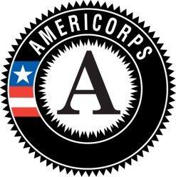

2017-2018 AmeriCorps Recruitment and Hiring Process

Recruitment
- CEDO utilizes local social networking tools, networking through our non profit partners, various listserves, college employment sites, craigslist and other advertising to recruit. We also send our partners the link to position advertisements on our website to distribute through your networks.
- Please use your networks to advertise positions and if you have already identified potential candidates then send them through to us, as soon as possible.

Application & Cultural Competency Interview
- Applicants submit resumé and cover letter to the CEDO office. Recruitment team screens applications for demonstrated experience.
- When experience is demonstrated in written material, applicants are scheduled for a short screening (approx 30 min) with the recruitment team, to discuss their background, interest and experience and to cover the mechanics of the national service experience. If the applicant is assessed as having the necessary experience for AmeriCorps the resume and cover letter is sent along to the you.

Hiring Process
- Service Sites interview to evaluate applicants
- Sites identify preferred applicant and notify the CEDO office of preferred applicant. Offer the position to the applicant and inform CEDO of acceptance, or otherwise.
- Send CEDO proof that you have checked 2 references (letters, or email summary of phone call)
- Enrollment paperwork is completed at the CEDO office and background check requests submitted
- Your member may begin service once you receive notification of enrollment from CEDO. Enrollment may only occur after we receive the results of background checks.
- Members may begin training and orientation at sites prior to enrollment, NO direct service is permitted prior to notification of enrollment.

Please let us know if you have any questions. mgange@burlingtonvt.gov

