Assessment of Fair Housing

City of Burlington, Vermont
December 2017 – December 2022

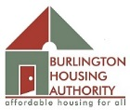

Table of Contents
I. Cover Sheet 3
II. Executive Summary 5
III. Community Participation Process 8
IV. Assessment of Past Goals and Actions 13
V. Fair Housing Analysis 23
A. Demographic Summary 23
B. General Issues 38
i. Segregation/Integration 38
ii. Racially or Ethnically Concentrated Areas of Poverty (R/ECAPs) 48
iii. Disparities in Access to Opportunity 49
a. Educational Opportunities 51
b. Employment Opportunities 56
c. Transportation Opportunities 61
d. Access to Low Poverty Neighborhoods 67
e. Access to Environmentally Healthy Neighborhoods 71
f. Patterns in Disparity to Opportunity 74
iv. Disproportionate Housing Needs 76
C. Publicly Supported Housing Analysis 83
D. Disability and Access Analysis 93
E. Fair Housing Enforcement, Outreach Capacity, and Resources 100
F. 1,250 Units or Fewer Winooski Housing Authority Insert 104
VI. Fair Housing Goals and Priorities 131

Due to formatting and edits for publication, the current table of contents may not match current page numbers. This will be finalized and corrected at publication.

Cover Sheet

- Submission date: [insert]

- Submitter name: City of Burlington, VT

- Type of submission: Joint Submission – City of Burlington, Vermont, Burlington Housing Authority and the Winooski Housing Authority

- Type of program participant(s): Consolidated Plan Participants and Public Housing Authority

- For PHAs, Jurisdiction in which the program participant is located: City of Burlington, VT

- Submitter members (if applicable): City of Burlington, Vermont, Burlington Housing Authority and the Winooski Housing Authority

- Lead submitter contact information:
- Name: Marcy Esbjerg

- Title: Assistant Director

- Department: Community & Economic Development Office

- Street address: 149 Church Street, Room 32

- City: Burlington

- State: Vermont

- Zip code: 05401

- Period covered by this assessment: 2017 - 2022

- Initial, amended, or renewal AFH: Initial Assessment

- To the best of its knowledge and belief, the statements and information contained herein are true, accurate, and complete and the program participant has developed this AFH in compliance with the requirements of 24 C.F.R. §§ 5.150-5.180 or comparable replacement regulations of the Department of Housing and Urban Development;

- The program participant will take meaningful actions to further the goals identified in its AFH conducted in accordance with the requirements in §§ 5.150 through 5.180 and 24 C.F.R. §§ 91.225(a)(1), 91.325(a)(1), 91.425(a)(1), 570.487(b)(1), 570.601, 903.7(o), and 903.15(d), as applicable. All Joint and Regional Participants are bound by the certification, except that some of the analysis, goals or priorities included in the AFH may only apply to an individual program participant as expressly stated in the AFH.

(Signature Page)

Executive Summary

Summarize the fair housing issues, significant contributing factors, and goals. Also include an overview of the process and analysis used to reach the goals.
The City of Burlington, in cooperation with the Burlington and Winooski Housing Authorities present this Assessment of Fair Housing for our jurisdiction and region.
The Assessment of Fair Housing (AFH) is a legal requirement that the City and Housing Authorities must complete in order to continue receiving federal housing and community development funding from the United States Department of Housing & Urban Development (HUD). The AFH is an analysis undertaken pursuant to 24 CFR Part 5.152 that includes an analysis of fair housing data, an assessment of housing issues and contributing factors, and identification of fair housing priorities and goals specific to Burlington and our surrounding area. Examples of fair housing issues include local and regional demographics related to segregation, racially and ethnically concentrated areas of poverty, access to opportunity, disproportionate housing need, publicly supported housing, accesses to housing by persons with disabilities, and fair housing enforcement.
For purposes of this document, the City is considered Burlington, Vermont, a jurisdiction in receipt of both Community Development Block Grant and HOME funds. The Region, by HUD definition, is considered Chittenden, Grand Isle and Franklin Counties.
The document includes a section on community participation and outreach, a review of past goals and progress, a fair housing analysis covers demographics for both the City and the Region, an analysis of data and contributing factors to fair housing issues, disparities in access to opportunity, disproportionate housing needs, publicly supported housing analysis, and an analysis of our community’s fair housing outreach and enforcement. The Assessment concludes with recommendations, goals and clear metrics for the City and its partners to affirmatively further fair housing.
The City of Burlington used a multi-faceted approach to meaningful community participation. The City and partners conducted outreach to gain comments, concerns and feedback on fair housing issues. An in-depth housing and neighborhood survey was developed and distributed in multiple languages, including a direct mailing to Burlington Housing Authority residents. Several focus groups and interviews were held with protected classes and/or agencies who serve protected classes. Attendance at public events such as Martin Luther King, Jr Day, World Refugee Day and Here to Help Clinics provided opportunities to specifically engage protected classes. Once a draft of the Assessment of Fair Housing was complete, public meetings, hearings and media outreach were conducted to gain feedback on the proposed AFH.
The progress on the five key goals established in the City's 2010 Analysis of Impediments to Fair Housing is carefully reviewed. The first impediment concerned high rental and homeownership prices impacted people in protected classes and the goal to encourage more affordable housing. Along with policy improvements, collaborative initiatives, almost 300 affordable units have been either preserved or built in the past 5 years. The second impediment stated some housing professionals' policies and practices limited housing options for protected classes. Progress under this goal included outreach and educational efforts both towards professionals as well as classes specifically geared to assist low income individuals and families gain success as renters and homeowners. Under the third impediment, the City has taken extensive measures to document and measure fair housing challenges and progress to justify needed funding for fair housing efforts in Burlington and the region. Continued awareness, education and enforcement activities are key to ensuring discrimination against people in protected classes by real estate and other housing professionals does not go undetected. Under the fourth impediment, goals and progress to ensure an adequate supply of homes available and accessible to populations of those with disabilities, frail elders and larger families is examined; new units for seniors have been constructed, units with 3+ bedrooms have been included in new affordable housing developments and investments in the Homeshare program continue. In addition, the SASH program (Support and Services at Home) for seniors has become a standard practice for service enriched senior housing. For the final impediment, the City continues to review housing development and occupancy policies; Mayor Weinberger and City Council approved a 22-point Housing Action Plan aimed at reducing the cost of housing for all Burlington residents, supporting existing affordable housing options and examining policies and regulations that negatively impact the affordable housing market.
In the demographic section, information on population trends for the City and Region are examined. Key trends for the City include an increase in the foreign-born, female and non-white populations. Demographics for the City also demonstrate a decrease in the number of families, white, 65+ populations. The Region is also becoming more racially and ethnically diverse, although at a slower pace; this is also true to the foreign-born population. Gender trends are similar in the Region. However, 65+ trend in the Region shows an increase which might be attributed to a rise in senior housing outside of Burlington. Family trends are comparable to the City's downward trend.
The Assessment also analyzes general fair housing issues. The data provided for Segregation/Integration do not rise to the level of segregation concerns in either the City or the Region. However, there is a steadily increasing trend of segregation between White and Non-white population since 1990. Population density maps based on National Origin and Limited English Proficiency (LEP) show evidence of segregation in Burlington. Areas in Burlington showing the highest density of Non-white populations also have the highest percentage of renter-occupied housing.
There are no racially or ethnically concentrated areas of poverty (R/ECAPS) located in Burlington or the Region. The definition is provided within the document.
In the section on disparities in access to opportunity, the presence and degree of disparities to opportunity in the areas of education, transportation, employment, low poverty exposure, environmentally healthy neighborhoods are reviewed and explored. Several key findings emerged in this section. There are more disparities in access to proficient schools among racial/ethnic groups for those living in poverty than the populations as a whole. Blacks living below the poverty line live closer to where they work and have higher levels of labor engagement than any other race. Access to transportation is higher within Burlington than in the region as a whole, although transportation costs between these areas are not significantly different. Black populations have higher exposure to poverty than any other population, and exposure to poverty is higher within Burlington than in the region. There is low disparity between access to environmentally healthy neighborhoods overall, although more disparity exists when considering only those below the federal poverty line, suggesting a socioeconomic factor.
Disproportionate housing needs examines which groups by race/ethnicity and family status experience higher rates of housing cost burden, overcrowding or substandard housing as compared to other groups. Within Burlington, Black households experience the highest rate of housing problems while Native American households experience the highest rate of severe housing problems. Within the Burlington-South Burlington region, Asian or Pacific Islander households experience the highest rate of housing problems, both in general and severe.
Housing burden seems to be spatially correlated to areas with higher non-white population densities. Almost 25% of the Burlington population experiences a severe housing cost burden compared to 15% in the Region. Housing cost burden continues to be the most significant issue faced by both protected classes and others.

The City partnered with both the Burlington Housing Authority and the Winooski Housing Authority for this 2017 Assessment of Fair Housing. Information on the demographics, locations, disparities, in terms of protected classes for both agencies is explored in two sections. In the section on Publically Supported Housing, the following key findings were noted. A higher percentage of non-Whites live in PHA managed properties than the percentage of non-Whites in the population as a whole. Half of the residents living in BHA properties have a disability. Properties with concentrated racial/ethnic populations correlate with properties with family units with more than 2 bedrooms.

In the analysis on disability and access, six types of recorded disabilities are noted with cognitive difficulty being the most prevalent disability in Burlington. Ambulatory difficult follows very closely as the next prevalent disability. These are reversed on a regional level. Disabled populations appear to cluster around more developed areas; however there does not appear to be any major geographic patterns for individual disability types.

Under the section on Fair Housing Enforcement, Outreach Capacity and Resource Analysis, information regarding the fair housing activities of Vermont Legal Aid under the Fair Housing Initiative Program, Champlain Valley Office of Economic Opportunity (CVOEO) Fair Housing Project and the Human Rights Commission is shared. The local programs are granted funded and therefore limited on the procurement of these additional funds.

In the final section of the AFH, Fair Housing Goals and Priorities, the City and its partners outline the contributing factors toward local fair housing issues, prioritize the factors and establish goals to address each fair housing issue. For the following goals, contributing factors, fair housing issues, metrics and milestones along with the responsible program participant are detailed.

The Assessment of Fair Housing goals are:

- Increase affordable housing opportunities
- Maintain or preserve affordable housing units
- Provide housing resources to low income renters, homeowners and increase homeownership opportunities
- Increase employment opportunities for protected classes
- Increase educational opportunities with a focus on protected classes
- Support Fair Housing Education and Equitable Outreach

The Burlington City Council held a Public Hearing on Monday, September 18, 2017 and formally approved the submittal of the AFH on Monday, September 25, 2017. The Burlington Housing Authority Commission approved submission of the AFH also on Monday, September 25, 2017. The Winooski Housing Authority

Community Participation Process

Describe outreach activities undertaken to encourage and broaden meaningful community participation in the AFH process, including the types of outreach activities and dates of public hearings or meetings. Identify media outlets used and include a description of efforts made to reach the public, including those representing populations that are typically underrepresented in the planning process such as persons who reside in areas identified as R/ECAPs, persons who are limited English proficient (LEP), and persons with disabilities. Briefly explain how these communications were designed to reach the broadest audience possible. For PHAs, identify your meetings with the Resident Advisory Board and other resident outreach.

The City of Burlington used a two-faceted approach to meaningful participation. To begin the process, the City and partners conducted outreach to gain comments, concerns and feedback on fair housing issues. Once a draft of the Assessment of Fair Housings was complete, public meetings, hearings and media outreach were conducted to gain feedback on the proposed AFH. This approach is detailed below.

Several methods to obtain community feedback included attendance and tabling at large events, the Chittenden County Housing and Neighborhood Survey and a series of group and individual interviews with protected classes. The combination of data received via the survey and the anecdotal information discovered in the interview process has provided the City with a helpful snapshot of what community members recognize as the most significant challenges to fair housing and economic opportunity. The City ensured a broad, yet targeted, dissemination of the survey. A wide variety of socioeconomic groups, as well as protected classes, were presented with the opportunity to provide feedback through an extensive interview process. The City of Burlington, the Burlington Housing Authority (BHA), and the Champlain Valley Office of Economic Opportunity (CVOEO), worked closely with a variety of community organizations to facilitate meaningful, open dialogue with community members from a range of protected classes and demographics.

Media outlets included connections on Facebook, the websites of the City of Burlington and other partners, two Channel 17 broadcasts on the Assessment of Fair Housing which aired multiple times and an electronic newsletter to over 1300 households in the City of Burlington.

PHA outreach included small group gatherings at housing authority properties with in-depth conversations with residents. A mailing to all the individuals and families in the Burlington Housing Authority portfolio – over 2400 postcards were sent to families in 3 different languages and the surveys were translated into Nepali and Vietnamese, encouraging residents to participate in the housing survey.

Events included the Martin Luther King, Jr. Day at ECHO, where over 1,900 people attended this free event as part of a nationwide initiative to make MLK Day a ‘day on, not a day off’, in which communities engage their citizenry in meaningful service and reflection. This was ECHO’s largest single day attendance in its 14 year history and double the previous year’s attendance; for many attendees it was their first time at the museum. The City provided free entry and free transport to the site. Each year, adults and children gather to explore issues of diversity and inclusion through story, song, and conversation. This year, we were proud to highlight our community’s youth and recognize their leadership in advancing social justice and eliminating racism and table the event with information and surveys regarding fair housing.

Several times the City participated in the Here to Help Clinic, an outreach organized by a partnership between the Chittenden County Homeless Alliance and the University of Vermont Medical School Schweitzer fellows to the area homeless to engage and received feedback on their challenges to housing. On World Refugee Day, 4 students of color did outreach to a diverse population of refugees for input and feedback.

Extensive interviews were conducted with persons with disabilities including representatives from Vermont Council for Independent Living, members of the Mayor’s Council on Accessibility and individuals.

Housing and Neighborhood Survey:
As an initial approach to capture the broadest array of data, the City designed the Chittenden County Housing and Neighborhood survey: a series of questions aimed at gathering citizen’s impressions and satisfaction with neighborhood amenities, housing opportunity, housing costs, and discrimination.

The Survey was administered over the course of January 15, 2017 to August 30, 2017, and was promoted through an array of communication and marketing outlets available to the CIty, including but not limited to: Facebook, Twitter, Front Porch Forum, and email. In addition to these primary networks of communication, the City also worked closely with community based organizations (CBOs), including those at the Chittenden County Homeless Alliance, the local Continuum of Care, to successfully reach different segments of the populations, specifically those that have been historically underserved, such as New Americans, Section 8 participants, and those who suffer from mental illness. A total of 776 responses were submitted.

The survey was administered by www.surveygizmo.com. Of the initial 776 responses, 710 were identifiable based on given information as completed by people who lived in either Chittenden, Franklin, or Grand Isle counties. The vast majority of those 710 surveys (635 or 89%) were completed by respondents who indicated that they lived in the City of Burlington.
Some notable findings are as follows:
- The majority of survey takers responded favorably to questions regarding neighborhood characteristics;
- Questions receiving responses that were more negative than average regarded the quality of streets and sidewalks, availability of housing, and job availability;
- Just under 87% of respondents indicated that they were satisfied with the quality of housing they currently resided in, but 51% of total respondents indicated that they had trouble finding safe, quality housing in a neighborhood that they could afford;
- Along those same financial lines, 78% (555/710) of respondents indicated that housing options were limited by what they could afford for rent;
- Over 70% of respondents indicated they had a bachelor’s or advanced degree; and
- 19% indicated that someone in their household had a disability.

Interviews and Focus Groups:
Over the course of six months, from November 2016 to July 2017, the City structured an extensive series of interviews with two distinct sets of stakeholders: service providers and services beneficiaries including those eligible to receive services but who may not be currently receiving benefits.

The dates of these interviews are included here and a summary of comments are included in a following section.

Anew Place – homeless shelter/transitional housing provider – 4.14.17
Cathedral Square – housing provider for senior population – 4.4.17
Champlain Housing Trust – affordable housing provider – 3.21.17
Chittenden County Regional Planning Commission 2.13.1
Community Health Centers of Burlington – federally qualified health clinic – 4.6.17
Decker Towers – RAD property with Burlington Housing Authority – series of meetings – 2.14/2.22.17
Howard Center – service provider for individuals with mental health and substance abuse issues- 4.17.17
Mayor’s Advisory Committee on Accessibility – 2.13.17
Pathways Vermont – homeless provider, veterans, hardest to house – 3.31.17
South Square – RAD property – coffee with residents – 2.8.17
Vermont Center for Independent Living – services for those with disabilities – 4.3.17
VNA Family Room – parent and child center – 4.24.17
United Way of Northwest Vermont – community and philanthropic organization – 4.5.17

Public Meetings:
As an effort to meet with the entire community, the AFH team discussed the project with participants of multiple Neighborhood Planning Assemblies (NPA)s. The NPAs serve as a forum for members of the community to discuss issues and challenges related to their neighborhoods with their representatives City Councilors.

Neighborhood Planning Assembly Ward 1 and 8: The AFFH team conducted a presentation and received feedback at the March 8, 2017 meeting. When presenting the AFFH, two challenges were cited as major impediments to fair housing: affordability and inclusionary zoning with apartments with less than five units.

Neighborhood Planning Assembly Ward 6: The AFFH team conducted a focus group with members of the Ward 5 and 6 Neighborhood planning committee on March 2, 2017. This meeting was an open-ended discussion centered on the major impediments to fair housing.

City Council – A public hearing was held at the Burlington City Council on Monday, September 18, 2017.

Provide a list of organizations consulted during the community participation process.

- Mayor’s Advisory Committee on Accessibility
- ANEW Pace
- Burlington Dismas House
- Cathedral Square
- Chittenden County Regional Planning Commission
- Champlain Housing Trust
- Champlain Valley Office of Economic Opportunity
- Committee On Temporary Shelter
- Community Health Centers of Burlington
- Homeshare Vermont
- Howard Center
- Pathways Vermont
- Vermont Legal Aid
- Vermont Housing Finance Agency
- Vermont Center for Independent Living
- VNA Family Room
- United Way of Northwest Vermont
- Chittenden County Homeless Alliance
- City of Burlington
- Burlington Housing Authority
- Winooski Housing Authority
- Associations of Africans Living in Vermont
- Vermont Refugee Resettlement Program

Describe whether the outreach activities elicited broad community participation during the development of the AFH. If there was low participation, or low participation among particular protected class groups, what additional steps might improve or increase community participation in the future, including overall participation or among specific protected class groups?
The City of Burlington received broad community participation and feedback during the development of the AFH including participation from the homeless, New Americans, those with limited English proficiency, disabled and people of color. Our non-profit organizations, housing authorities, interns of color, and outreach events were invaluable in reaching a diverse audience.

Summarize all comments obtained in the community participation process. Include a summary of any comments or views not accepted and the reasons why.

Of the interviews conducted, the following list contains the most frequently cited comments regarding barriers to fair housing are listed below.

- Lack of affordable housing stock
- Noncompetitive housing vouchers
- Policies and Practices of PHA
- A lack of economic opportunity
- Shortage of available Vouchers
- Ineffective General Assistance Benefits
- Limited Transportation Options
- Private Discrimination

Mayor’s Advisory Committee on Accessibility: On February 13th, 2017 - Participants were adamant about making changes to the city’s marketplaces and storefronts to make them more accessible to individuals with disabilities. In addition, members discussed experiences and challenges regarding integration/segregation of disabled populations, as well as the over-institutionalization and medicalization of living arrangements and transportation for those with disabilities, both mental and physical.

ANEW Place: April 14th, 2017 - ANEW Place residents and Case Managers. The most significant barriers cited by both Case Managers and Residents included difficulty findings employment opportunity, addiction, and a lack of affordable housing stock.

Cathedral Square: April 4th, 2017 - Cathedral Square, a major housing provider in the community for elderly populations which manages 30 different properties in the county. The most significant challenges noted were a limited number of available units, and the competitiveness created by certain policies to favor some groups over others (e.g. homeless versus. elderly, with a preference placed on homelessness).

Champlain Housing Trust: March 21st, 2017 - Of the challenges cited, the most prevalent and emphasized were lack of private landlords willingness to make accommodations for those with disabilities, a lack of funding for service provision to homeless individuals, and language barriers with New American populations.

Decker Towers: Over a series of meetings to include residents of Decker Towers, the largest HUD Rental Assisted Development in Burlington, the residents expressed major concerns regarding incredibly long waitlists (as high as 10+ years), limited number of affordable housing units, and lack of employment opportunities. Additionally, a number of residents noted a few common concerns regarding their housing situation regarding safety, policies, and communication with administrative workers.

Howard Center: April 17th, 2017 - Howard Center workers expressed the most notable challenges to providing clients with fair housing as affordability of housing, stigmas surrounding mental health, and poor quality of available housing.

Pathways Vermont: On March 31, 2017 – Staff members who serve the homeless, veterans and other underserved populations, a number of specific impediments were mentioned, such as a limited number of housing vouchers, a limited number of landlords willing to accept Section 8 vouchers, insufficient General Assistance payments, Not-In-My-Backyard or NIMBYism when it comes to renting to those with mental illness, lack of integration, and access to the internet.

It is important to note that comments and feedback do not always match the reality of the situation at hand. Respondents often reflected on their own experience or that of their clientele.

Of the 710 surveys received, the City received written comments and input. Many of these results and comments are highlighted in specific sections of the AFH. Additionally, over 90 comments were received on the following question: “Do you think you were treated differently than other people looking for housing?” Ten percent of the comments referred to Section 8 vouchers. An additional 10% referenced white privilege in being treated different. “White and Class privilege – I think I was treated better than people of color or people of low socio-economic status might have been.” Having children was mentioned over ten times; two of those times, respondents said it put them higher on the list. Size of units was a frequent comment; the most referenced was finding an affordable one bedroom unit. However, some mentioned the larger sized units. A complete analysis of the survey can be found in the Appendix.

During the public comment period, which spanned from August 18 to October 3, including the public hearing at City Council, no comments were received. However, several City Councilors and the Mayor spoke about the AFH during the Council meeting. One councilor remarked on the importance of the AFH in the City’s work to build more inclusive communities. Another councilor asked if there was demographic information on the LGBT community in Burlington and fair housing issues. (It was explained that although sexual orientation is a protected class in Vermont, it is not considered a protected class under the federal Fair Housing Law.) Additionally, the trend of decreasing families in the City and Region was noted and considered troubling; and the trend of a greater 65+ population in the Region was recognized. Finally, the Mayor spoke of the importance of the AFH and the work done by staff to prepare the document.

Assessment of Past Goals and Actions

Discuss what progress has been made toward the achievement of fair housing goals.

The City of Burlington last published an Analysis of Impediments (AoI) to Fair Housing Choice in 2010. The AoI identified five impediments, as well as five specific goals to overcome impediments to fair housing. This analysis is available online at:

- http://www.vhfa.org/documents/cedo_2010.pdf

Following is a summary of each goal and the progress the City and its partners have made toward achieving those goals:

Impediment 1
High rental and homeownership prices, and limited land and public resources, have a disparate impact on people in protected classes who have low incomes by limiting their housing options.

Goal
Encourage more affordable and subsidized housing development within the City and throughout the greater Chittenden County region.

Progress:

In order to encourage more affordable and subsidized housing development within the city and throughout the county, over the course of the past five years, the City and partners have been carrying out the following activities:
- Sharing best practices and data, answering questions and advocating regionally for a wide range of housing policies that promote housing development that will benefit people in protected classes by participating in the Chittenden County Sustainable Communities Regional Planning Grant stakeholders group – a group that promotes fair housing policies across the county.
- Along with other stakeholders, the City has provided sufficient resources for the Champlain Housing Trust (CHT) redevelopment plans for the Bright Street Co-op project as well as new affordable housing at the Thayer School. Please see the total units created in the table below.
- In addition, no publically-assisted affordable housing units were lost to conversion to market rate units, conversion to commercial use, or by demolition. The City advocated for local Section 8 properties which were at risk of contract expirations or conversions to market rate housing, worked with property owners and potential buyers to ensure that existing tenants’ homes were protected and rents remain stable, and/or helped to find sufficient resources (including dedicating HOME and CDBG funds) to preserve the affordable units at Wharf Lane, Bobbin Mill, Salmon Run, and the scattered site City Neighborhoods project.
- The City regularly discusses housing development plans, enrollment plans, and creative housing options with both the University of Vermont (UVM) and Champlain College. There is a clear understanding that increasing the supply of student housing will increase the supply of affordable rental housing available to non-student renters in protected classes. UVM has added over 400 student beds on campus and Champlain College has added nearly 300 beds with another 400 beds in the construction phase.
- Since 2016, the City advocated for an increase to the City’s Housing Trust Fund and has made available almost double the amount of funding to go to affordable housing projects.
- In 2016, Vermont Legal Aid (VLA) provided comments on land use planning and zoning proposals and on large housing, and mixed use developments in Burlington, urging developers to include, and the city require, more units that are subsidized or affordable than market rate.
- In order to maintain an affordable mobile home park in Burlington, the City played a key role both in helping the residents purchase the park from the previous owner which prevented wide scale displacement of low income residents. Not only did CEDO provide very substantial development and staff support to the resident cooperative, the City Housing Trust Fund invested over $160,000 in City funds to help with the purchase and improvement of the park. Specifically, funds helped a) prevent the loss of land and allowed the cooperative to retain important green space and; 2) fund the removal and disposal of abandoned and dilapidated mobile homes.
- Building Homes Together is a campaign which aims to build 3,500 homes by 2021, for people of all incomes, including 700 affordable homes, in Chittenden County. Launched in June 2016, the campaign is a joint effort of Champlain Housing Trust, Housing Vermont and the Chittenden County Regional Planning Commission, fueled by the housing shortage which is accompanied by unhealthy vacancy rates and high rents. About 20% of the 3,500 goal are anticipated to be developed by nonprofit housing organizations, with the remainder by private developers. Building Homes Together is targeted with millennials in mind, and the increase in production will not only expand the housing stock and infrastructure for communities, but will help boost the economy and contribute to the tax base. The campaign is supported by a broad coalition of housing, business, local and state government, and social services leaders.
- In June 2017, Vermont Legislature approved a $35 million housing revenue bond which will be used for the creation of rental housing and homeownership opportunities for 550-650 low-and moderate-income Vermonters over the next two to three years. The bond will be matched with state, federal and private resources to leverage approximately $2-$3 for every one dollar of bond funds, resulting in $70-$100 million in additional resources for housing development. At least 25% of the housing will be targeted to households with incomes below $35,000 and another $25% will be targeted to middle-income Vermonters earning $55,000-$83,000 annually (for 4-person households). The balance of the funds will be awarded to projects based on community needs, applications received and the availability of resources for leverage. The revenue bond will be issued by the Vermont Housing Finance Agency (VHFA) which is currently gathering input on the highest priority housing needs and potential projects across the state.
- In the past five year Consolidated Plan (2013-2017) the following goals were set and accomplished to increase the supply of affordable housing in the City of Burlington:

Table 1: Housing goals, targets and actual units.
Housing Goals | Target Goal | Actual Units
New Permanent Supportive Housing Units | 22 | 31
New Special Needs Units | 36 | 6
New Affordable Rental Units | 75 | 96
New Affordable Homeowner Units | 67 | 32
Acquire/Preserve/Upgrade Affordable Units | 287 | 292
Total Units |  | 457

Impediment 2

Some housing professionals’ policies and practices limit housing options for protected classes.

Goal (A)
Discourage housing professionals from using unfair or illegal housing practices that discriminate against protected classes.

Progress:

In order to discourage housing professionals from using unfair or illegal housing practices that discriminate again protected classes, the City has adopted the following practices and activities:
- The Community & Economic Development and Code Enforcement Offices continue to hand out Fair Housing booklets to landlords during inspections of registered rental properties, with around one-third of all city rental properties routinely inspected annually.
- Vermont Legal Aid undertakes numerous activities to combat discriminatory housing practices by housing professionals including: receiving Fair Housing Act complaints, conducting fair housing testing; providing legal counseling about fair housing rights to complaints; and reviewing advertisement and responding to the poster, advising them of Fair Housing law.
- Champlain Housing Trust (CHT) offers Ready Set Rent, a program designed to remove credit and other barriers to renting an apartment. The program serves rental applicants who have been denied a CHT apartment because of poor credit or no credit history. Once an applicant completes their education and develops an action plan to address their credit, CHT applies $100 towards one month's rent. Many vulnerable tenants who were previously denied an apartment are now developing solid rental histories through this program.
- With ongoing City funding, the Champlain Housing Trust's Homeownership Center is providing interpreters for its eight-hour homeownership classes.
- Since 2014, Champlain Valley’s Office of Economic Opportunity has offered RentRight courses to serving over 250 Burlington attendees. The Program combines the expertise of three programs in one educational setting. Vermont Tenants, Financial Futures and Housing Assistance programs have teamed up to create and implement it. Participants attend 10 hours of course work and individual sessions as well as commit to follow-up work with the program. The curriculum covers credit repair and building, spending management skills, setting financial goals, communicating with and understanding the landlord's perspective; legal responsibilities and avoiding eviction. Those who successfully complete the course earn a Preferred Renter card, giving them a significant edge in a tight housing market.
- VLA's FHIP continually conducts fair housing testing and investigation and has published two reports of its systemic and complaint-based testing results, furthering fair housing by adding to the information available to analyze the types and prevalence of such discrimination. VLA published its most recent testing and investigation findings in June, 2014. It is available online: http://www.vtlegalaid.org/sites/default/files/Rental%20Discrimination%20Report%202014.pdf

Goal (B)
Educate the public about unfair or illegal housing practices which can limit housing choices.

Progress:

The City and other particular institutions have worked hard to administer education and outreach to the public and other housing entities about unfair and illegal housing practices that can limit housing choices. These activities include:

- CEDO and the Code Enforcement Office continue to hand out Fair Housing booklets to landlords during inspections of registered rental properties, with around one-third of all city rental properties routinely inspected annually.
- The Fair Housing Project distributed 60 Fair Housing Guides for Families including 10 each in English, Somali, Burmese, Nepali, Chinese and Arabic at the libraries in Burlington, South Burlington and Winooski. In addition, Guides were distributed to the Vermont Refugee Resettlement Program and the Association of Africans Living in Vermont.
- The CVOEO Fair Housing Project conducts neighborhood outreach meetings promoting the benefits of inclusive communities and affordable housing. Over several years, Fair Housing presentations were given to neighborhood planning assemblies reaching over 75 residents and also televised quarterly Fair Housing shows reaching a wider audience.
- The City, in association with the Fair Housing Project, sponsored a Heart and Home art project during April in celebration of Fair Housing Month. It was organized in collaboration between ONE Art Center, Fair Housing Project, and Burlington City Arts plus others. Exhibit and performance venues included but were not limited to: ONE Art Center, North End Studio, Radio Bean, Burlington City Hall, and Arts Riot. Many exhibits were up for the entire month and all exhibits and performances revolved around some aspects of home, affordability, inclusion and diversity.
- In 2015, the Fair Housing Project sponsored a month long art exhibit themed Inclusive Communities and Home at the Old North End Art Center during Fair Housing Month.
- The City convenes a Realtor Luncheon with a panel featuring the CVOEO Fair Housing Project to educate Realtors about their Fair Housing obligations.
- The Vermont Human Rights Commission (HRC) continues to lead proactive outreach and education efforts to the public. Efforts included a public service announcements on local broadcasting stations. Efforts are expected to continue during FY17 due to additional grant funding from HUD. See Table II below.

Table 2: Education Provided by HRC Staff
Event Type | Number of Events | Number of People | Amount Collected
Employment | 1 | 150 | $0
Housing | 23 | 377 | $1,370
Public Accommodation | 7 | 305 | $0
Implicit Bias | 9 | 321 | $500
Total | 40 | 1109 | $1870

Impediment 3
Discrimination against people in protected classes by real estate and other housing professionals may go undetected and unaddressed if not adequately monitored and enforced. Considering the growing number of residents in protected classes there is greater need for fair housing awareness, education and enforcement opportunities.

Goal:
Need additional funding for fair housing efforts in Burlington and Statewide.

Progress:
The City has taken extensive measures to document and measure fair housing challenges and progress in order to present sufficient evidence to justify additional funding for housing efforts in Burlington and elsewhere. These activities include the following:
- Vermont Legal Aid’s (VLA) testing and report of findings has affirmatively furthered fair housing by detecting violations and making them known.
- The City produced a HUD grant funded webinar regarding Affirmatively Furthering Fair Housing and economic development including the value of density to increase affordability of housing and increase housing opportunity for people in protected classes.
- VLA receives over 100 fair housing complaints per year and provides a wide range of legal services from legal advice to representation in discrimination enforcement actions in state and federal courts.
- VLA conducts approximately 80 tests per year.
- The City convened a Burlington Fair Housing Working Group, a consortium of housing providers, social workers, and municipal officials that will work to ensure that the City takes affirmative steps to address identified impediments to fair housing choice.
- The City provided Certifications of Consistency for three local HUD Fair Housing applications to ensure additional funding for the community.
- Issued proclamations on Fair Housing Month by Mayors Weinberger and Kiss. Other Actions include Fair Housing previews shown at local movie theaters and public access television shows plus a Channel 3 “Across the Fence” show on Fair Housing.
- VLA provides fair housing education through six outreach/education events, media interviews, website maintenance, newsletter articles and sharing information via Facebook.
- VLA monitors and responds to discriminatory advertisements for housing informing the poster that the advertisement is discriminatory and requesting that they change the language of the advertisement.
- In 2015, the City worked with a team of partners including Chittenden County Regional Planning Commission, Northwest Regional Planning Commission, AARP, and Vermont Natural Resources Council, and Community Foundation, regarding the intersection of affordable housing, transportation opportunities and inclusive communities. Study area encompassed Franklin Grand Isle, and Chittenden Counties including Burlington.

Impediment 4
Fair housing policies attempt to ensure that all housing units are available and accessible to all people in protected classes. In order to guarantee an adequate supply of homes are available and accessible, some housing must be tailored to these populations. Burlington’s lack of enough housing units designed to accommodate people with disabilities who need accessibility modifications, frail elders, and larger families limits the housing choices of the protected class.

Goal:
Increase the number of rental housing units with more than three bedrooms.

Progress:
- At the City's request to accommodate larger families which are disproportionately families of color, the nonprofit housing development organizations have included some 3 and 4 bedroom units in new rental developments including the Bright Street Cooperative and Thayer School Apartments.
- Accessory dwelling units separate housing units built within single family homes or in a smaller structure on the same piece of land, and can help relieve pressure on a community’s housing market as well as allow an aging population to remain in their homes. CEDO, in consultation with Planning & Zoning, is evaluating the consequences of incentivizing this kind of construction and establish clear protections that prevent abuse of this type of unit within one year of the Housing Action Plan’s adoption by the City Council. CEDO’s evaluation will also include a thorough exploration of micro-housing, an innovative idea that has been pursued in other communities. The evaluation will consider various ways in which such a housing type could potentially work in Burlington.
- The Fair Housing Working Group attempted to collect more data on the family size of current refugee populations, to assess whether changes in the nature of that population has changed the need for larger apartments.

Goal (B):
Prioritize universal design elements that serve people of all abilities

- CEDO continues to operate an accessibility modification program for both rental and owner-occupied housing. In an effort to increase accessibility in Burlington, CEDO is collaborating with the Vermont Center for Independent Living and leveraging CDBG funds to modify single family homes and apartments. CEDO has reached out to non-profit partners CHT and Northgate Apartments to improve accessibility.
- The City works proactively to ensure that our HOME funded projects comply with the requirements of Section 504 and 24 CFR part 8 Subpart C.
- Both Housing Authority partners provide housing and assistance to persons with disabilities as well as accommodations. This is discussed later in the document.
- The City provides annual operating support and CDBG funds to HomeShare Vermont in support of elderly and persons with disabilities. Home-sharing is a simple idea where two or more people share a home to their mutual benefit, just like an old-fashioned barter. A person offers accommodations in exchange for help around the house, rent, or a combination of the two. See Table III below on the progress made through this program during this 5 year Consolidated Plan timeframe.

Table 3: Total number of persons assisted by grant period.
Grant Period | Total Number of Persons Assisted
2013 | 113
2014 | 73
2015 | 18
2016 | 123
Total | 324

- VLA represents approximately 25 people with disabilities annually on a range of fair housing issues from how to request a reasonable modification or reasonable accommodation to actions in before the Human Rights Commission, state and federal courts.

Goal (C):
Require any housing that may be intended for elders to have a complete menu of supportive services.

- The Burlington Advisory Committee on Accessibility advocated for consideration of people with disabilities and elder housing in the Burlington Housing Action Plan. They also encouraged departmental training on accessibility led by the Vermont Center for Independent Living, a statewide organization that supports mobility and independence in the home and built environment for people with disabilities.
- In the Thayer School project, Cathedral Square developed 33 service-enriched apartments for seniors with a new program Support and Services at Home (SASH), offered through a care partnership between Cathedral Square, the VNA of Chittenden and Grand Isle Counties, AgeWell, and the PACE program.

Impediment 5
Housing development and occupancy policies run the risk of limiting the number of affordable housing units most needed by protected classes. The following steps should be taken to ensure these regulations and policies encourage affordable housing options for all city residents.

Goal (A):
Change the Burlington Comprehensive Development Ordinance to increase the burden of proof when vague design review standards are used block housing development.

- A comprehensive, 22-Point Housing Action Plan, approved by Mayor Weinberger and City Council aimed at reducing the cost of housing for all Burlington residents and supporting existing affordable housing options within the City. The Action Plan outlines specific initiatives aimed at reducing regulatory barriers to the development of new housing; expanding and applying municipal resources to new low and moderate-income housing; finding creative solutions to college student housing; preserving the character of historic neighborhoods and buildings; adopting innovative approaches to combating chronic homelessness; and ensuring appropriate housing options for the City’s aging population.

- In the Housing Action Plan, the City continues to examine policies and regulations that negatively impact our affordable housing market. During the development of the Plan, VLA urged the city to use public land for subsidized and workforce rather than college student housing.

Goal (B):
Track zoning variance and local permit applications and denials. In addition, track substantially adjusted residential permit applications to monitor if any systematic barriers to fair or affordable housing exist.

- The City continues to extensively review barriers to housing affordability and the creation of both affordable and market rate housing, exploring all aspects of the development review process, zoning application fees, and inclusionary housing requirement with an emphasis on addressing challenges.
- A review of the City’s Inclusionary Zoning Ordinance is in progress.
- The City will continue to work with the Vermont Legislature to ensure fair property tax policy for deed-restricted, perpetually-affordable owner-occupied homes. There are over 200 such homes in Burlington and the City will continue to advocate for taxation based on the restricted value of the subjected homes.
- Burlington’s City Council voted to remove the 50% residential limitation in the downtown core. This stipulation was preventing the creation of meaningful mixed use development.

Goal (C):
Conduct further research on the impact of protected classes of the city’s ordinance of a single home’s occupants being limited to “no more than four unrelated adults and their minor children.”

- CEDO continues to advocate for Fair Housing in discussions regarding enforcement of the limit on the number of unrelated adults. When the City Council expanded the Residential High Density Zoning District, all existing properties where more than four unrelated adults were “grandfathered.”

Goal (D):
Routinely monitor housing market data and policies for indicators of progress in increasing housing options for protected classes.

- The City commissioned a consultant to analyze the impact of the IZ Ordinance on new housing construction and to identify changes to the Ordinance that would render it a more effective tool for meeting both low- and moderate-income and workforce housing.

Discuss how successful in achieving past goals, and/or how it has fallen short of achieving those goals (including potentially harmful unintended consequences).

With the help of several other groups who are committed to reviewing progress with implementation of the 2010 Analysis of Impediments to Fair Housing Choice, the City of Burlington and the greater Chittenden County has made substantial improvements to both fair housing awareness and the implementation of fair housing actions. Two organizations in particular, Champlain Valley Office of Economic Opportunity and Vermont Legal Aid, have been instrumental in achieving the fair housing goals listed in the 2010 Analysis of impediments.

The City has performed well against the goals stated in the 2010 Analysis of Impediments. There is always room for improvement. One key area to improve would be the inclusion of new partners as well as the assignment of specific objectives and metrics for goals.

The City has produced 96 new affordable rental units from 2013 through 2017, and preserved and rehabilitated 292 rental units during the same timeframe. New units continue to be developed within the next five years. Acquiring and renovating expiring subsidy units continues to be high priority for this jurisdiction.

Although Inclusionary Zoning Ordinance compliance systems have been significantly strengthened and the first substantive monitoring will occur the fall of 2017, the City is examining how the ordinance and its administration can be improved.

Discuss any additional policies, actions, or steps that the program participant could take to achieve past goals, or mitigate the problems it has experienced.
The City of Burlington’s variety of planning documents contains a host of policies and objectives that encourage the production of affordable housing in strong market neighborhoods. The City will continue to encourage developers to engage fair housing objectives as development continues. The City, BHA, and partners are engaged in a wide range of affordable housing and community development activities. Improved coordination of these programs and alignment of available/potential funding (local, state and federal) opportunities will help ensure that the greatest number of residents possible have housing choice. Finally, the City and the Housing Authorities will promote outreach and training on the fair housing rule and how each partner can play a part in providing meaningful actions to address fair housing challenges.
To further support of achieving the objectives outlined in the 2010 Analysis of Impediments, this past year, the City Council approved a Housing Action Plan for the City of Burlington. The Action Plan can be found here:
https://www.burlingtonvt.gov/sites/default/files/CEDO/About_Us/Housing%20Action%20Plan.pdf

In this plan, the Mayor outlined 22 initiatives to decrease the cost of housing, increase the supply of housing and ensure Burlington is more affordable, inclusive, livable, walkable, sustainable, and vibrant for all its residents, since more housing downtown means less need for cars, less congestion, less environmental impact, improved active transportation options, job creation, and increased economic activity.

The Action Plan focuses on addressing regulatory barriers that have limited Burlington’s ability to create new subsidized and non-subsidized housing options over the last 15 years. Additionally, the Housing Action Plan discusses using existing municipal tools strategically and expanding public resources to develop perpetually affordable low-income housing, promote the value of inclusion described in the City’s inclusionary zoning ordinance, and better support those not eligible for subsidy but unable to compete within Burlington’s housing market.
In this 2017-2021 document, the Winooski Housing Authority, Burlington Housing Authority, the City and other partners have expanded on the goals from the previous Plan to prioritize goals and set more targeted metrics and milestones to measure progress to ensure that strategies are effective in addressing the fair housing issues.
Discuss how the experience of program participant(s) with past goals has influenced the selection of current goals.

Program participants – housing service providers and community residents -- play a critical and ongoing role in prioritizing fair housing and community development goals. All stakeholders and partners have stressed the importance of continuing programs that supported the 2010 Analysis of Impediment goals. These include taking a strategic approach to address the need to increase economic opportunities; preserve and create new affordable housing options; maintain or increase education and training; partnerships, education and outreach to private landlords.

Fair Housing Analysis
In this section, the City and its partners of the Burlington and Winooski Housing Authorities, use HUD provided data and mapping to assess fair housing issues. In each area, an analysis is provided both for the City of Burlington (the jurisdiction for Community Development Block Grant and HOME funds) and the Region which consists of Chittenden, Grand Isle and Franklin Counties per the instructions of the tool provided by the U.S. Department of Housing and Urban Development. The first part of the analysis consists of a demographic summary of population, housing and economics information and historical trends. Following demographics, the fair housing issues of segregation/integration, racially or ethnically concentrated areas of poverty, significant disparities in access to opportunity for any protected class and disproportionate housing needs for any protected class are examined within the jurisdiction and region. An analysis of publically supported includes information specific to Burlington Housing Authority and Winooski Housing Authority as partners in the Assessment. An analysis on disability and access follows. The Fair Housing Analysis section is completed by an analysis of fair housing enforcement, outreach capacity and resources for the jurisdiction and region.

Demographic Summary

Describe demographic patterns in the jurisdiction and region, and describe trends over time (since 1990).

Burlington Population Demographics
The City of Burlington is located on the eastern shores of Lake Champlain. It is the largest city in the state of Vermont. According to the most recent 2011-2015 American Community Survey, the population of Burlington is 42,570 residents (2010 Census – 42,417). The City lies 45 miles south of the Canadian border. Burlington is considered a vibrant city and one of America’s most livable communities.
There are 16,153 households living in Burlington. Of these households, with 65% of the householders are living alone and the remaining 35% living in families.

Figure 1: 2015 ACS Age Data for City of Burlington.
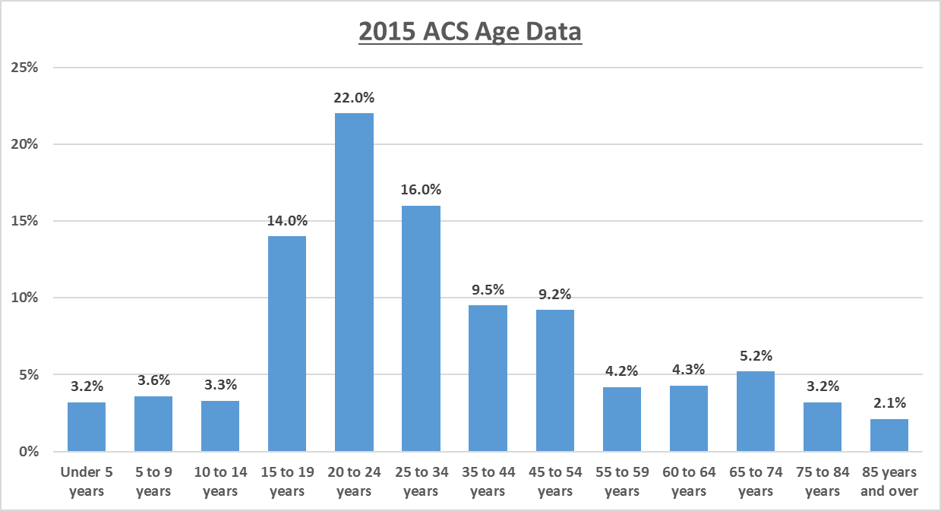

Figure 2: Student Population Information for City of Burlington.
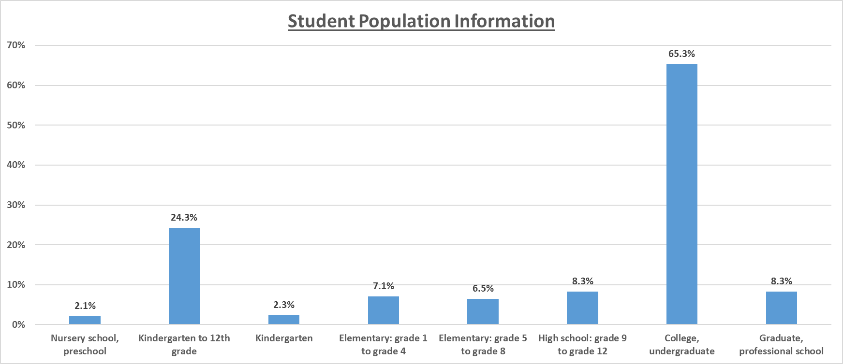

According to the demographics provided by HUD, 13.5% of Burlington’s population is under 18, 77% between the ages of 18-64 and 9.4% over 65. Examining the American Community Survey data from 2011-2015, figure 1 exhibits a more specific view of the age population of Burlington with the largest age group 20-24 reflecting the significant college population. In figure 2, the undergraduate college population comprises 65% of the Burlington student population while elementary, middle and high school is divided somewhat evenly. The population over 65 will grow in time as baby boomers continue to age; in ten years, over 20% of the population should be over 65.

Table 4: Age Demographics for City of Burlington. Source: Decennial Census 2010; ACS.
Table 4: Age Demographics | Burlington, VT
Age | # | %
Under 18 | 5,729 | 13.51%
18-64 | 32,702 | 77.10%
65+ | 3,986 | 9.40%

Table 5 describes the demographic trends in age since 1990. In the general age categories, there are some minor shifts with the under 18 group decreasing which corresponds to the decrease in the number of families in Burlington. The middle age group (18-64) has increased and the over 65 age group is currently showing a decrease from 2000.

Table 5: Age Demographic Trends Over Time for City of Burlington. Source: Decennial Census 2010; ACS.
Table 5: Age Demographic Trends | Burlington, VT
Age | 1990 |  | 2000 |  | 2010
 | # | % | # | % | # | %
Under 18 | 6,253 | 15.98% | 6,733 | 17.31% | 5,729 | 13.51%
18-64 | 28,750 | 73.46% | 28,077 | 72.17% | 32,702 | 77.10%
65+ | 4,134 | 10.56% | 4,095 | 10.53% | 3,986 | 9.40%

Figure 3: Burlington Age Demographics Over Time for Burlington, VT (Bar graph, 3 categories). Source: Decennial Census, 2010; Decennial Census, 2000; Decennial Census, 1990

Table 6: Gender Demographics for City of Burlington, VT. Source: Decennial Census 2010; ACS
Table 3: Gender Demographics | Burlington, VT
Male | 20,619 | 48.61%
Female | 21,798 | 51.39%

Burlington’s female population is higher than its male population by about 1100 persons. Over time, this gap used to be wider; as 2015 ACS data is included, the gap between male and female populations has closed considerably.

Figure 4: 2015 ACS Gender Demographics Over Time in Burlington, VT. Source: Decennial Census 1990, 2000, 2010; 2011-2015 ACS.

Table 7: Family Type Demographics for City of Burlington, VT. Source: Decennial Census 2010; ACS
Table 7 a: Family Type Demographics | Burlington, VT
Families with children | 2,986 | 45.51%

For the Burlington jurisdiction, less than half (45.51%) of the households consist of families with children. According to the trend table, this percentage spiked in 2000 but then declined in 2010.
Table 7 b | (Burlington, VT CDBG, HOME) Jurisdiction
 | 1990 Trend |  | 2000 Trend |  | 2010 Trend |  | Current
 | # | % | # | % | # | % | # | %
Family Type
Families with children | 3,504 | 48.96% | 3,251 | 47.97% | 2,986 | 45.51% | 2,986 | 45.51%

Figure 5: Families with Children Trends Over Time in Burlington, VT. Source: Decennial Census and 2015 ACS.

Please refer to Table 8 and Figure 6 for HUD provided information about the race and ethnic composition of Burlington and trends. Although the population of Burlington is becoming more and more diverse, the majority of the population, is 87.29% White. Black/African Americans comprise 3.71% of the population and Asians are 3.58% of the total population. Hispanic or Latino of any race consists of 2.7% of the Burlington population. Over the course of 30 years, the White population of the Jurisdiction has decreased by almost 12% and the largest increase of population is seen in Asian households going from 1.4% to 5.9%

Table 8: Race/Ethnicity Demographics for Burlington. Decennial Census 2010; ACS.
Table 8: Race/Ethnicity Demographics | Burlington, VT
Race/Ethnicity | # | %
White, Non-Hispanic | 37,027 | 87.29%
Black, Non-Hispanic | 1,575 | 3.71%
Hispanic | 1,144 | 2.70%
Asian or Pacific Islander, Non-Hispanic | 1,518 | 3.58%
Native American, Non-Hispanic | 111 | 0.26%
Two or More Races, Non-Hispanic | 969 | 2.28%
Other, Non-Hispanic | 73 | 0.17%

Figure 6: Race/Ethnicity Demographics Trends Over Time for Burlington, VT. Source: Decennial Census 1990, 2000, 2010; 2011-2015 ACS.

Almost 2700 Burlington residents were born in other countries with the largest component being from Vietnam. This corresponds to the early refugee resettlements beginning in 1989 through 1991 with 245 Vietnamese refugees. Vietnamese refugees continued to be resettled through 2002 bringing the total of Vietnamese refugees to 1056. Refugees from Bosnia were settled in Chittenden County beginning in 1993 through 2005. Somalia and Sudan refugees began arriving in 2003 and 2001 respectively. Groups from Iraq, Bhutan and Burma began to arrive in 2008.

Figure 7: Foreign Born Residents Demographic Trends Over Time for Burlington, VT. Source: Decennial Census; ACS 2011-2015.

The number of foreign-born residents increased dramatically from 2010 to 2015 as noted in the graph provided. More recent data has been gathered from the American Community Survey 2011-2015, reflecting a greater increase in the number of foreign born from 8% to over 13% of the City’s population. Foreign born residents represent 34% of Burlington’s non-white population.
Figure 8: Foreign Born Regions of Birth Demographics for Burlington, VT. Source: 2011-2015 ACS 5-Year Estimates.

Table 9: National Origin Demographics for Burlington and Burlington-South Burlington Region. Source: Decennial Census 2010; ACS.
TABLE 9: National Origin Demographics | Burlington, VT |  |  | Burlington-South Burlington Region
#1 country of origin | Vietnam | 477 | 1.16% | Canada | 2,534 | 1.26%
#2 country of origin | Bosnia & Herzegovina | 439 | 1.07% | Vietnam | 893 | 0.44%
#3 country of origin | Other South Central Asia | 390 | 0.95% | Bosnia & Herzegovina | 810 | 0.40%
#4 country of origin | Nepal | 307 | 0.75% | China excl. Hong Kong & Taiwan | 614 | 0.30%
#5 country of origin | Canada | 265 | 0.65% | Other South Central Asia | 520 | 0.26%
#6 country of origin | Other Eastern Africa | 199 | 0.49% | Other Eastern Africa | 484 | 0.24%
#7 country of origin | China excl. Hong Kong & Taiwan | 169 | 0.41% | Germany | 481 | 0.24%
#8 country of origin | India | 161 | 0.39% | India | 424 | 0.21%
#9 country of origin | Germany | 153 | 0.37% | Nepal | 352 | 0.17%
#10 country of origin | Other Middle Africa | 115 | 0.28% | Other UK | 308 | 0.15%

Table 10: Limited English Proficiency Demographics for Burlington, VT. Source: Decennial Census 2010; ACS.
Table 10 | Burlington, VT Jurisdiction
LEP | 1990 Trend |  | 2000 Trend |  | 2010 Trend |  | Current (2015 ACS)
 | # | % | # | % | # | % | # | %
Limited English Proficiency | 668 | 1.71% | 1,525 | 3.92% | 1,788 | 4.22% | 1,994 | 4.70%

Table 10 demonstrates the upward trend in the jurisdiction of individuals who have limited English proficiency from 1.71% in 1990 to 4.7% in 2015. This trend mirrors the increase in the number of foreign-born residents but the percentages are not as high.

Economic Demographics
Burlington is the heart of the largest urbanized region in Vermont and is Vermont’s principal economic and cultural engine. Burlington is home to the Flynn Theater, Church Street Marketplace and national companies including Burton Snowboards and Lake Champlain Chocolates. Burlington remains the birthplace of Ben and Jerry’s Ice Cream and the band Phish.
The City’s goal is that a prosperous Burlington economy provides all Burlington residents with access to livable wage jobs, to the education and training that qualify them for those jobs, to business ownership opportunities, and to the supports necessary to access those opportunities.
Based on the 2011-2015 American Community Survey, 60% of Burlington’s population over 16 is employed in the civilian labor force with approximately 4.7% unemployed. Women represent almost 52% of the labor force. The top three occupations in the City of Burlington are Management/Business/Science (43%), Service Occupations (24%) and Sales and Office Occupations (22%). The top three industries are Educational Services and Health (35%), Arts, Entertainment and Recreation (16.6%) and Retail (12%).
Over 78% of the workforce are private wage or salary employees with the remaining 17% government workers and almost 5% self-employed. The median income of a Burlington household is $44,671. The median family income is considerably higher than the median nonfamily income by over double which accounts for dual income households. In addition median income for full-time males ($42,224) exceeds those of full-time females ($36,414) by 16%.
The City tracks a number of economic indicators:

Job Growth and Unemployment
Burlington’s unemployment rate continues to track state and national rates, declining each year since 2009 but at a lower level. Job growth in the City and in the Labor Market Area (LMA), which is based on commuting patterns, declined sharply between 2008 and 2009. Employment, however, did appear to be following national trends with a slight increase in jobs in the LMA, including those in the private sector.

Figure 9: Trends in Unemployment Rates for Burlington, VT; Vermont; and the U.S. Source: Local Area Unemployment Statistics, Not Seasonally Adjusted.

Figure 10: Job Growth Trends 2012-2016. Source: Quarterly Census of Employment and Wages.

Figure 11: Office and Retail Space Vacancy in Burlington, Vermont. Source: Allen & Brooks Report Dec. 2016.

Commercial Vacancy Rates

The downtown retail vacancy rate jumped upwards in June 2008, leveled out for several years, and peaked in December 2016 at 10.9%, higher than the historic average of 8.3%. Much of this increased vacancy is attributed to broad, long-term redevelopment plans at the Burlington Town Center shopping mall. The complex was purchased in 2014 and is undergoing a period of re-tenanting that will likely keep vacancy rates higher than average throughout the redevelopment transition.

Sales and Entertainment Revenues
Vermont saw a significant rise in sales and gross use receipts between January 2010 and 2011; on a month-to-month basis, these receipts increased gradually throughout 2010, from 48,027,596 to 64,779,961 in a one year period. Burlington meals, rooms and alcohol receipts have remained largely stable since 2011, increasing by 10.81% in 2012, dipping slightly in 2013 and 2014, and finally increasing in January 2016.
Figure 12: Monthly Change in Tax Revenues, Jan. 2008-Jan. 2016. Source: Vermont Department of Taxes Monthly Reports.

Burlington Housing Demographics
The number of units that make up the Burlington housing inventory include both market rate and affordable units. According to the American Community Survey 2011-15, there are 16,702 units in the city with almost 97% of the units occupied. The homeowner vacancy rate dropped from 2.5% to .5% and the rental vacancy rate dropped from 1.5% to 1.0%.
It has been noted that Vermont has the 7th oldest housing stock in the nation. Overall, Burlington’s housing stock is predominately older, renter-occupied homes and apartments. Burlington has five times as many housing units over 50 years old than any other municipality in Chittenden County. The median year of construction for renter-occupied housing unites is estimated to be 1961 for the State of Vermont and 1965 for Chittenden County. Over 50% of the rental units are found by Code Enforcement to be out of compliance with minimum housing code. Almost 60% of Burlington’s housing units were built before 1960.
Of the total number of housing units in Burlington, almost 60% of those units are occupied by renters. The rental vacancy rate in both Burlington and Chittenden County remains low but significantly higher than previous years due to the increased number of units being built in Chittenden County.
Figure 13: Rental Vacancy Rates. Source: Allen & Brooks Report and Census.

The remaining 40% of housing units are occupied by homeowners and the increase in housing costs is steady but not as dramatic as rent. Foreclosure rates have declined since the peak of the foreclosure crisis in 2009.
Figure 14: Burlington Residential Foreclosures. Source: City of Burlington Clerk/Treasurer’s Office Land.

Burlington-South Burlington Region Population Demographics
Burlington is part of Chittenden County and the population of the County is 156,545 (ACS 2015 ) Burlington is part of the Burlington-South Burlington metropolitan statistical area as well as a core based statistical area. A Core Based Statistical Area (CBSA) is a U.S. geographic area defined by the Office of Management and Budget. The CBSA represents one or more counties tied together by an urban center, in this case, Chittenden, Franklin (population 47,746) and Grand Isle (population 6,970) Counties with Burlington being the urban center. These areas are linked together socioeconomically via commuting.
Table 11: Race/Ethnicity Demographics for Burlington-South Burlington Region. Source: Decennial Census 2010; ACS
Table 11 | Burlington-South Burlington Region
Race/Ethnicity | # | %
White, Non-Hispanic | 194,738 | 92.18%
Black, Non-Hispanic | 3,395 | 1.61%
Hispanic | 3,507 | 1.66%
Asian or Pacific Islander, Non-Hispanic | 4,668 | 2.21%
Native American, Non-Hispanic | 923 | 0.44%
Two or More Races, Non-Hispanic | 3,843 | 1.82%
Other, Non-Hispanic | 187 | 0.09%

According to the 2010 Census, the Burlington- South Burlington CBSA represented in Table 11, the Region’s population includes a total population of 211,261 persons of which 92% are White, Non-Hispanic. There are 83,242 households living in the Region with 38% of the householders are living alone and the remaining 62% living in families.
According to the 2011-2015 American Community Survey, of Region’s residents, 80% are ages 18 and older. Those over 65 comprise 13.0% of the population. The percentage of children under 18 is 21% of the population and children under 5 are 5.1% of the population. The median age in the Region is 37.7 years. The gender trend has remained somewhat static over the course of the past 35 years.
Foreign-born residents almost doubled in number from 1990 to 2015 in the region; however the percentages are still half the Burlington rate.
The numbers and percentages of individuals within the region with limited English proficiency has a demonstrable increase from 1990 to 2015; however, the increase is not as significant as in Burlington which emphasizes the refugee resettlement within the urban core of Burlington and Winooski.

Table 12: Demographic Trends overtime for Burlington-South Burlington Region. Source: Decennial Census 2010; ACS.
Table 12
 | Burlington-South Burlington, VT Region
 | 1990 Trend |  | 2000 Trend |  | 2010 Trend |  | Current
Race/Ethnicity | # | % | # | % | # | % | # | %
White, Non-Hispanic | 172,306 | 97.31% | 188,533 | 94.79% | 194,738 | 92.18% | 194,738 | 92.18%
Black, Non-Hispanic | 832 | 0.47% | 1,958 | 0.98% | 4,494 | 2.13% | 3,395 | 1.61%
Hispanic | 1,308 | 0.74% | 1,841 | 0.93% | 3,507 | 1.66% | 3,507 | 1.66%
Asian or Pacific Islander, Non-Hispanic | 1,522 | 0.86% | 3,602 | 1.81% | 5,760 | 2.73% | 4,668 | 2.21%
Native American, Non-Hispanic | 862 | 0.49% | 2,312 | 1.16% | 2,495 | 1.18% | 923 | 0.44%
National Origin
Foreign-born | 6,845 | 3.87% | 10,648 | 5.35% | 12,255 | 5.80% | 12,920 | 6.12%
LEP
Limited English Proficiency | 2,517 | 1.42% | 4,199 | 2.11% | 5,266 | 2.49% | 5,092 | 2.41%
Sex
Male | 86,194 | 48.68% | 97,158 | 48.85% | 103,475 | 48.98% | 103,475 | 48.98%
Female | 90,859 | 51.32% | 101,727 | 51.15% | 107,786 | 51.02% | 107,786 | 51.02%
Age
Under 18 | 44,281 | 25.01% | 50,364 | 25.32% | 44,537 | 21.08% | 44,537 | 21.08%
18-64 | 117,235 | 66.21% | 128,990 | 64.86% | 142,252 | 67.33% | 142,252 | 67.33%
65+ | 15,537 | 8.78% | 19,531 | 9.82% | 24,472 | 11.58% | 24,472 | 11.58%
Family Type
Families with children | 23,376 | 53.27% | 14,814 | 51.34% | 23,440 | 45.47% | 23,440 | 45.47%

Burlington-South Burlington Economic Demographics
Based on the 2011-2015 American Community Survey, 66.7% of the Region’s population over 16 is employed in the civilian labor force with approximately 5.8% unemployed. Women represent almost 52% of the labor force. The top three occupations in the Region are Management, Business and Science (40.6%), Sales and Office Occupations (23.16%) Service Occupations (15.36%). The top three industries are Educational Services and Health 26.36%), Manufacturing (12.83%) and Retail (11.76%)
Over 78% of the workforce are private wage or salary employees with the remaining 14.9% government workers and almost 8% self-employed. The median income of a Burlington-South Burlington Region household is $61,387 with the highest income in Chittenden County ($65,350), Grand Isle County ($62,423) and Franklin County ($58,199). The median family income ($77,441) is considerably higher than the median nonfamily income ($35,017) by over double which accounts for dual income households. In addition median income for full-time males ($51,332) exceeds those of full-time females ($40,991) by 25%.

Burlington-South Burlington Housing Demographics
The number of units that make up the Burlington- South Burlington Region housing inventory include renter and owner-occupied units. According to the 2010 Census, there are 92,358 units in the Region with 90% (83,242) of the units occupied. The vacancy rate in the Region is significantly higher than Burlington. There is also a higher rate of owner-occupied units at 68% and renter occupied at 32% almost the exact opposite of the housing make up in Burlington. Housing units in the Region demonstrates a 4% increase, from 88,796 units (2005-2009) to the 2010 figure; the vacancy rate in the Region increased during this timeframe as well.

General Issues
  - Segregation/Integration

Key Findings
- Segregation between White and Nonwhite populations remain low for both within Burlington and throughout the Burlington-South Burlington Region.
- Segregation between White and Nonwhite populations have been steadily increasing since 1990 both within Burlington and throughout the greater region.
- Within Burlington, the overall spatial distribution of segregation between populations has not changed significantly since 1990.
- Population density maps based on National origin and Limited English Proficiency (LEP) show evidence of segregation in Burlington, VT.
- Areas in Burlington that show the highest density of non-white populations also have the highest percentage of renter-occupied housing.

Analysis
Describe and compare segregation levels in the jurisdiction and region. Identify the racial/ethnic groups that experience the highest levels of segregation.
To analyze segregation levels within Burlington and the surrounding region, we use racial/ethnic dissimilarity trend data provided by HUD. The dissimilarity index measures the degree to which two groups are evenly distributed across a geographic area (shown in Table 13). Values range from 0 to 100, where higher values denote a larger degree of segregation. Segregation is considered “low” when dissimilarity values are between 0 and 39, “moderate” when values are between 40 and 54, and “high” when values are 55 or above.

Burlington
As of 2010, segregation in Burlington is considered low between all measured racial/ethnic groups. Integration is the highest between Hispanic and White population, while segregation is the highest between Black and White Populations. Dissimilarity is generally lower within Burlington than the greater Burlington-South Burlington region.
Table 13: Racial/Ethnic Dissimilarity Trends in Burlington, VT and the Burlington-South Burlington Region. Source: and Brown Longitudinal Survey using Decennial Census data for years 1990, 2000 and 2010.
Table 13: Racial/Ethnic Dissimilarity Trends
 | Burlington |  |  | Burlington-South Burlington Region
 | 1990 | 2000 | 2010 | 1990 | 2000 | 2010
Non-White/White | 12.37 | 17.17 | 18.85 | 21.69 | 22.48 | 24.30
Black/White | 9.48 | 21.38 | 27.46 | 31.96 | 33.01 | 36.14
Hispanic/White | 17.72 | 11.45 | 11.23 | 23.39 | 18.14 | 18.70
Asian or Pacific Islander/White | 15.87 | 19.16 | 20.74 | 33.94 | 37.17 | 36.34
Burlington-South Burlington Region
In the greater Burlington-South Burlington region, racial/ethnic dissimilarity between Non-White and White populations, as well as Hispanic and White populations show low levels of segregation.
As we see within Burlington, the greater region also shows the highest level of segregation between Asian or Pacific Islander and White populations, and the lowest segregation levels between Hispanic and White Populations. Dissimilarity is higher overall in the Burlington-South Burlington region when compared to the Burlington jurisdiction.
Identify areas with relatively high segregation and integration by race/ethnicity, national origin, or LEP group, and indicate the predominant groups living in each area.
Using the AFH mapping tool, it is difficult to see the geographic distribution of segregation and integration within Burlington. This is due to the overall population being primarily white, to the point that white population density visually crowds out non-white population densities (see Map 1).
Map 1: Map of 2010 Racial/Ethnic Group population density in Burlington-South Burlington Region.
Including the White, Non-Hispanic population density makes it difficult to see population densities of non-white populations. Source: Decennial Census.
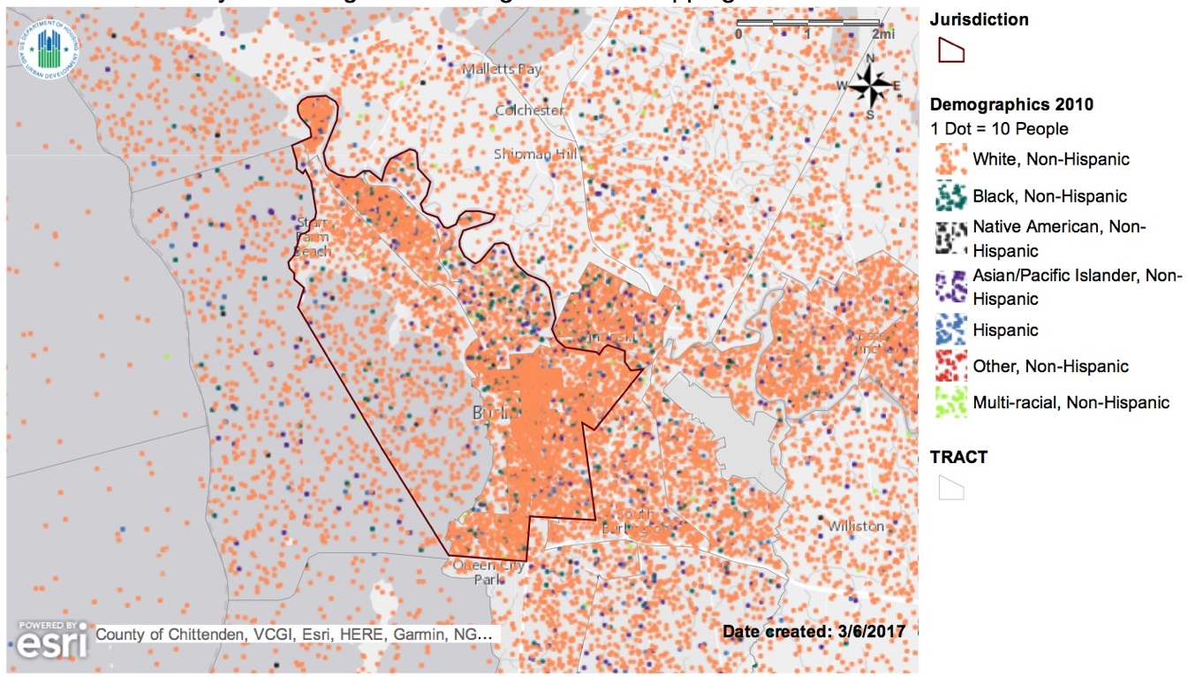

To compensate for this, we removed the white population density to allow us to see how non-white population densities are distributed throughout the Burlington-South Burlington region. This is shown in maps 2-4 shown below. These maps tell us that population densities have slightly increased over time, but the geographic distribution of different populations has not changed significantly between 1990 and 2010, with concentrations of non-white populations higher in Burlington’s Old North End (census tracts 3, 4 and 5), the New North End (census tract 1), and Winooski (census tracts 24 and 25). White Populations densities are also higher in these areas, but seem to be more distributed throughout the region than non-white populations. See map 7 for detail regarding Burlington census tracts.
While we can see the overall distribution of different racial/ethnic populations, it is difficult to say how overall segregation/integration has changed overtime in these areas based solely on the mapping tool provided by HUD, since doing so would require us to better visual detail how density distributions of non-white populations compare to non-white populations.
It should also be noted that there are mapping errors present in this data, resulting in many density dots being placed in the middle of Lake Champlain, further muddling the story that these maps are designed to tell. However, this only effects the analysis for census tract 2, since it is that tract which has a boundary encompassing Lake Champlain. Therefore, for all future maps, dots that appear in Lake Champlain are actually representing people within the land portion of census tract 2.

Maps 2-4: Maps showing Racial/Ethnic Group Population Density from 1990 – 2010. White population density was removed to show detail of non-white groups. Source: Decennial Census.
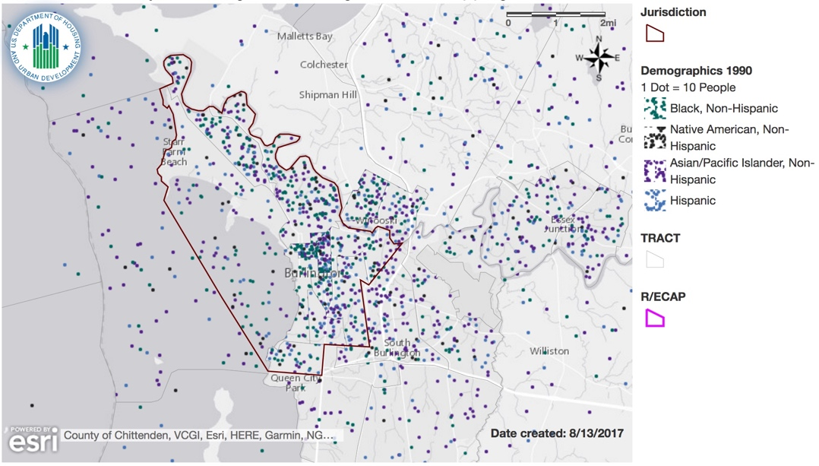
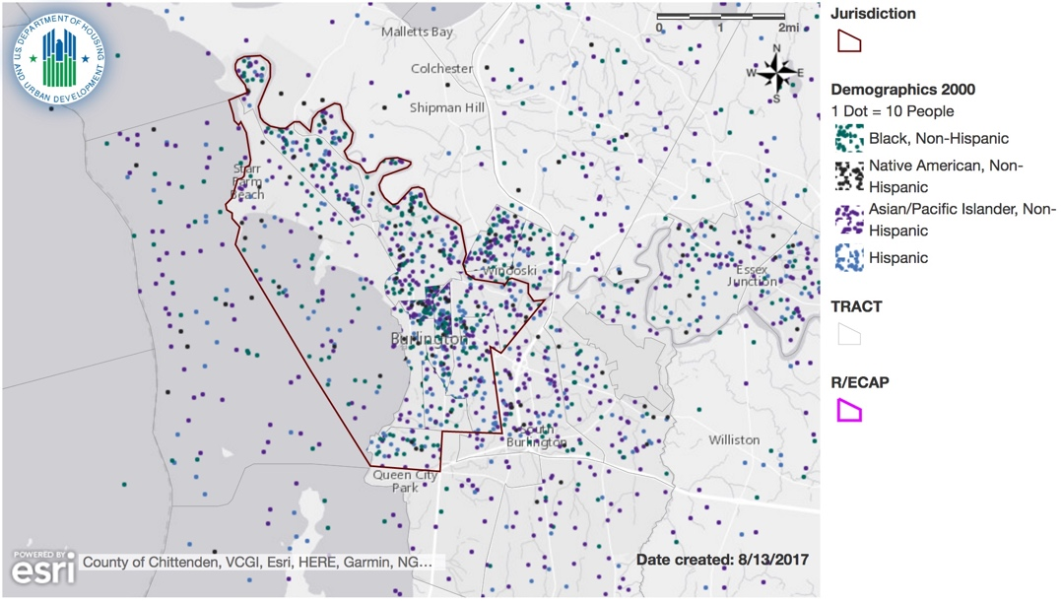
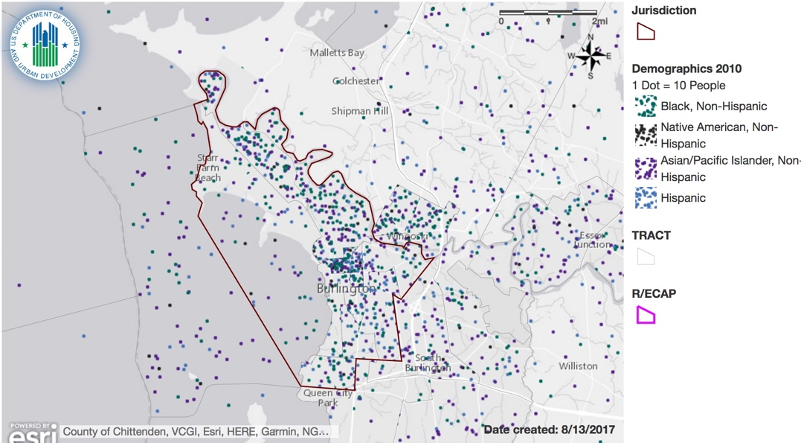

Examining the population density of the top national origin groups (map 5) and limited English proficiency (map 6), it appears that ethnic population densities follow similar trends as overall population density distributions described earlier, with clusters in Burlington’s Old North End (census tracts 3, 4 and 5), and to a lesser extent Burlington’s New North End (census tract 1) and Winooski (census tracts 24 and 25). However, maps 5 and 6 do show more detail in how different neighborhoods are being settled, showing signs of segregation happening that isn’t captured in the demographic populations grouping used above.
Map 5: Map showing National Origin Population Density in Burlington, VT and Surrounding Area. Source: Decennial Census.
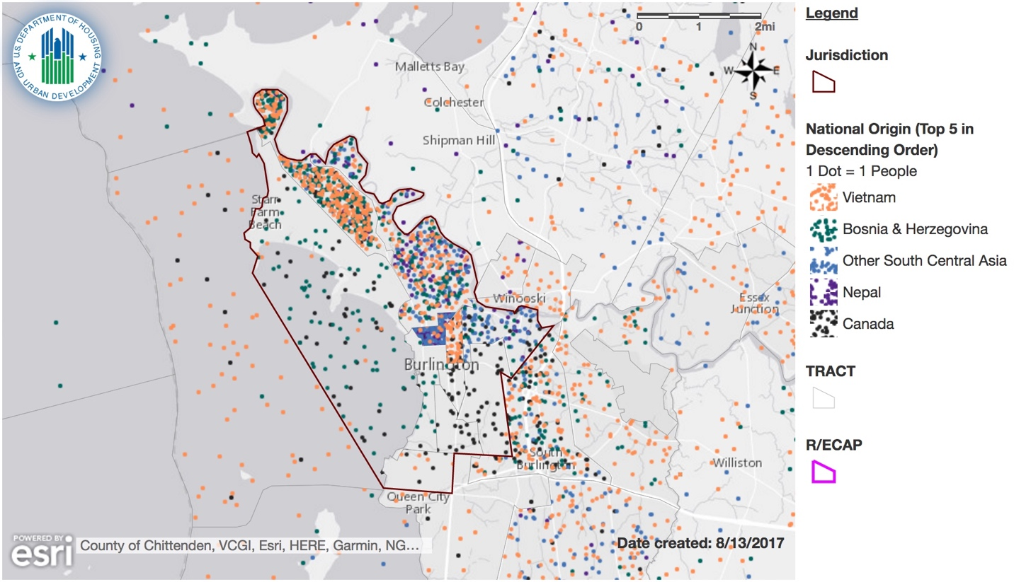

Map 6: Map Showing Limited English Proficiency Population Density in Burlington, VT and Surrounding Area. Source: Decennial Census.
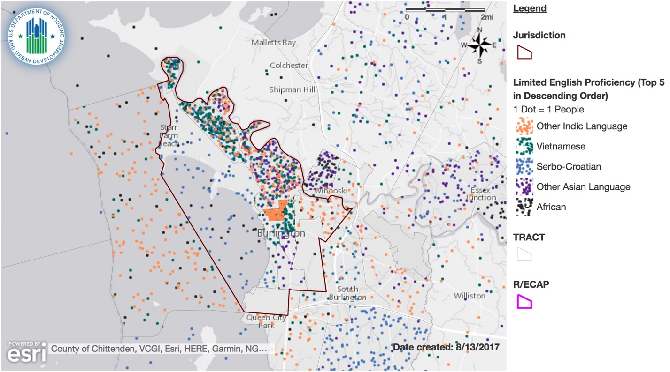

Explain how these segregation levels and patterns in the jurisdiction and region have changed over time (since 1990).

Burlington
Figure 15 visualizes the data Burlington dissimilarity data found in table 13, showing how dissimilarity between white and non-white population have changed overall within Burlington. Segregation between non-white and white populations has consistently increased since 1990, yet remains in the “low” category overall.
Black/White segregation has steadily risen over time within the Burlington jurisdiction. The rate of increase in dissimilarity is larger in Burlington when compared to the greater region, showing an increase of 17.98 index points between 1990 and 2010. Even though the rate of increase in segregation levels has been high within Burlington, overall segregation has consistently been lower in Burlington when compared to the greater region, as it remains today.
Hispanic/White segregation decreased within Burlington from 1990 to 2010. Since, 1990, segregation between Asian or Pacific Islander and White populations has increased within Burlington.
Figure 15: Racial/Ethnic Dissimilarity Trends Over Time in Burlington, VT. Source: Decennial Census for years 1990, 2000 and 2010.

Burlington-South Burlington Region
Similar to figure 15, figure 16 visualizes table 13 data for the Burlington-South Burlington region. The region has also experienced a steady increase in segregation between non-white and white populations since 1990, yet remains in the “low” category.
Like Burlington, the Burlington-South Burlington region has experienced a consistent increase in dissimilarity between Black and White populations since 1990. The rate of this change is lower than that seen in Burlington, showing an increase of 4.18 dissimilarity index points since 1990.
Throughout the Burlington-South Burlington region, segregation between White and Hispanic populations decreased from 1990-2000, but has begun increasing again since 2000.
In the region, dissimilarity between White and Asian or Pacific Islander populations increased from 1990 to 2000, but decreased from 2000 to 2010. Segregation between Asian or Pacific Islander and White populations appear remains in the “low category”.
Figure 16: Racial/Ethnic Dissimilarity Trends in the Burlington-South Burlington Region. Source: Decennial Census for years 1990, 2000 and 2010.

Spatially, segregation patterns have not changed drastically since 1990, although overall segregation has been increasing, as mentioned earlier. However, it is difficult to discern changes in segregation patterns at a sub-jurisdictional level using the data provided to us via the HUD mapping tool.
Consider and describe the location of owner and renter occupied housing in determining whether such housing is located in segregated or integrated areas.
Figures 17 below shows the percentages of housing that is owner-occupied vs. renter occupied by Burlington census tract (see map 7 for a map of Burlington census tracts). While it is difficult to speak directly to areas of relatively higher segregation for the reasons mentioned above, the two areas that have the highest density of non-white populations, census tracts 3 and 4 (Burlington’s Old North End), also have the highest rate of renter-occupied housing. Interestingly, census tract 1 (Burlington’s new north end) has the highest percentage of owner-occupied housing, even though we recognize this as an area of relatively higher density of non-white populations (third highest after census tracts 3 and 4). However, the significant minority population in this census tract is the Vietnamese population who also maintain the highest rate of homeownership after the white population. Although we see correlation between a high percentage of renter occupied housing and higher diversity (and possibly segregation) in tracts 4 and 5, this correlation is not consistent throughout Burlington.
Map 7: Map of Census Tracts within Burlington, VT.
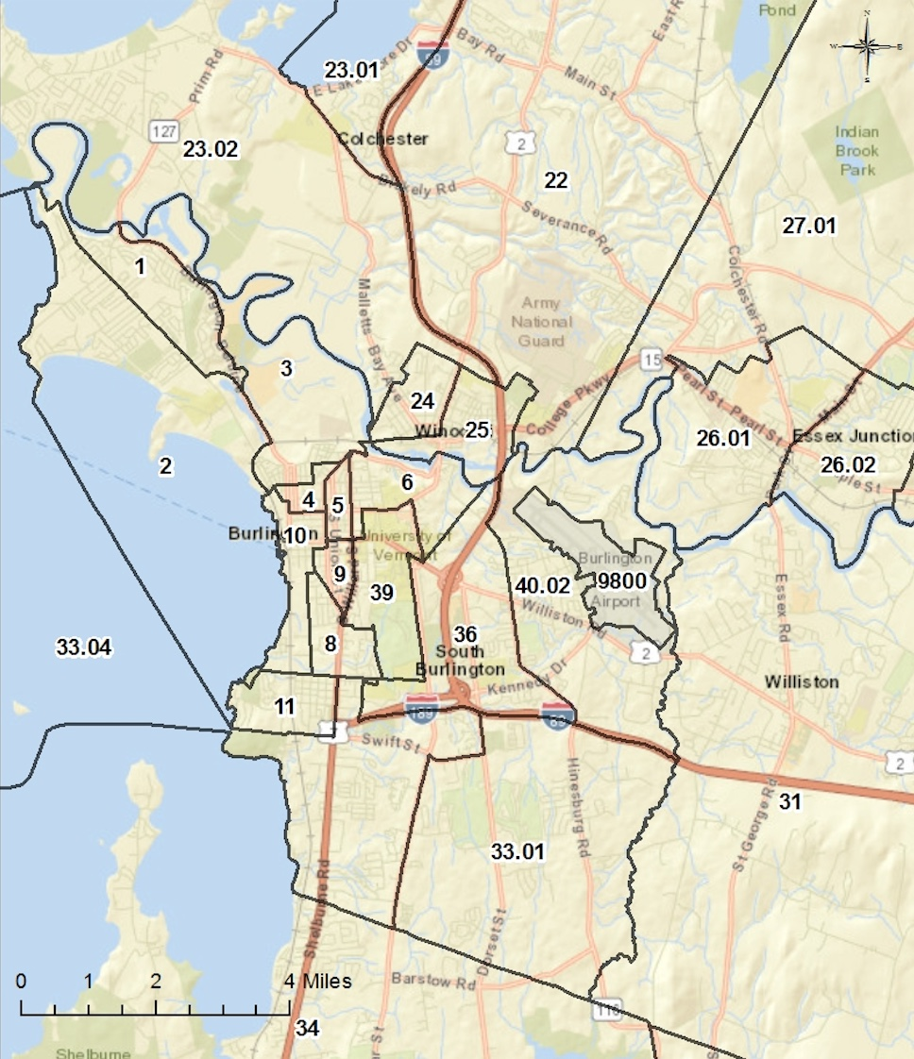

Figure 17: Percentage of owner-occupied vs renter occupied housing in Burlington, VT, by Census Tract.
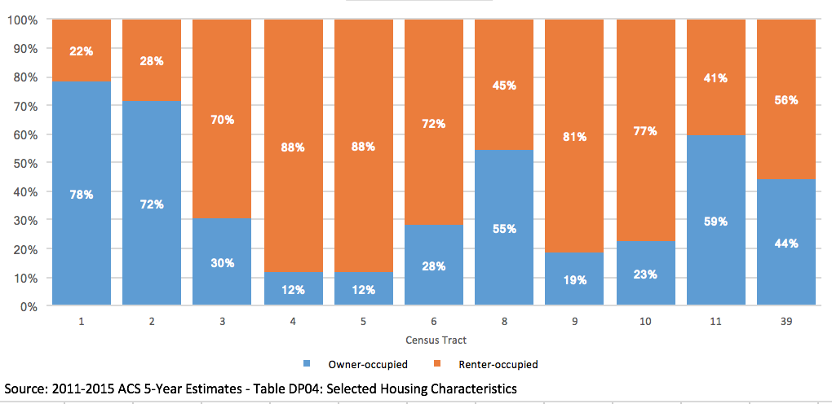

Figure 18: 2015 Demographic Estimates for Burlington, VT Census Tracts.
Discuss whether there are any demographic trends, policies, or practices that could lead to higher segregation in the jurisdiction in the future. Participants should focus on patterns that affect the jurisdiction and region rather than creating an inventory of local laws, policies, or practices.
Policies that reduce affordable housing, or isolate the location of affordable housing to certain areas within Burlington will likely lead to higher segregation. Similarly, policies that reduce public transit opportunities, or increase the cost of public transit, will likely increase localized segregation of populations based on socioeconomic factors. There are several areas with a higher proportion of rental properties and conversely, several tracts with a high percentage of owner-occupied units. This imbalance could lead to higher segregation in the jurisdiction. While the Inclusionary Zoning Ordinance has been successful in creating inclusive communities, it does not apply to housing projects under 5 units. Therefore, the most urbanized areas of the City, where new developments might tend towards infill projects, the absence of inclusionary zoning application might exacerbate segregation trends.

Additional Information
Beyond the HUD-provided data, provide additional relevant information, if any, about segregation in the jurisdiction and region affecting groups with other protected characteristics.
Through almost two dozen interviews with individuals from a variety of protected classes, it became clear that Burlington’s challenges with segregation are particular and nuanced. While there are no explicit areas of concentrated racial or ethnic poverty as defined by HUD, the City certainly contains specific areas and neighborhoods, slightly smaller than census tracts, where higher levels of poverty coincide with concentrated groups of New Americans, immigrant families, and more generally, groups receiving benefits from the state - housing or otherwise.

The program participant may also describe other information relevant to its assessment of segregation, including activities such as place-based investments and mobility options for protected class groups.

Several factors contribute to the assessment of segregation in the jurisdiction and region. As a refugee resettlement community, 300+ new arrivals annually must access housing within the community, either with private landlords, sponsoring families or friends. During their first months, agencies assist refugees with housing applications, and other supportive services for language and job skills. Once units within the affordable housing inventory and the waitlist opens up, new arrivals access public and/or affordable properties. The properties with larger units, also hold a number of refugee families. In Burlington’s New North End, the Franklin Square property contains 37 units 3 bedrooms or larger and is home to a number of families of African descent. At Riverside properties with 24 3 bedroom or larger units, refugee families include Nepali, Somali and other populations. The location of affordable housing properties, including those administered by the Housing Authorities as well as Champlain Housing Trust do influence the jurisdiction’s analysis of segregation. However, Burlington Housing Authority administers a robust and well distributed Section 8 program where individuals and families can access housing anywhere in their service area. The location of and access to public transportation heavily influences where voucher holders choose to live. Transportation options within the City of Burlington and surrounding urban core of Chittenden County are significantly greater than more rural areas of the region. In addition, access to jobs and services within the City influence housing options based on the need for public transportation. All these factors contribute to clusters of minority populations in the jurisdiction. Finally, the basic desire to live in communities with people from similar cultures, where one can also access specialty markets and food will also influence clustered living patterns.

Contributing Factors of Segregation
Consider the listed factors and any other factors affecting the jurisdiction and region. Identify factors that significantly create, contribute to, perpetuate, or increase the severity of segregation.
- Location and type of affordable housing

As non-white populations grow in Burlington and the surrounding region, the location and type of affordable housing is crucial for keeping segregation levels low in Burlington. Often, it is difficult to disentangle cultural and socioeconomic factors, but it is clear that one of the best ways to increase integration throughout Burlington is to have mixed income housing distributed relatively evenly throughout the jurisdiction. Burlington’s inclusionary zoning ordinance also promotes diversity and inclusion and a recent study indicates it has been successful in that regard for the past 30 years. However, some types of affordable housing properties serve certain populations and therefore can limit housing choice. For example, Decker Towers, Thayer House, Heineberg Senior Housing, McAuley Square and Monroe Plan all provide housing for the elderly. Franklin Square, Riverside and Bobbin Mill apartments include a larger number of 3+ bedroom units, appealing to larger refugee families.

  - Private discrimination
According to the Vermont Human Rights Commission, a majority of cases they investigated in 2016 were in the area of public accommodation. Cases on housing have declined over the past 3 years. Vermont Legal Aid mostly sees cases where there might be discrimination regarding the use of Section 8 vouchers, transgender or sexual orientation. During individual interviews and focus groups, a number of respondents noted being denied housing while using a Section 8 voucher or based on race.

  - Racially or Ethnically Concentrated Areas of Poverty (R/ECAPs)

Key Findings
- There are no designated R/ECAPS in Burlington, Vermont.

Analysis
Identify any R/ECAPs or groupings of R/ECAP tracts within the jurisdiction and region.

The AFFH rule defines “racially or ethnically concentrated areas of poverty” as “a geographic area with significant concentrations of poverty and minority concentrations.” 24 C.F.R. § 5.152.

There are no R/ECAPs in the Burlington, VT jurisdiction or region.

Describe and identify the predominant protected classes residing in R/ECAPs in the jurisdiction and region. How do these demographics of the R/ECAPs compare with the demographics of the jurisdiction and region?

There are no R/ECAPs in the Burlington, VT jurisdiction or region.

Describe how R/ECAPs have changed over time in the jurisdiction and region (since 1990).

There are no R/ECAPs in the Burlington, VT jurisdiction or region.

Additional Information
Beyond the HUD-provided data, provide additional relevant information, if any, about R/ECAPs in the jurisdiction and region affecting groups with other protected characteristics.

N/A

The program participant may also describe other information relevant to its assessment of R/ECAPs, including activities such as place-based investments and mobility options for protected class groups.

N/A

Contributing Factors of R/ECAPs
Consider the listed factors and any other factors affecting the jurisdiction and region. Identify factors that significantly create, contribute to, perpetuate, or increase the severity of R/ECAPs. N/A
For similar reasons mentioned earlier, policies that create pockets of homogeneously priced housing will likely increase segregation, which, as overall nonwhite populations grow, could lead to areas within Burlington to become classified as an R/ECAP.

  - Disparities in Access to Opportunity

Key Findings
- There are more disparities in access to proficient schools among racial/ethnic groups for those living in poverty than the populations as a whole.
- Blacks living below the poverty line live closer to where they work and have higher levels of labor engagement than any other race.
- Access to transportation is higher within Burlington than in the region as a whole, although transportation costs between these areas are not significantly different.
- Black populations have higher exposure to poverty than any other population, and exposure to poverty is higher within Burlington than in the region.
- There is low disparity between access to environmentally healthy neighborhoods overall, although more disparity exists when considering only those below the federal poverty line, suggesting a socioeconomic factor.

Analysis
In this section, we analyze the presence and degree of disparities in access to opportunity among various populations in Burlington (Table 14) and the greater Burlington-South Burlington region (Table 15). These two tables show seven indices of opportunity: the 1) Low Poverty Index, 2) School Proficiency Index, 3) Labor Market Engagement Index, 4) Transit Trip index, 5) Low Transportation Cost Index, 6) Jobs Proximity Index, and 7) the Environmental Health Index. Each of these indices are described in more detail below, but in general, higher values are used to denote higher levels opportunity.
Table 14: Opportunity Indicators by Race/Ethnicity for Burlington, VT. Sources: Decennial Census; ACS; Great Schools; Common Core of Data; SABINS; LAI; LEHD; NATA .
Table 14: Opportunity Indicators, by Race/Ethnicity (Burlington)
 | Low Poverty  Index | School  Proficiency  Index | Labor Market  Index | Transit Trip  Index | Low Transportation Cost Index | Jobs  Proximity Index | Environmental Health Index
Total Population
White, Non-Hispanic | 52.14 | 41.88 | 76.18 | 65.44 | 80.31 | 59.45 | 63.95
Black, Non-Hispanic | 39.82 | 35.06 | 69.98 | 65.96 | 81.18 | 55.13 | 65.99
Hispanic | 50.30 | 43.38 | 76.15 | 65.67 | 81.22 | 63.15 | 61.86
Asian or Pacific Islander, Non-Hispanic | 43.97 | 33.99 | 72.14 | 65.59 | 80.26 | 52.76 | 64.97
Native American, Non-Hispanic | 38.71 | 40.86 | 70.73 | 68.68 | 84.07 | 62.38 | 60.94
Population below federal poverty line
White, Non-Hispanic | 44.66 | 35.14 | 74.36 | 71.69 | 85.37 | 59.55 | 52.31
Black, Non-Hispanic | 41.79 | 64.16 | 85.45 | 65.78 | 82.64 | 71.05 | 69.14
Hispanic | 40.24 | 42.33 | 72.30 | 66.30 | 81.67 | 52.40 | 63.89
Asian or Pacific Islander, Non-Hispanic | 31.96 | 24.04 | 68.50 | 68.82 | 83.11 | 47.98 | 62.11
Native American, Non-Hispanic | 29.67 | 32.31 | 64.67 | 76.33 | 90.67 | 65.75 | 46.00

Table 15: Opportunity Indicators by Race/Ethnicity for Burlington-South Burlington Region. Sources: Decennial Census; ACS; Great Schools; Common Core of Data; SABINS; LAI; LEHD; NATA.
Table 15: Opportunity Indicators by Race/Ethnicity (Burlington-South Burlington Region)
 | Low Poverty  Index | School  Proficiency  Index | Labor Market  Index | Transit  Index | Low Transportation Cost Index | Jobs  Proximity Index | Environmental Health Index
Total Population
White, Non-Hispanic | 68.23 | 41.88 | 79.02 | 37.77 | 62.05 | 59.45 | 85.45
Black, Non-Hispanic | 52.54 | 35.06 | 76.28 | 54.91 | 74.47 | 55.13 | 72.33
Hispanic | 64.34 | 43.38 | 79.81 | 44.96 | 67.55 | 63.15 | 79.27
Asian or Pacific Islander, Non-Hispanic | 62.69 | 33.99 | 81.40 | 50.37 | 71.52 | 52.76 | 74.54
Native American, Non-Hispanic | 57.17 | 40.86 | 67.01 | 35.72 | 58.60 | 62.38 | 87.49
Population below federal poverty line
White, Non-Hispanic | 54.72 | 42.38 | 73.02 | 49.83 | 69.85 | 51.49 | 72.82
Black, Non-Hispanic | 40.24 | 49.30 | 82.99 | 60.54 | 77.38 | 55.83 | 72.74
Hispanic | 57.25 | 52.91 | 80.77 | 48.31 | 67.64 | 43.83 | 79.26
Asian or Pacific Islander, Non-Hispanic | 43.64 | 35.83 | 74.14 | 61.94 | 79.71 | 53.58 | 64.32
Native American, Non-Hispanic | 40.85 | 22.34 | 62.96 | 48.33 | 67.96 | 44.14 | 73.25

- Educational Opportunities
To assess access to educational opportunities, we utilized the School Proficiency Index as provided by HUD. This index is shown in tables 14 and 15, figures 19 and 20, and map 8 ,for both the City of Burlington and the Burlington-South Burlington region, and is based on 2012 ACS data. The School Proficiency Index is a function of the percent of 4th grade students proficient in reading and math on state test scores for up to three schools within 1.5 miles of the block-group center, combined with enrollment and attendance. Values are percentile ranked and range from 0 to 100. The higher the score, the higher the school system quality is in a neighborhood. The index results, as shown in the tables and figures provided in this section, were used to answer the following questions.

For the protected class groups HUD has provided data, describe any disparities in access to proficient schools in the jurisdiction and region.

Burlington
Considering the total population of each race/ethnic group, there are not large disparities in access to proficient schools across these groups (see figure 19). That said, the Hispanic population has the highest level of access to proficient schools within the Burlington jurisdiction, while the Asian or Pacific Islander population has the lowest level of access. The difference in access level between these two groups is approximately 10 index points. In Burlington, White, Native American, and Hispanic students have similar school proficiency index scores at 41.88, 40.86, and 43.38 respectively. The index scores for Black and Asian/Pacific Islander students are lower at 35.06 and 33.99. Students below the federal poverty line had index scores lower than that of the total population across all races with the exception of Black students. Black, Non-Hispanic students below the federal poverty line had an index score of 64.16, higher than any other student group across the board and twice as high as Black students across all income categories.

There is a higher degree of disparity between these racial/ethnic groups when considering the portion of the population that fall below the federal poverty line (figure 19). With this consideration, we see the portion of the Asian or Pacific Islander population that is living in poverty having the lowest level of access to proficient schools, while the Black population living poverty has the highest. The difference in access between these two groups is roughly 40 index points, showing a high level of disparity across racial/ethnic populations that are living at or below the federal poverty line.

Figure 19: School Proficiency Index Among Racial/Ethnic Groups in Burlington, VT. Source: Great Schools(proficiency data), 2013-14; Common Core of Data (4th grade enrollment and school addresses), 2013-14; Maponics School Attendance Zone database, 2016.

Based on map 8, it appears that areas with higher diversity in national origin generally have lower access to proficient schools. This appears to be true in census tracts 1, 3 and 4.

Burlington-South Burlington Region
Access to proficient schools by the total populations of various racial/ethnic group in the Burlington South Burlington region exactly mirror those found within the Burlington jurisdiction, as described above.

When considering the the portion of these populations that fall below the poverty line, however, a different story emerges. The portion of the Native American population that is living below the federal poverty line in the Burlington-South Burlington region has the lowest level of access to proficient schools, while the Hispanic population living in poverty has the highest. The difference in access between these two groups is approximately 30 index points, showing a relatively high level of disparity in access to profiecient schools among racial and ethnic groups living in poverty.
Figure 20: School Proficiency Index Among Racial/Ethnic Groups in the Burlington-South Burlington Region. Source: Great Schools(proficiency data), 2013-14; Common Core of Data (4th grade enrollment and school addresses), 2013-14; Maponics School Attendance Zone database, 2016.

In contrast to Burlington, map 8 does not seem to show any strong correlations between national origin and access to school proficiency at the regional level.

For the protected class groups HUD has provided data, describe how the disparities in access to proficient schools relate to residential living patterns in the jurisdiction and region.
Map 8 below shows the School Proficiency Index throughout the Burlington, VT area. The dark grey tracts have the highest School Proficiency Index scores and the light grey areas have the lowest index scores.

Burlington
Census tracts 4, 5, and parts of tract 3 have the highest concentration of non-White residents. Census tract 4 has the highest concentration of Black residents in the City of Burlington. Census tracts 3, 4, and 5 have the lowest School Proficiency Index scores at a range of 0-10, and block groups in census tracts 11 and 8 have the highest with an index score of 50.1-60. Census tract 39 is in the mid-range with an Index of 30.1- 40.

As described earlier, it appears that the census tracts with the most diversity in national origin tend to be in areas with lower access to proficient schools.

Burlington-South Burlington Region
According to map 8 below, Winooski (census tracts 24 and 25) has the lowest access to proficient schools, and also appears to have the highest Black, non-Hispanic population density outside of the city of Burlington. South Burlington has the highest access to proficient schools, and also shows the lowest concentration of nonwhite residents.

Again, Winooski has the highest concentration of Limited English Speakers and non-European national origin residents, and also shows one of the lowest access to proficient schools outside the city of Burlington.

Map 8: Map showing School Proficiency Index in the Burlington, VT area. (HUD Map 7)
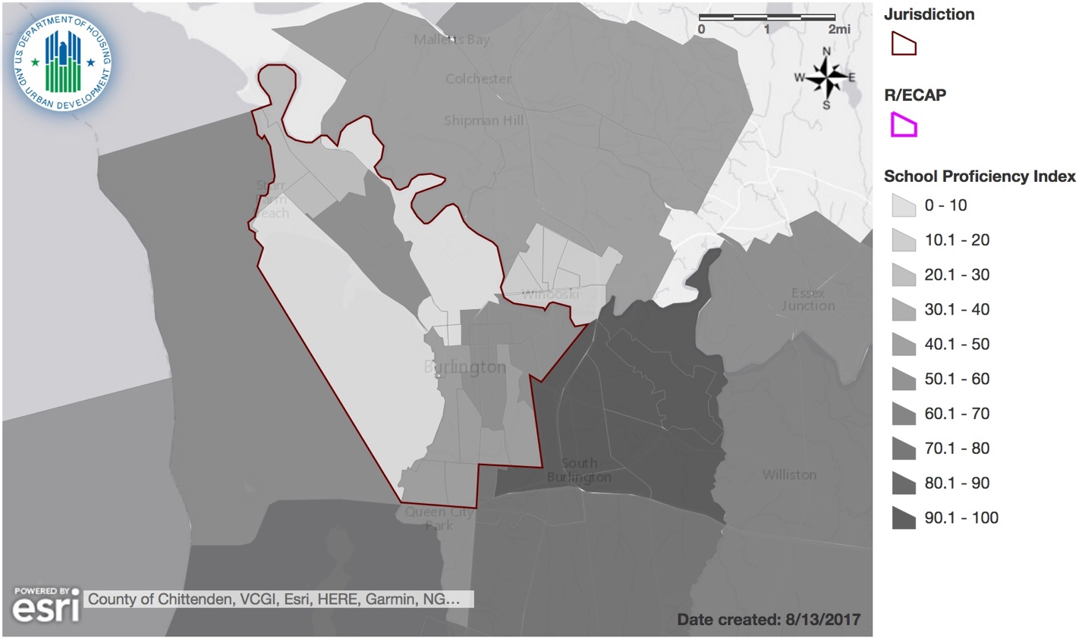

Informed by community participation, any consultation with other relevant government agencies, and the participant’s own local data and local knowledge, discuss programs, policies, or funding mechanisms that affect disparities in access to proficient schools.

Much of elementary enrollment is geographic but the introduction of the magnet schools opened up ‘school choice’ and competition for places in the Old North End to the magnet schools located there. Since 2012, each student can choose any of the 6 elementary schools in order of preference. The school assigns places according to the following:

1) Sibling already at the school
2) Distance to home from school

Except the two magnet schools have a 50/50 free and reduced lunch/non-free and reduced lunch requirement. So places will be filled according to that balance first. Previous competition was for places at Edmunds and Champlain Schools where Burlington has a higher proportion of white and higher income students.

Prior to magnet schools (when this data was derived) there would have been more low income students of color in the two Old North End schools and then conversely fewer low income kids of color at Champlain (still like that) and Edmunds (less like that).

School enrollment policy used to be that siblings and those not closest to school would have to get a waiver to attend anything other than the closest school; this was not common.

The creation of the magnet schools was a direct policy response to ‘failing’ schools with higher than district average of low income and youth of color. The desirability of these additionally resourced magnet schools and the accompanying change to prioritize economic status over geography to balance recruitment has reduced the number of low income students in these schools and simultaneously the redistribution of students has increased the number of low income and/or students of color at other elementary schools.

The Burlington School District also implemented an Equity and Diversity Strategic Plan which includes staff training and data collection on outcomes based on race, ethnicity, economic status, IEP etc. This collection of equity data has been very important in supporting data based decision making for policy on equity.

As a result of data collection, changes in disciplinary procedures and recognition of disproportionate impact of suspension on youth of color and low-income youth and youth on IEP – the district is in early implementation of positive behavior implementation systems and restorative practices at middle and high schools is in early implementation.

The City of Burlington announced its acceptance of President Obama’s My Brother’s Keeper (MBK) Challenge in May 2016. MBK addresses opportunity gaps facing American youth, particularly boys and young men of color. MBK has been a movement that has led to action by all levels of government, schools, non-profits, private, and individuals to take meaningful steps to improve opportunities. Burlington’s MBK overarching goals are to ensure that all youth are safe, on track to graduate from high school, ready for college or career, and given opportunities to lead and thrive.

The City has a relatively small youth of color population of students and probably should be targeting resources better to those individuals – this is underway – the City is also seeking to partner of internships and other partnerships with business etc. to improve access to opportunity for older students (MBK).

For our community survey respondents, access to schools in their neighborhood was rated at 72% fair and above with 28% noting poor access.

- Employment Opportunities
We use two indices to assess the level of access to employment opportunities various subpopulations have: the Jobs Proximity Index, and the Labor Market Engagement Index.

The Jobs Proximity Index quantifies the accessibility of a given residential neighborhood as a function of its distance to all job locations within a region, with larger employment centers weighted more heavily than smaller ones. Higher values denote better employment opportunities within a neighborhood.

The Labor Market Engagement Index describes the relative intensity of human capital and how engaged the labor market is in a given neighborhood. It is a function of the level of employment, labor force participation, and educational attainment in a census tract. The higher the value, the higher the labor force participation and human capital in a neighborhood.

Both indices are percentile ranked and range from 0 to 100.

For the protected class groups HUD has provided data, describe any disparities in access to jobs and labor markets by protected class groups in the jurisdiction and region.

Burlington
The Labor Market Engagement Index in Burlington (figure 21) appears to be more consistent across racial groups than the region as a whole. In Burlington, this index shows that White and Hispanic populations have the highest labor market engagement, at 76.18 and 76.15 index points, respectively. Relative to other populations, the Black population in Burlington has the lowest engagement with the labor market, with 69.98 index points. Similarly, the Native American population show relatively low labor market access at 70.73 index points, while the Asian or Pacific Islander population has slightly higher labor market access at 72.14 index points. The overall variation among population is relatively low, showing a difference of 6.2 index points between White and Black populations in Burlington.

The Jobs Proximity Index (figure 22) in Burlington shows that the Asian or Pacific Islander population has the lowest level of employment opportunity, with 52.76 index points. In contrast, Hispanic populations have the highest employment opportunity, with 63.15 index points, followed by Native Americans with 62.38 points. White and Black populations fall in the middle, with 59.45 and 55.13 index points, respectively. Again, variation among populations is quite low, with the difference between the Hispanic and Asian or Pacific Islander populations being 10.39 index points.

For populations below the poverty line in the city, the Labor Market Engagement Index (figure 21) and Jobs Proximity Index (figure 22) show the Black population leading on both indices relative to other races, with scores of 85.45 and 71.05, respectively. The data suggests that Blacks living below the poverty line live closer to employment opportunities and have higher levels of labor engagement than any other race. This might be explained by the growing immigrant population – New Americans from Africa who have fled violence in their home countries in Burundi, Congo, Rwanda, Somalia and Sudan - to Burlington and are concentrated in low-paying occupations (e.g. housekeeping, caregiving and in restaurants as cooks and waiters) - close to where they reside.

Figure 21: Labor Market Engagement Index Among Racial/Ethnic Groups in Burlington, VT. Source: American Community Survey (ACS), 2009-2013.

Figure 22: Jobs Proximity Index Among Racial/Ethnic Groups in Burlington, VT. Source: Longitudinal Employer-Household Dynamics (LEHD), 2014.

Burlington-South Burlington Region
The Labor Market Engagement Index within the greater Burlington-South Burlington region (figure 23) shows, overall, slightly higher labor market engagement when compared to the Burlington jurisdiction. Asian or Pacific Islanders have the highest level of labor market engagement at the regional level, with 81.4 index points. The Native American population, however, has much labor market engagement with 67.01 index points. The disparity in labor market access between these two groups is higher than that found within Burlington, showing a difference of 14.39 index points.

Interestingly, while Asian or Pacific Islanders experience the lowest level of labor market engagement at the regional level (highest index value), they live closer to their jobs than any other race, according to the Jobs Proximity Index, with 52.76 index points (figure 24). Showing a similar but not quite as dramatic of a reversal, the Native American population had the lowest labor market index rating, but has the second highest Jobs Proximity Index rating, at 62.38 index points. The Hispanic population at the regional level has the highest proximity to jobs with 63.15 index points.
In the Burlington-South Burlington region, Blacks also have the highest scores on both the Labor Market Engagement Index and Jobs Proximity Index across all races, that is, 82.99 and 55.83, respectively, although there’s not significant variation across the races on these two indices. However, the data does suggest that low-income people in Burlington are closer to jobs than their counterparts in the region, as a whole.
Figure 23: Labor Market Engagement Index Among Racial/Ethnic Groups in the Burlington-South Burlington Region. Source: American Community Survey (ACS), 2009-2013.

Figure 24: Jobs Proximity Index Among Racial/Ethnic Groups in the Burlington-South Burlington Region. Source: Longitudinal Employer-Household Dynamics (LEHD), 2014.

For the protected class groups HUD has provided data, describe how disparities in access to employment relate to residential living patterns in the jurisdiction and region.

Generally, an individual's residential location has implications for their ability to get a job. Proximity matters for lower-income workers and people with disabilities or they should have easy access to reliable transportation – personal or public – in order to access jobs and keep employment. For low-income residents, living closer to jobs increases the likelihood of working and leaving welfare. Many workers without access to a car could spend hours on multiple buses traveling to work and some might be unable to get these jobs at all.
Notwithstanding the foregoing, as noted, low-income Blacks in Burlington, including immigrant populations, have good access to transportation or live close to jobs. Therefore, given the high Jobs Proximity Index for this group, place of residence does not appear to be a significant barrier to employment. Regarding other groups, data levels are much lower when compared with Blacks, although fairly consistent throughout the city.

Burlington-South Burlington Region
Finally, it should be noted that the jobless rate in the Burlington-South Burlington region was a low 2.6 percent in June 2017, slightly up from the 2.3 percent recorded the previous month, according to the Vermont Department of Labor. Such a low unemployment rate would suggest that, the number of persons actively seeking work in the region is low relative to the population of active workers.

Map 9: Map showing the Jobs Proximity Index in the Burlington, VT area.
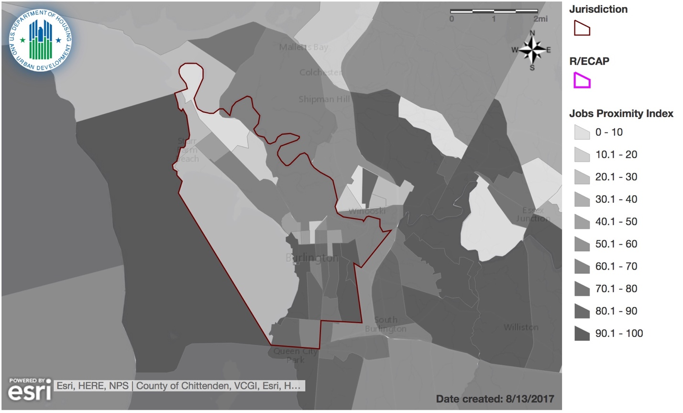

Map 10: Map showing the Labor Market Engagement Index in the Burlington, VT area.
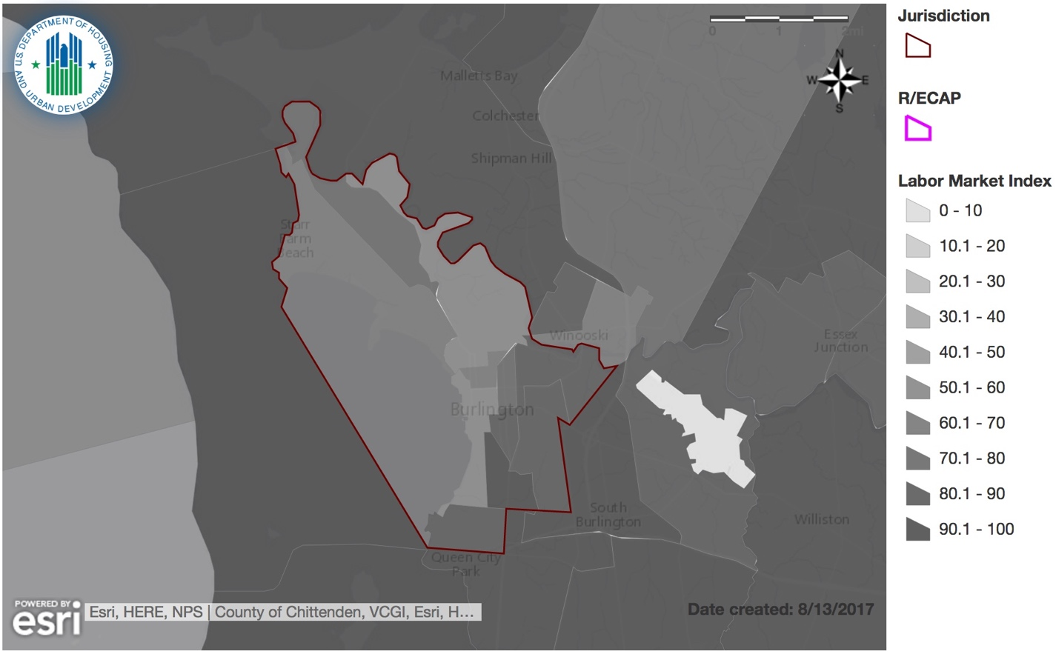

Informed by community participation, any consultation with other relevant government agencies, and the participant’s own local data and local knowledge, discuss whether there are programs, policies, or funding mechanisms that affect disparities in access to employment.
As noted, Vermont’s increasing refugee population has led to a more diverse state. Immigrants, Latinos and Asians account for a growing share of the economy and population in Vermont. As noted in our demographics section, the foreign-born share of Burlington's population rose to 13.5%. Burlington/Winooski have welcomed almost 7,000 refugees or “New Americans” through 2015.
In reference to refugees, Vermont’s welcoming stance and the range of services and assistance provided by organizations like Association of Africans Living in Vermont (AALV) and Vermont Refugee Resettlement Program (VRRP), makes the Burlington area particularly appealing. Refugees get a one-time payment of $925 to $1,125 to start anew in the U.S., and employment counseling, refugee placement services, workforce development, translation services, English-language classes and other support is provided to assist with their assimilation. Additionally, there are larger employers who provide English as a Second Language classes in their workplace to improve their retention, safety and success of their ESOL workers.
While the Black, non-Hispanic population has the lowest ranking in the Labor Market Engagement Index in the city, they are not seriously disadvantaged across all racial groups. Moreover, this reverses and this population group scores the highest across all races below the federal poverty line, both in the city and the region.
Within our community survey, respondents were asked about the availability of jobs in their neighborhood and 59% responded fair to excellent, whereas 21% responded poor. The survey also asked how easy it would be to get to places with jobs the respondent would like to have and 30% noted it would be either very difficult or somewhat difficult revealing a possible disparity with access to transportation to employment.
In the Burlington-South Burlington region, the Native American, non-Hispanic populations are the least successful in accessing employment and have a considerably lower ranking in the Labor Market Engagement Index, overall, as well as populations below the federal poverty line.
- Transportation Opportunities
To assess the level of access to transportation opportunities in the Burlington area, we use both the Low Transportation Cost index, as well as the Transit Trips index. Both indices are percentile ranked and range from 0 to 100.

The Low Transportation Cost Index is based on estimates of transportation costs for a family that meets the following description: a 3-person single-parent family with income at 50% of the median income for renters for the region. These estimates are actually derived from a different index called the Location Affordability Index, and calculates transportation costs based on a percent of renter income in a neighborhood, which is based on census tracts. The higher the index, the lower the cost of transportation in that neighborhood.

The Transit Trips Index is also based on the Location Affordability Index, but instead focuses on the average number of trips taken by a family that meets the same description as described above: a 3-person single-parent family with income at 50% of the median income for renters for the region. The higher the transit trips index, the more likely residents in that neighborhood utilize public transit.

For the protected class groups HUD has provided data, describe any disparities in access to transportation related to costs and access to public transit in the jurisdiction and region.

Burlington
Tables 14 and 15 include information on access to transportation by using the Low Transportation Cost Index and the Transit Trips Index. Maps 11 and 12 visualize these indices for the Burlington, VT area, respectively.
In Burlington, the Transit Trips Index score is very similar across all racial/ethnic groups (figure 25). The highest score is 65.96 for the Black population and the lowest score is 65.44 for the White population. For the population below the poverty line, the Transit Trips Index is fairly consistent across racial groups, with the Asian population having the highest index score of 76.33.
The Low Transportation Cost Index is also very similar across racial/ethnic demographics in Burlington for the total population (figure 26). The highest score is 84.07 for the Native American population and the lowest score is 80.26 for the Asian or Pacific Islander population. There is a little bit of variation between racial/ethnic groups for the population below the poverty line. The highest score (90.67) is the Native American population and the lowest score (81.67) is the Hispanic population.

Figure 25: Transit Trips Index Among Racial/Ethnic Groups in Burlington, VT. Source: Location Affordability Index (LAI) data, 2008-2012.

Figure 26: Low Transportation Cost Index Among Racial/Ethnic Groups in Burlington, VT. Source: Location Affordability Index (LAI) data, 2008-2012.

Burlington-South Burlington Region
The region as a whole has generally lower scores for the Transit Trips Index (figure 27). For the total population of the region, the lowest Transit Trips Index score is the Native American population with a score of 35.72 and the highest score is the Black, non-Hispanic population with 54.91. For the population below the poverty line, the highest score is Asian or Pacific Islanders with 61.94 and the lowest is the Hispanic population with a score of 48.31.
The scores for the Low Transportation Cost Index are generally lower and show greater variance in the region as a whole than it is in Burlington (figure 28). For the total population, the highest score was 74.47 (Black, non-Hispanic) and the lowest score was 58.60 (Native American). For populations below the poverty line, the highest score was 79.71 for the Asian population and the lowest score was 67.64 for the Hispanic population.
Figure 27: Transit Trips Index Among Racial/Ethnic Groups in the Burlington-South Burlington Region. Source: Location Affordability Index (LAI) data, 2008-2012.

Figure 28: Low Transportation Cost Index Among Racial/Ethnic Groups in the Burlington-South Burlington Region. Source: Location Affordability Index (LAI) data, 2008-2012.

For the protected class groups HUD has provided data, describe how disparities in access to transportation related to residential living patterns in the jurisdiction and region.

Burlington
In Burlington, there is not a lot of variability across racial groups with regard to the lack of reliable, affordable transportation with populations above and below the poverty line. However, the Black, non-Hispanic population below the poverty line does score the lowest on the Transit Trips Index, suggesting the least utilization of public transportation.

Burlington-South Burlington Region
In the Burlington-South Burlington region, the Native American, non-Hispanic population has the lowest score on the Transit Trips Index, both above and below the federal poverty line, meaning they are more likely to experience higher transportation costs relative to other groups.

Map 11: Map showing the Low Transportation Cost Index in the Burlington, VT area.
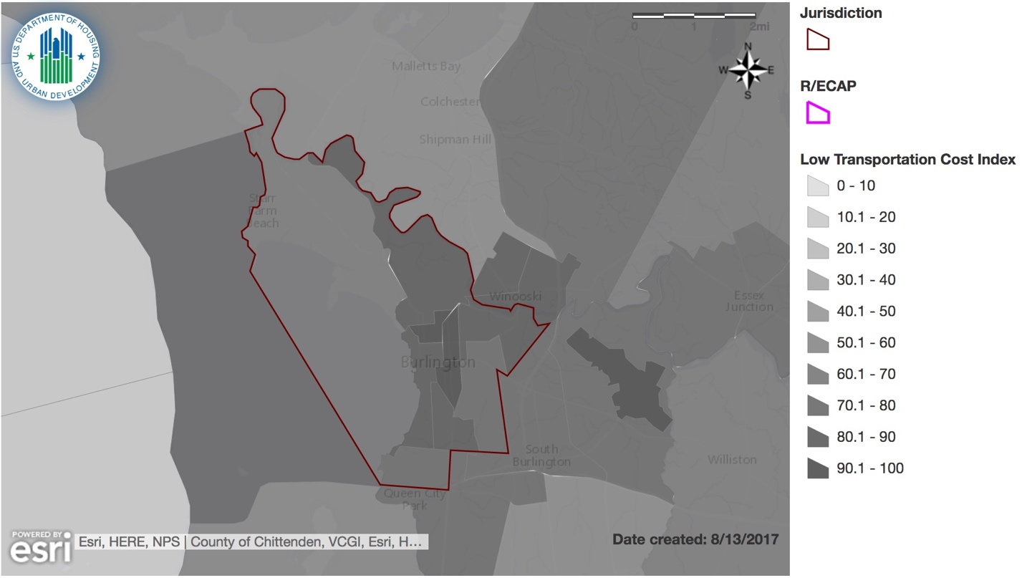

Map 12: Map showing the Transit Trips Index in the Burlington, VT area. (HUD Map 10)
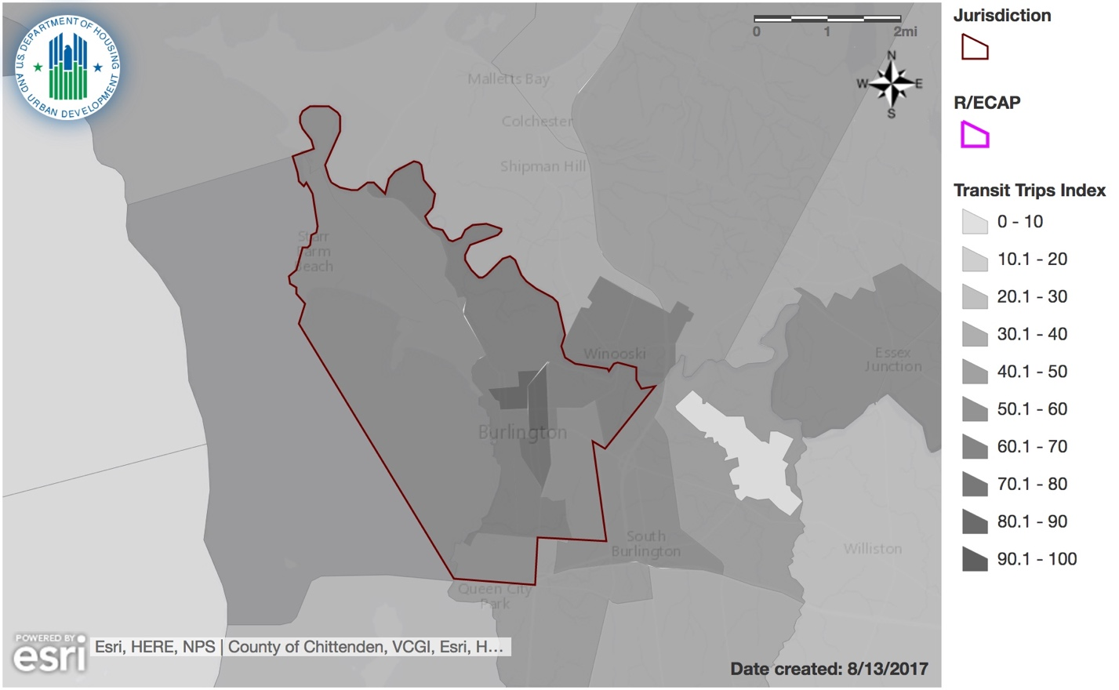

Informed by community participation, any consultation with other relevant government agencies, and the participant’s own local data and local knowledge, discuss whether there are programs, policies, or funding mechanisms that affect disparities in access to transportation.

Burlington has a longstanding commitment to provide a range of interconnected, safe, affordable, efficient and convenient transportation choices not only for residents, but visitors alike. Specifically, regarding public transit, Green Mountain Transit (GMT) is the regional public transit system based in Burlington. GMT offers Chittenden County residents and employees in the region many affordable and convenient options to get to work. Commuter services include the LINK Express routes and Local Commuter routes. The GMT serves several communities including Burlington, Essex, South Burlington, Shelburne, Williston, and Winooski and a portion of Colchester.
In October 2016, GMT opened its new $7.7 million transit center in Burlington’s downtown. The new transit center services as a transfer point for other bus companies such as Megabus and Greyhound. Also, GMT recently launched a mobile phone application that delivers real-time bus information to passengers, thus enhancing the ridership experience. Recently, the transit authority upgraded its rolling stock with a fleet of new buses and added twenty-three new routes in various Vermont communities.
In personal interviews, several people noted a challenge in transportation needs for people who work during a second or third shift with limitations on public transportation.
Our community survey asked respondents to rate access to public transportation in their neighborhood. Seventy-five percent of the respondents rated public transportation access as excellent or good and only 5% rating transportation access as poor. In addition, a local non-profit, as well as a local ministry provide bus passes to those in need.

Burlington-South Burlington Region
According to the 2013 Chittenden County ECOS Plan produced by the Chittenden County Regional Planning Council, our region is served by a Northern Corridor, meeting the travel needs connecting Burlington to Franklin and Grand Isle Counties. Since Burlington remains an economic and employment hub, much of the travel and transportation needs focus on car travel to residential living.
Although most of the public transportation needs are served by GMT in the urban core of Chittenden County, public transportation services are limited through the Northern Corridor. Outside of Chittenden County, including Franklin and Grand Isle Counties, GMT provides a variety of public transportation services including local routes, commuter routes, demand response medical shuttles, and service to elders and persons with disabilities. It is the first and only transit authority in Vermont. GMT offers one way fares, monthly passes and 10-ride tickets and many routes offer discounts for senior citizens, youth and children. GMT operates rural public transportation within our northern counties which includes some fixed route and special shopping shuttles as noted next. GMT operates a daily and limited bus to St. Albans in Franklin County. Commuter from Alburgh to Georgia. Richford to St. Albans. Free Price Chopper Shopping Shuttle in St. Albans and Swanton.
With a number of road improvements, bicycle and pedestrian accommodations are improving, especially in village areas. Some excellent examples of cyclist accommodations include the shoulders on US 2 from Chimney Corners to the Sandbar Causeway and the seasonal operation of a specially equipped bike ferry, run by a local nonprofit, Local Motion, to carry bicyclists comfortably across the 200 foot cut in between Chittenden and Grand Isle Counties.
Some populations including protected classes of youth and elderly, communities of color have less access to public transportation in suburban/rural areas, limiting access to employment, recreation and economic opportunities. Reliance on personal transportation creates a household cost burden – rural and suburban residents are more important by household transportation costs. More vehicle miles traveled in the outer regional areas may potentially increase air pollutants and greenhouse gases.
- Access to Low Poverty Neighborhoods
Low poverty exposure is measured by the Low Poverty Index, which captures the level of poverty in a given neighborhood. The index is based on the poverty rate, and is calculated at the census tract level. Values are inverted and percentile ranked nationally. The resulting values range from 0 to 100. The higher the score, the less exposure to poverty in a neighborhood.
AFH Prompt 1.d.i: For the protected class groups HUD has provided data, describe any disparities in access to transportation related to costs and access to public transit in the jurisdiction and region.

Burlington
Native American and Black populations have the most exposure to poverty within Burlington, with 38.71 and 39.82 low poverty index points, respectively. This contrasts with the White, Non-Hispanic population which has the least exposure to poverty with 52.14 index points. The Asian or Pacific Islander population in Burlington has relatively high exposure to poverty, with 43.97 index points, while the Hispanic population has lower exposure with 50.30 index points. Overall, disparity between populations based on race and ethnicity is moderate, with a difference of 13.43 index points between White and Native American populations (figure 29).

Figure 29: Low Poverty Index Among Racial/Ethnic Groups in Burlington, VT. Source: American Community Survey (ACS), 2009-2013.

Burlington-South Burlington Region
Within the Burlington-South Burlington region, there is less exposure to poverty, in general, when compared to poverty levels within Burlington (figure 30). However, disparity in exposure to poverty among populations based on racial and ethnic differences are slightly higher in the region than compared to the Burlington jurisdiction. Again, the White population experiences the least exposure to poverty with 68.23 index points, and the Black population has the highest exposure to poverty with 52.54 points. Native American, Asian or Pacific Islander, and Hispanic populations’ exposure to poverty fall in between those two groups, with 57.17, 62.69, and 64.34 index points, respectively.
Figure 30: Low Poverty Index Among Racial/Ethnic Groups in the Burlington-South Burlington Region. Source: American Community Survey (ACS), 2009-2013.

For the protected class groups HUD has provided data, describe how disparities in access to transportation related to residential living patterns in the jurisdiction and region.

Map 13 shows the Low Poverty Index by census tract. Based on this map, as well as with maps explored in previous sections, you can see that exposure to poverty is higher (lower index points) on the western side of Burlington than on the eastern side. Based on the data in tables 13 and 14, as mentioned earlier, exposure to poverty is higher within Burlington than without.
Map 13: Map showing the Low Poverty index in the Burlington, VT area.
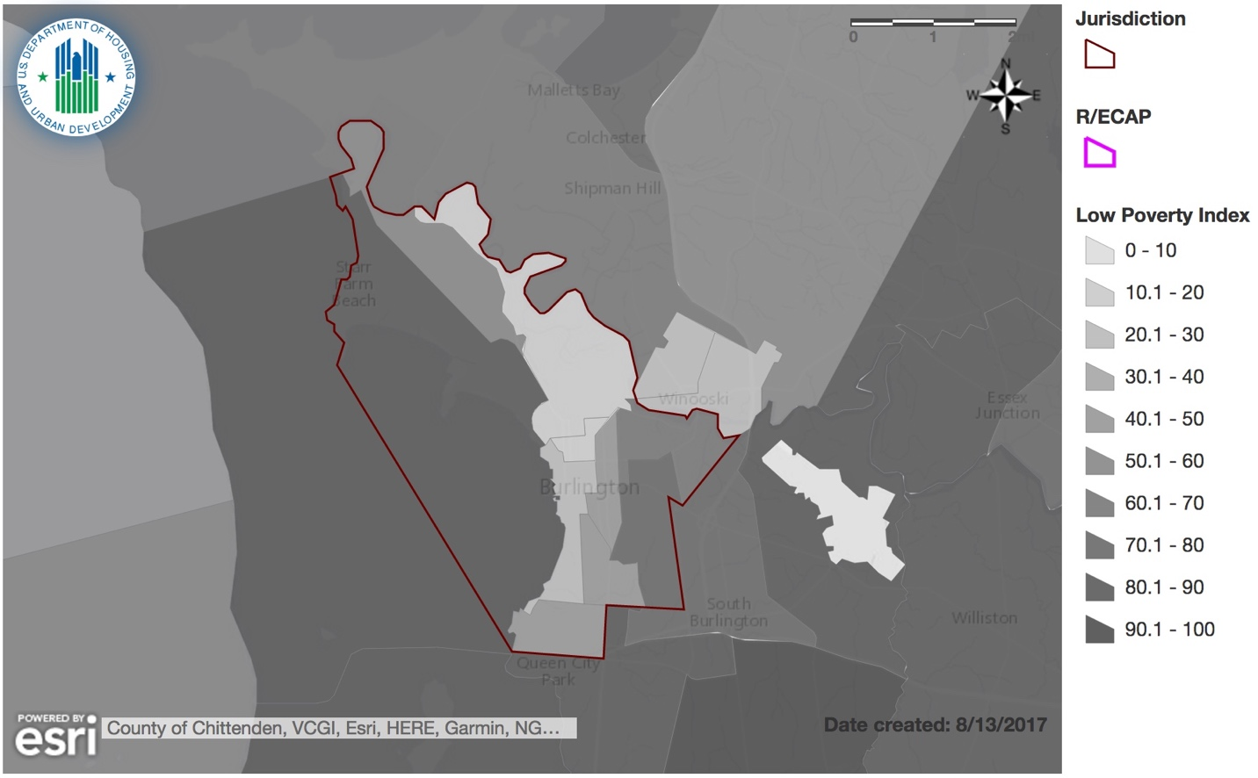

Informed by community participation, any consultation with other relevant government agencies, and the participant’s own local data and local knowledge, discuss whether there are programs, policies, or funding mechanisms that affect disparities in access to transportation.

A 2012 Chittenden County Transit Authority (now Green Mountain Transit Authority), Customer Service Survey, conducted to gather input about riders’ transit needs, and perceptions of the service, found that the majority of respondents either began or ended their trips within the city of Burlington and nearly half of riders had both their origin and destination within the city limits. South Burlington is the second most common destination, followed by Winooski, Essex, Shelburne, Williston and Colchester. The Survey also found that the average wait time for a bus was 7 minutes and improvements most requested by riders include Sunday service, more frequent service and more bus shelters. A guaranteed ride home program and employer-subsidized bus passes were reported as the most effective ways to encourage people to drive less.
In recent years, the city of Burlington has continually recommitted itself to a transportation vision which stresses transportation choices and livability, included in the Legacy Plan (2000) and the Climate Action Plan (2000).
The Burlington Transportation Plan which was approved by the City Council in April 2011, is a multi-modal transportation improvement plan that provides a comprehensive and coordinated list of roadway, transit, bicycle and pedestrian facility, streetscape and land use recommendations for implementation that satisfy the overall vision of the City, developed in the Burlington Municipal Development Plan and the Burlington Legacy Project. The Transportation Plan is evolutionary and takes seriously the goals, vision and values of the Municipal Development and the Legacy Plan and proposed the steps that can move the City to realize them. The Municipal Development Plan vision statement calls for by 2026 an “interconnected system” where “transit, cycling, and walking are successfully competing with the automobile for the dominant mode of choice.”
Residents and visitors of Burlington enjoy bicycling and walking for shopping, commuting, recreation and general transportation. From the installation of the first shared use path along the waterfront in 1986 to the ongoing installation of bicycle facilities and sidewalks, the City of Burlington continues to support bicycling and walking as viable, healthy and non-polluting modes of transportation. Burlington applied for Bicycle Friendly Community recognition from the League of American Bicyclists in 2005 and 2007 and in 2011 was recognized with a Silver award. In 2011, the City was also recognized with a Silver award as a Walk Friendly Community.
Despite Burlington’s vision for becoming a more walkable, bikeable place, up until last year, the Queen City did not have a dedicated plan defining strategies and priorities for walk/bike-related investments. In August 2016, and in line with the aims of the Transportation Plan, Burlington’s first comprehensive plan for walking and biking was released for public comment. This Plan sets out an ambitious goal: to make Burlington the best small city of walking and biking on the East Coast. Known as PlanBTV Walk Bike, the Plan defines strategies and priorities for investments in walk/bike improvements. It is a road map to rapidly transform Burlington into a place where walking and biking are viable, and enjoyable transportation option for people of all ages and abilities, all year round.
Over the past two years, the City has invested $1.5 million annually in sidewalk repair/replacement and will need to maintain this level of annual investment, at a minimum going forward. Additional annual funding needs called for in the 10-year Capital plan through 2021 is estimated to be $1 million. Specifically, with regard to implementing recommendations set out in PlanBTV Walk Bike, it is estimated that another $2.1 million would be needed annually for investing in serious sidewalk failures over the next five years. Beyond 2021, sustainable annual funding is estimated at $1.5 million annually, along with $2 million for expansion of the transportation system.

Burlington-South Burlington Region
Some populations including protected classes of youth and elderly, and communities of color have less access to public transportation in suburban/rural areas, limiting access to employment, recreation and economic opportunities. Reliance on personal transportation creates a household cost burden – rural and suburban residents are more important by household transportation costs. More vehicle miles traveled in the outer regional areas may potentially increase air pollutants and greenhouse gases.
- Access to Environmentally Healthy Neighborhoods
Environmentally healthy neighborhoods are measured using the Environmental Health Index. This index summarizes potential exposure to harmful toxins at a neighborhood level. The index is a linear combination of standardized EPA estimates of air quality carcinogenic, respiratory and neurological hazards with indexing census tracts. Values are inverted and then percentile ranked nationally. Values range from 0 to 100. The higher the index value, the less exposure to toxins harmful to human health, and therefore the better the environmental quality of a neighborhood.
For the protected class groups HUD has provided data, describe any disparities in access to environmentally healthy neighborhoods in the jurisdiction and region.

Burlington
Within the Burlington jurisdiction, there is little disparity between racial/ethnic groups regarding environmental health, with a total difference of 5.05 index points between the populations with the highest and lowest levels of environmental health exposure (figure 31). The Black population has the highest access to environmentally healthy neighborhoods, with 65.99 Environmental Health Index points, while the Native American population has the lowest Environmental Health Index score, at 60.94 points.

However, when you look at the proportion of the population that is below the poverty line, there is much more disparity among different racial/ethnic populations. The proportion of the Native American population living below the federal poverty line has an Environmental Health Index of 46 points, significantly lower than any other population. The Black population below the poverty line still has the highest access to environmentally healthy neighborhoods, with 69.14 index points. Overall, disparity between these two groups span 23.14 index points when considering just those below the poverty line.

Figure 31: Environmental Health Index Among Racial/Ethnic Groups in Burlington, VT. Source: National Air Toxics Assessment (NATA) data, 2011.

Burlington-South Burlington Region
There is more disparity among racial/ethnic groups’ access to environmentally healthy neighborhoods within the greater Burlington-South Burlington region than within the Burlington jurisdiction (figure 32). In contrast to Burlington, the Native American population at the regional level has the highest access to environmentally friendly neighborhoods, with 87.49 index points. The white population has the second highest access to environmentally healthy neighborhoods, with 85.45 index points. The Black population, in a complete reversal from the Burlington jurisdiction, has the lowest access to environmentally healthy areas with 72.33 index points. Overall disparity is moderate regionally, spanning 13.12 index points.

Figure 32: Environmental Health Index Among Racial/Ethnic Groups in the Burlington-South Burlington Region. Source: National Air Toxics Assessment (NATA) data, 2011.

For the protected class groups HUD has provided data, describe how disparities in access to environmentally healthy neighborhoods relate to residential living patterns in the jurisdiction and region.

As mentioned above, the Black population has the highest access to environmentally friendly neighborhoods, with low disparity between races and ethnicities overall. Map 14 shows that environmental health in Burlington is generally good, with the exception of tract 39. However, the areas within Burlington that have the highest Nonwhite population density, tracts 4 and 5, do have slightly lower Environmental Health Index scores than the immediate surrounding areas, although this trend is not consistent overall.
Map 14: Map showing the Environmental Health Index in the Burlington, VT area.
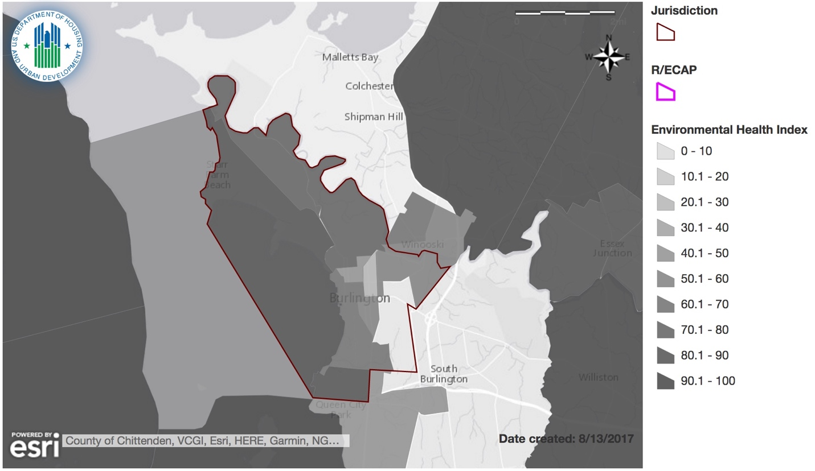

Informed by community participation, any consultation with other relevant government agencies, and the participant’s own local data and local knowledge, discuss whether there are programs, policies, or funding mechanisms that affect disparities in access to environmentally healthy neighborhoods.
The City of Burlington's Community & Economic Development Office (CEDO) administers a HUD-funded program to reduce lead-based hazards in pre-1978 homes. The program also provides education and outreach to resident to help keep their families safe from lead poisoning. A healthy home assessment can provide information on a holistic approach to a family's health and well-being. Many free services are available to households in Burlington and Winooski.

CEDO also offers a repair program of low-income owner-occupied housing as well as access modifications for the elderly and disabled in partnership with VCIL.

In a recent land purchase, the City gained access to a strip of land connecting census tracts 3 and 4 (lowest income, most racially diverse) to the City's waterfront thereby providing access to one of Burlington's most treasured recreational areas.

The assessment, cleanup and redevelopment of Brownfields (properties with real or perceived contamination) is a high priority for the City of Burlington. Brownfield site conversions can improve ecological conditions, reduce risk to human health and the environment, increase the tax base, create new jobs, housing, and green space.

Additionally, the City's Parks, Recreation and Waterfront Department serves over 1400 individuals and their families annually in the Burlington Area Community Gardens Program. Several of these gardens are located in areas where protected classes live and strive to engage a diverse audience by assisting with the growing of specific ethnic vegetables as well as wheel chair accessible gardens.

Our community survey responses rated access to parks, playground and other green spaces at a high of 70% excellent and for public libraries 75% expressed it was either easy or somewhat easy to access this amenity.

Burlington – South Burlington Region

Pine Island Community Farm represents a partnership between the Vermont Land Trust and the Association of Africans Living in Vermont. Located in nearby Colchester, it supports New American farmers who wish to raise goats, chickens, or garden crops at the farm and sells pasture grown animals to families who wish to slaughter their own goats and chickens for meat. The farm is based on a collaborative. Each individual farm enterprise is run by the owner as his own small business. Together, the business operations share the land, the barns, and the equipment.
- Patterns in Disparity to Opportunity

For the protected class groups HUD has provided data, identify and discuss any overarching patterns of access to opportunity and exposure to adverse community factors. Include how these patterns compare to patterns of segregation, integration, and R/ECAPs. Describe these patterns for the jurisdiction and region.

Burlington
With the exception of the Environmental Health Index, non-White and non-Hispanic populations tend to have lower opportunity and higher exposure to adverse community factors. Interestingly, White and Hispanic dissimilarity is the lowest in Burlington. Thus, there is some correlation between increased segregation and decreased access to opportunity. However, correlation does not mean causation, and this is not true in all cases yet this trend should be closely watched in the future.

Further, socioeconomic factors tend to play a large, if not larger role than race/ethnicity by itself, in determining access to opportunity and exposure to adverse community factors. More consistent than variation by race and ethnicity, populations living below the poverty line across all race/ethnicities tend to experience less access to opportunity and more adversity community factors. Although it is often difficult to disentangle socioeconomic factors from racial ones, it is important to consider how future policies and actions taken within Burlington improve the general socioeconomic condition of protected class groups.

Burlington – South Burlington Region
In general, there is less exposure in the Region to poverty and environmentally friendly neighborhoods. The scores for the Low Transportation Cost Index are generally lower and show greater variance in the region as a whole than it is in Burlington. The Labor Market Engagement Index within the greater Burlington-South Burlington region shows, overall, slightly higher labor market engagement when compared to the Burlington jurisdiction.

Based on the opportunity indicators assessed above, identify areas that experience: (a) high access; and (b) low access across multiple indicators.

The North and West section of Burlington tend to have lower access to opportunity across multiple indicators, while the South-Eastern part of Burlington tends to have higher access to opportunities. Again, the Environmental Health Index is an exception to this trend.

Additional Information
Beyond the HUD-provided data, provide additional relevant information, if any, about disparities in access to opportunity in the jurisdiction and region affecting groups with other protected characteristics.
Burlington
Although the City of Burlington has a low unemployment rate, unemployment disproportionately impacts Black/African Americans at a rate significantly higher than other races. Low wages places additional burdens on both renters and homeowners. According to the 2016 Out of Reach study, the State of Vermont places 13th in the ability to afford a two-bedroom Fair Market Rate apartment. The annual income needed to afford the 2 bedroom apartment is over $54,000 in the Burlington-South Burlington Region; however the City of Burlington median household income is $44,671. This median household income is significantly less for Black/African American households at $31,250.
According to the USDA Economic Research Service, an average of 12.4% (32,000) Vermont households were food insecure from 2011 to 2015. In Burlington, a distinct disparity exists between populations based on race for those who access food stamps. Fifteen percent of White households received food stamps as opposed to 45% Black/African American households; 42% Asian households and 35% American Indian households. Food insecurity can lead to significant disparities in access to opportunity. According to the Urban Institute’s 2010 study on food insecurity, it suggests that SNAP receipt reduces the likelihood of being food insecure by roughly 30 percent and reduces the likelihood of being very food insecure by 20 percent. These findings provide evidence that SNAP is meeting its key goal of reducing food-related hardship.
Burlington School District Equity and Diversity Report and Vermont Legal Aid Report of 2014, note youth of color in Burlington receive in-school suspension three times more often, and out-of-school suspension twice as often as white students, while enrollment in Honors and AP classes is at half the rate. These statistics hold true for low income youth and youth on Individual Education Plans (IEP). The four year cohort graduation rate is lower for youth of color than white students and community reports name high levels of disinterest and disconnection among young men of color within ELL classes. Statewide, 4 year graduation rates show a 14% gap between black and white students (ACS 2014). ELL students enroll at a disproportionally low rate in post-secondary institutions within two years of high school completion and fail to complete college within six years.

Burlington – South Burlington Region

More than 29% of the workers in the Region commute over 30 minutes to their workplace. This travel time can and does impact their opportunities for employment and transportation. In addition, there is considerable disparity between protected classes on the utilization of an automobile for transportation to work. For Whites in the Region, 74% are more likely to use private automobile transportation for their commute. However, the protected classes by race and ethnicity are significantly less likely to use their own car – 56% Black, 57% Asian, 59% American Indian or 57% Hispanic. As protected classes relying more on public transportation, taxi cabs or perhaps other means of transportation, it could result in paying a significant amount of their income on housing and transportation as well as limiting the employment or labor opportunities based on other means of transportation.

For the Region, significant disparities also exist among protected race/ethnicity populations receiving food stamps, indicative of both higher poverty level and perhaps food insecurity issues. While only 11% of the White population in the Region receive food stamps, 20% of Asians, 30% of Blacks and American Indians and 19% of Hispanics receive food stamps.
UVM Professor Stephanie Seguino, in a published report "DRIVING WHILE BLACK AND BROWN IN VERMONT", notes there is a higher incidence of traffic stops by law enforcement of people of color. Incidents with the criminal justice system also lead to disparities in opportunities.
Other disparities exist for youth of color. Black youth are referred to court for delinquent and criminal charges at five times the expected rate for their population. Black youth are sent to Woodside Juvenile Detention nearly twice as often as White youth relative to cases adjudicated in court and Black youth are sent to Woodside eight times more often than expected based on population alone.

The program participant may also describe other information relevant to its assessment of disparities in access to opportunity, including any activities aimed at improving access to opportunities for areas that may lack such access, or in promoting access to opportunity (e.g., proficient schools, employment opportunities, and transportation).

In 2014 Downtown Strategy Report, it was noted that Burlington is lagging behind the region &
peer cities in the production of new downtown housing – housing that is particularly
important for serving low-income families, young professionals, empty nesters, families, and
seniors. Proposed new mixed-use development will allow individuals and families to live close to
where there are employment opportunities. Development was approved with changes
to density requirements.

The development of a Plan BTV/Bike Walk provides safe transportation opportunities for all; coupled with a Bike Recycle Program which provides free bicycles to low income persons, safe, healthy and available transportation options help access opportunities for employment, schools and recreation.

Contributing Factors of Disparities in Access to Opportunity
Consider the listed factors and any other factors affecting the jurisdiction and region. Identify factors that significantly create, contribute to, perpetuate, or increase the severity of disparities in access to opportunity.

Availability, type, frequency, and reliability of public transportation
Public transportation, in Burlington and the Region consists of Green Mountain shared passenger bus transportation service available for use by the general public. Public transportation also includes paratransit services for persons with disabilities. Although there appears to be availability, frequency and reliable bus transportation within Burlington, Winooski and adjoining towns in Chittenden County, concerns arose on accessibility with residents who are working second and third shifts as well as connectivity and frequency between the downtown hub of Burlington and the other counties within the jurisdiction.

Impediments to mobility
Impediments to mobility refers to barriers faced by individuals and families when attempting to move to a neighborhood or are of their choice. With the conversion of public housing units to RAD properties, residents now have the option of moving with their housing voucher to other properties or even perhaps moving out of the Burlington area. However, there appears to be a lack of units priced either in Burlington or the Region at Fair Market Rent level. Private landlords, to increase their returns on investment have opted to price units at market rate levels and due to perpetually low vacancy rates, are able to find renters in college students and higher wage earners

Displacement of residents due to economic pressures

With local private and public investments into low-income census tracts some residents might be forced to relocate as previously low-income housing is renovated and then rented at market rate. Additionally, with renovated older properties, new public infrastructure, private landlords and the market itself may sustain higher rents, displacing current residents.

  - Disproportionate Housing Needs

Key Findings
- Within Burlington, Black households experience the highest rate of housing problems while Native American households experience the highest rate of severe housing problems.
- Within the Burlington-South Burlington region, Asian or Pacific Islander households experience the highest rate of housing problems, both in general and severe.
- Housing burden seems to be spatially correlated to areas with higher non-white population densities.

Analysis
Which protected class groups (by race/ethnicity and familial status) experience higher rates of housing problems (cost burden, overcrowding, or substandard housing) when compared to other groups for the jurisdiction and region? Which groups also experience higher rates of severe housing cost burdens when compared to other groups?
Table 16 shows the demographics of households with disproportionate housing needs, both within Burlington and throughout the Burlington-South Burlington region. This table shows the number of households within different subpopulations that experience any of the 4 housing problems identified by HUD. These problems include:
- Lacks complete kitchen facilities
- Lacks complete plumbing facilities
- More than one person per room
- Cost Burden - monthly housing costs (including utilities) exceed 30% of monthly income
The bottom half of table 16 shows the number of households experiencing “severe” housing problems, which includes the following housing problems:
- Lacks complete kitchen facilities
- Lacks complete plumbing facilities
- More than one person per room
- Severe Cost Burden - monthly housing costs (including utilities) exceed 50% of monthly income
You will notice that the first three problems are the same, with the major difference between the standard housing problems and “severe” housing problems being the definition of cost burden.
Information on housing problems is drawn from CHAS, which demonstrate the extent of housing problems and housing needs, particularly for low-income households. The CHAS data are produced via custom tabulations of ACS data by the U.S. Census Bureau.

Table 16: Demographics of people with disproportionate housing needs in Burlington and Burlington-South Burlington Region. Source: Comprehensive Housing Affordability Strategy (CHAS).
Table 16: Demographics of Households with Disproportionate Housing Needs
Disproportionate Housing Needs | Burlington |  |  | Burlington-South Burlington Region
Households experiencing any of 4 housing problems | # with problems | # households | % with problems | # with problems | # households | % with problems
Race/Ethnicity
White, Non-Hispanic | 6,870 | 14,648 | 46.90% | 27,780 | 79,387 | 34.99%
Black, Non-Hispanic | 389 | 489 | 79.55% | 603 | 1,032 | 58.43%
Hispanic | 215 | 374 | 57.49% | 449 | 999 | 44.94%
Asian or Pacific Islander, Non-Hispanic | 380 | 584 | 65.07% | 869 | 1,338 | 64.95%
Native American, Non-Hispanic | 54 | 78 | 69.23% | 157 | 307 | 51.14%
Other, Non-Hispanic | 138 | 226 | 61.06% | 647 | 1,130 | 57.26%
Total | 8,065 | 16,425 | 49.10% | 30,520 | 84,225 | 36.24%
Household Type and Size
Family households, <5 people | 2,205 | 6,125 | 36.00% | 12,970 | 47,404 | 27.36%
Family households, 5+ people | 360 | 680 | 52.94% | 2,084 | 5,162 | 40.37%
Non-family households | 5,500 | 9,619 | 57.18% | 15,450 | 31,659 | 48.80%
Households experiencing any of 4 Severe Housing Problems | # with severe problems | # households | % with severe problems | # with severe problems | # households | % with severe problems
Race/Ethnicity
White, Non-Hispanic | 3,735 | 14,648 | 25.50% | 12,803 | 79,387 | 16.13%
Black, Non-Hispanic | 139 | 489 | 28.43% | 289 | 1,032 | 28.00%
Hispanic | 105 | 374 | 28.07% | 236 | 999 | 23.62%
Asian or Pacific Islander, Non-Hispanic | 283 | 584 | 48.46% | 559 | 1,338 | 41.78%
Native American, Non-Hispanic | 50 | 78 | 64.10% | 78 | 307 | 25.41%
Other, Non-Hispanic | 113 | 226 | 50.00% | 408 | 1,130 | 36.11%
Total | 4,440 | 16,425 | 27.03% | 14,370 | 84,225 | 17.06%

In table 17, we specifically examine the demographics of households experiencing severe housing cost burden. According to HUD, housing cost burden is defined as “monthly housing costs (including utilities) exceeding 50% monthly income”. This differs from the lower half of table 16 because it does not include the other 3 housing problems, instead focusing only on severe housing cost.
Table 17: Demographics of Households experiencing server housing cost burden. Source: CHAS.
Table 17: Demographics of Households with Severe Housing Cost Burden
Households with Severe Housing Cost Burden | Burlington |  |  | Burlington-South Burlington Region
Race/Ethnicity | # with severe cost burden | # households | % with severe cost burden | # with severe cost burden | # households | % with severe cost burden
White, Non-Hispanic | 3,540 | 14,648 | 24.17% | 11,745 | 79,387 | 14.79%
Black, Non-Hispanic | 129 | 489 | 26.38% | 234 | 1,032 | 22.67%
Hispanic | 40 | 374 | 10.70% | 155 | 999 | 15.52%
Asian or Pacific Islander, Non-Hispanic | 200 | 584 | 34.25% | 440 | 1,338 | 32.88%
Native American, Non-Hispanic | 50 | 78 | 64.10% | 80 | 307 | 26.06%
Other, Non-Hispanic | 104 | 226 | 46.02% | 335 | 1,130 | 29.65%
Total | 4,063 | 16,425 | 24.74% | 12,989 | 84,225 | 15.42%
Household Type and Size
Family households, <5 people | 974 | 6,125 | 15.90% | 4,879 | 47,404 | 10.29%
Family households, 5+ people | 94 | 680 | 13.82% | 350 | 5,162 | 6.78%
Non-family households | 3,014 | 9,619 | 31.33% | 7,761 | 31,659 | 24.51%

Burlington
Based on this data it is clear that, within Burlington, Black households experience the highest rate of housing problems when compared to any other group. Nonfamily households in Burlington experience more housing problems than family households.

Although Black households experience the highest rate of housing problems within Burlington (as described above), Native American households have the highest rate of experiencing severe household problems and severe housing cost burden within the Burlington jurisdiction. Again, nonfamily households experience the highest rate of severe housing cost burden within Burlington.

Burlington-South Burlington
The Burlington-South Burlington data show us that Asian or Pacific Islander populations have the highest percentage of housing problems when compared to other populations. Similar to Burlington, nonfamily households experience more household problems than households with families.

Within the greater region, Asian or Pacific Islander populations also experience the highest rate of severe household problems, including severe housing cost burden. Like Burlington, nonfamily households experience the highest rate of severe housing cost burden at the regional level.

Which areas in the jurisdiction and region experience the greatest housing burdens? Which of these areas align with segregated areas, integrated areas, or R/ECAPs and what are the predominant race/ethnicity or national origin groups in such areas?

Map 15 below shows the percent of households experiencing housing burden by census tract in the Burlington area. Areas that have the highest density of non-white populations, specifically census tracts 3, 4, and 5 appear to experience the greatest housing burdens.

Map 15: Map showing percent of households experiencing housing burdens in Burlington, VT area.
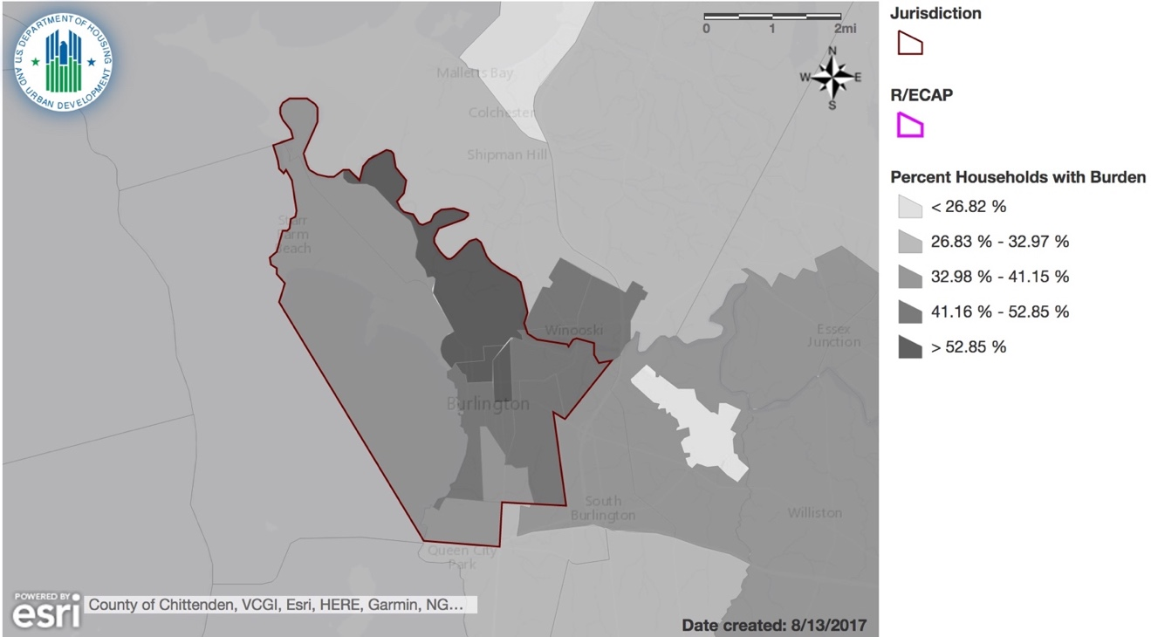

Compare the needs of families with children for housing units with two, and three or more bedrooms with the available existing housing stock in each category of publicly supported housing for the jurisdiction and region.

Table 18 shows the characteristics of affordable housing units within Burlington. There are a total of 1,152 affordable housing units in Burlington over 2 bedrooms in the inventory of 9,651 rental units. In our public housing inventory, as noted in Table 18, there are 250 units of 2 or more bedrooms, representing 22% of the current inventory. According to ACS 2015, there are 1,846 families with children in Burlington who consist of 4 or more persons, most likely in need of this size of housing. Following the same ratio of owner versus renter (60 vs. 40%), approximately 1,100 families would need housing but not all families would be income-qualified. There is definitely a need for subsidized housing units for our lowest income families.

Table 18: Types of housing units in Burlington, VT.
Properties | Total units | Single room occupancy units | Zero bedroom units | 1 bedroom units | 2 bedroom units | 3 bedroom units | 4 bedroom units | 5+ bedroom units
70 | 2320 | 138 | 164 | 866 | 762 | 366 | 21 | 3

Table 19: BHA Developments, Number of Bedrooms.
BHA Property | Studio | 1 BR |  | 2 BR | 3 BR | 4 BR | 5 BR | Total Units
105 East Allen (Winooski) |  | 3 |  | 3 |  |  |  | 6
693-711 Riverside Avenue | 5 | 1 |  | 6 |  |  |  | 12
Bobbin Mill Apartments |  | 17 |  | 23 | 11 |  |  | 51
Duggan Row House |  | 2 |  | 5 | 7 |  |  | 14
Elderly - Champlain |  | 44 |  | 4 |  |  |  | 48
Elderly - Decker | 53 | 100 |  |  |  |  |  | 153
Family - Franklin |  | 4 |  | 15 | 30 | 5 | 2 | 56
Family - Hillside |  |  |  | 16 | 9 |  |  | 25
Family - Riverside | 1 | 3 |  | 16 | 18 | 5 | 1 | 44
KSNRC/Maple St Apartments | 2 | 5 |  | 2 | 2 |  |  | 11
Lake Champlain Apartments |  | 11 |  | 22 | 5 |  |  | 38
Peterson Place Apartments |  | 2 |  | 7 |  | 2 |  | 11
South Square Apartments | 2 | 54 |  | 9 |  |  |  | 65
South St. Paul Apartments |  | 2 |  | 16 |  | 3 |  | 21
Wharf Lane Apartments | 2 | 29 |  | 6 |  |  |  | 37
TOTAL Bedrooms | 65 | 277 |  | 150 | 82 | 15 | 3 | 592

Describe the differences in rates of renter and owner occupied housing by race/ethnicity in the jurisdiction and region.

Burlington
According to the 2010 Census, there is significant disparity in homeownership rates among racial and ethnic groups. The homeownership rate for Whites in Burlington is 43%, Asian 32%, Native Hawaiian/Other Pacific Islander 25%, Hispanic/Latino 18% and Black/African American 15%.

Although 86% of the renters in Burlington are white, this number is influenced by the significant student population. It tells a more impactful story to compare the renter and homeownership rates within each race/ethnicity category. See table 20 below.

Table 20A: Number of Renters and Homeowners in Burlington by Race/Ethnicity.
Race/Ethnicity | Renter | Homeowner
White | 8,313 | 6,212
Black/African American | 569 | 18
Asian | 497 | 162
American Indian | 118 | 12
Native Hawaiian/Other Pacific Islander | n/a | n/a
Hispanic/Latino | 260 | 44

Burlington/ South Burlington Region
According to the 2010 Census, there is significant disparity in homeownership rates among racial groups in the Region. The most significant disparity exists with Black three times more likely to rent than own. Asian renter and owner occupied households are equal and there are slightly more American Indian owner-occupied households than renter households.

Sixty-five percent of the owner occupied units in the Region are white demonstrating the higher rate of homeownership by Whites in the Region. See Table 20B below.

Table 20B: Number of Households by Renters and Homeowners in the Burlington/South Burlington Region by Race/Ethnicity.
Race/Ethnicity | Renter | Homeowner
White | 24,106 | 54,412
Black/African American | 699 | 204
Asian | 645 | 634
American Indian | 172 | 218
Native Hawaiian/Other Pacific Islander | 12 | 1
Hispanic/Latino | 558 | 458

Additional Information
Beyond the HUD-provided data, provide additional relevant information, if any, about disproportionate housing needs in the jurisdiction and region affecting groups with other protected characteristics.

Burlington
Disproportionate housing needs in Burlington also include rehabilitation and energy efficiency needs of the aging housing stock. Housing conditions vary widely by housing type, location and investment objectives of rental property owners. It has been noted that Vermont has the 7th oldest housing stock in the nation. Overall, Burlington’s housing stock is predominately older, renter-occupied homes and apartments. Burlington has five times as many housing units over 50 years old than any other municipality in Chittenden County, and over 50% of the rental units are found by Code Enforcement to be out of compliance with minimum housing code. Over 47% of Burlington’s housing units were built before 1950. These homes need energy efficiency upgrades, lead-based paint hazard reduction, and other rehabilitation to make them safe, affordable and sustainable over the long term.

There is an acute need to help low-income homeowners make repairs that allow them to improve and retain their housing, and to help make the homes of low-income tenants and homeowners accessible. Creating new homeowners and retaining existing homeowners is the single best way for low and moderate-income households to build family wealth, maintain economic independence and move out of poverty.

Domestic violence is one of the single largest contributing factor to housing insecurity.
A large percentage of temporary motel stays paid for by the state is related to domestic violence.

When asked about the availability and quality of housing in their neighborhoods, almost half of our community respondents (47%) said availability of housing was fair to poor and over half (53%) responded that quality of housing was fair to poor. Both responses confirm the low vacancy rate and the concern for the age and condition of the housing in the neighborhoods of our respondents. Eight-nine of the respondents indicated that they were somewhat dissatisfied or very dissatisfied with the quality of their current housing. Of the 89 respondents, 96% said they have trouble finding safe, quality housing in a neighborhood they can afford; 90% said cost limited their housing options; 80% said their current neighborhood safety was fair, good, or excellent; and 35% rated the quality of their current housing as fair, good, or excellent.

Fifty-one percent of our respondents were homeowners.

Burlington/South Burlington Region
The age of housing in the Region is substantially different than that of Burlington. Only 24% of housing in the Region was built before 1950, demonstrating less need for rehabilitation of, energy efficiency upgrades and perhaps lead remediation for households in the Region.

Household types also present a clear picture of disproportionate housing needs. Female heads of households with children under 18 tend to experience a higher degree of poverty than married couple households or male head of household. In fact, in the Region, 68% of Black female heads of household with children under 18 have income in the past 12 months below the poverty level compared to 56% of White female heads of households and only 28% of Asian female heads of households.

The program participant may also describe other information relevant to its assessment of disproportionate housing needs.
A key factor contributing to housing affordability and housing choice is our local vacancy rate. A rental vacancy rate between 3% and 5% is generally considered by most experts to be “balanced.” When it falls below that level, a lack of supply will lead to escalating rents, leave people unable to find housing, and limit economic growth.
The County rental vacancy rate, measured twice a year by the Allen & Brooks Report, is running at 4.4% in Chittenden County as of December 2016, a 1.4% increase from 2015 and within the ‘balanced’ range.
In all previous years, it ran well below national and regional rates which are reported by the Census Bureau and displayed in the graph below.
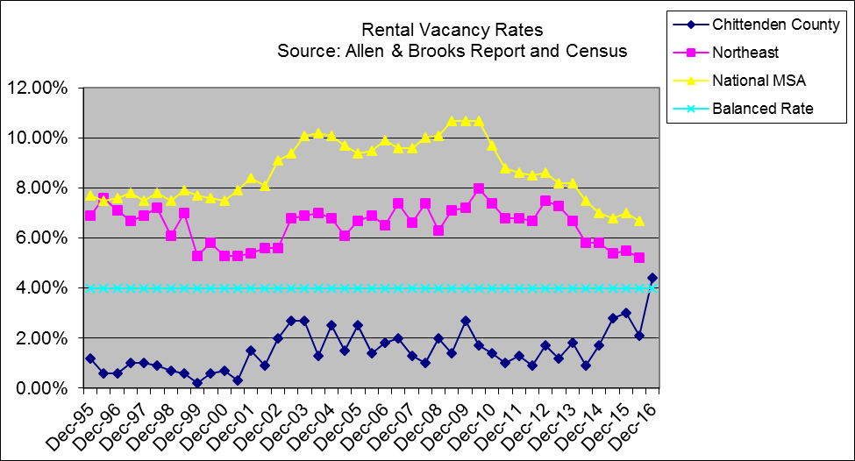

The Special Needs populations of the City include seniors over 65, those living with both physical and developmental disabilities, and those with substance abuse and mental health needs. This population generally needs additional supports, or wraparound services to accompany their housing needs.

As of the 2010 Census, there were 3,986 Burlington seniors, age 65 and older, living in the City. Not all of those residents have supportive service or supportive housing needs. However, 36.6% of Burlington seniors (a total of 1,460) reported having some kind of disability. That includes mental illness as well as physical disabilities. Thirty-six percent were living alone, 20.6% with an independent living difficulty, and 16% had no vehicle.

The Vermont State System of Care uses a prevalence rate of 2.1% of the City’s general population who have intellectual disabilities and Pervasive Development Disorders. Applying the overall percent to Burlington’s population, there are an estimated 890 residents with developmental disabilities.

As defined by the Centers for Disease Control and Prevention, people with developmental disabilities have problems with major life activities such as language, mobility, learning, self-help, and independent living. Developmental disabilities begin anytime during development up to 22 years of age and usually last throughout a person’s lifetime. The vast majority of people with developmental disabilities are supported by families or other non-Developmental Services Waiver supports.

According to an analysis by the Substance Abuse and Mental Health Services Administration (SAMHSA), about 4.7% of Vermont’s population over age 18 has a severe mental illness, defined as a mental illness that caused substantial functional impairment with one or more major life activities. Using this estimate, around 1760 Burlington residents suffer from severe mental illness. It is estimated that roughly half of those who suffer from severe mental illness are also affected by substance abuse.

According to the 2010 Census, 821 individuals, ages 65+ in the City, identified an independent living difficulty. In addition, 1,179 senior households, or 29.5% of the population over 65 are paying over 30% of their income for housing and are cost burdened. According to Cathedral Square Corporation, a key housing provider serving the elderly and individuals or families with special needs, their waiting list hovers between 700 and 1,000 people which demonstrates a high need for special needs/senior housing. By 2017, one in three Vermonters will be 55 years of age or older. Services needed for older adults range from chronic care self-management, to prevention, to nursing home level of care in their homes.

Eligibility requirements often force seniors to “spend down” assets in order to access housing and care. Other challenges for the elderly in maintaining an independent living environment include reliance on fixed incomes, juggling housing costs with medical care, special transportation needs, in-home care and assistance with daily tasks and the physical aspects of aging in place. A more detailed list of challenges faced by these populations can be found below.

Non-elderly residents with mobility and self-care limitations share many of the same challenges as their elderly counterparts. Also, as residents with mental illness and developmental disabilities age, they also share the challenges of changing medical and physical conditions.

Residents with developmental delays are dependent upon a fixed social security payment as their primary source of income and rely on subsidized housing options. Those who choose to live in a family living situation or in one of a few remaining supportive group homes can access funding support. Those who choose an independent living situation are accommodated by Section 8 and other subsidized housing programs; they do not have preferential status on the waiting lists for those programs but do have other housing options while they wait.

Service-enriched housing needs for the population with severe mental illness range from affordable, independent apartments with support services provided by visiting mental health workers to 24-hour supervised “group home” settings. Right now, there is a need for additional supportive housing at all levels for those living with severe mental illness.

Substance abuse treatment and recovery for the 3,300 + residents require affordable, appropriate, alcohol-free and drug-free housing with a range of management and supportive services, from a high level of on-site management (for treatment and early recovery) to self-management in housing such as Oxford Houses to self-management in an at-home setting. Housing that does not require a lease will often not qualify for assistance, creating additional burdens for this population.

Contributing Factors of Disproportionate Housing Needs

Contributing Factors of Disproportionate Housing Needs
Consider the listed factors and any other factors affecting the jurisdiction and region. Identify factors that significantly create, contribute to, perpetuate, or increase the severity of disproportionate housing needs.
Availability of affordable units in a range of sizes
Affordable housing is important to individuals and families with certain protected characteristics because these groups are disproportionately represented in the need for affordable housing. As a refugee community, several of the nationalities who come to Burlington and Winooski choose to live multi-generations under one roof and therefore need more bedroom space. In terms of affordability, a renter or homeowners should not expend more than 30% of his income on housing costs. Unfortunately, in Burlington, not only are market rates excessive, but units with multiple bedrooms are frequently rented to college students to increase a landlord’s return on investment.

Lack of affordable housing units
Although 25% of Burlington’s housing stock is made affordable via subsidies, vouchers and other programs, many of our residents find it difficult to find an available unit due to the low vacancy rate.

Publicly Supported Housing Analysis

Key Findings
- A higher percentage of non-Whites live in PHA managed properties than the percentage of non-Whites in the population as a whole
- Half of the residents living in BHA managed properties have a disability
- Properties with concentrated racial/ethnic populations correlate with properties with family units with more than 2 bedrooms

The Burlington Housing Authority (BHA), established in 1962, is Vermont’s oldest and largest municipally-based public housing authority. BHA has converted all of its conventional public housing units to RAD units with project-based vouchers. The data presented in this section represents 593 units of affordable housing that is owned or managed by BHA and 1,867 Section 8 Housing Choice Voucher holders.
Winooski Housing Authority, located in the Burlington/South Burlington region, is a partner with this Assessment of Fair Housing and has information in an insert following this assessment’. WHA has a 3-5 year wait list for Section 8 Housing Choice Vouchers and for public housing units from 6 months to 5 years. Their properties include Spring Gardens, Elm and Franklin Street Apartments, Senior Tower and The Terrace.

Analysis

Publicly Supported Housing Demographic Analysis
Are certain racial/ethnic groups more likely to be residing in one program category of publicly supported housing than other program categories (public housing, project-based Section 8, Other Multifamily Assisted developments, and Housing Choice Voucher (HCV)) in the jurisdiction?
The percentages of non-White persons living in BHA owned and managed buildings (over 30%) as well as voucher holders (almost 15%) are much greater than the population in Burlington and the Burlington/South Burlington MSA. This is also true for the Winooski Housing Authority where non-White persons are 23% of the residential population/ The highest percentage of Blacks are enrolled in the Housing Choice Voucher program at 11. 73%. Asians at 6.54% are enrolled in Project-Based Section 8 programs. The highest minority population in WHA’s demographics consists of the Asian population at 12%.

Table 21: Publicly Supported Housing Units by Program Category in Burlington, VT. Source: Decennial Census; APSH.
Table 21 - Publicly Supported Housing Units by Program Category
 | Burlington, VT Jurisdiction
Housing Units | # | %
Total housing units | 16,897 | -
Public Housing | N/a | N/a
Project-based Section 8 | 617 | 3.65%
Other Multifamily | 60 | 0.36%
HCV Program | 1,446 | 8.56%

Table 22: Publicly Supported Housing Units by Race/Ethnicity in Burlington, VT and Burlington-South Burlington Region. Source: Data Sources: Decennial Census; APSH; CHAS.
Table 22: Publicly Supported Households by Race/Ethnicity
 | Race/Ethnicity
Burlington, VT Jurisdiction | White |  | Black |  | Hispanic |  | Asian or Pacific Islander
Housing Type | # | % | # | % | # | % | # | %
Public Housing | N/a | N/a | 0 | 0.00% | N/a | N/a | N/a | N/a
Project-Based Section 8 | 471 | 83.22% | 49 | 8.66% | 5 | 0.88% | 37 | 6.54%
Other Multifamily | 34 | 85.00% | 1 | 2.50% | 0 | 0.00% | 1 | 2.50%
HCV Program | 1,121 | 80.19% | 164 | 11.73% | 18 | 1.29% | 74 | 5.29%
Total Households | 14,648 | 89.18% | 489 | 2.98% | 374 | 2.28% | 584 | 3.56%
0-30% of AMI | 3,243 | 83.73% | 160 | 4.13% | 70 | 1.81% | 230 | 5.94%
0-50% of AMI | 4,653 | 76.81% | 249 | 4.11% | 190 | 3.14% | 300 | 4.95%
0-80% of AMI | 7,228 | 80.78% | 374 | 4.18% | 230 | 2.57% | 405 | 4.53%
Burlington-South Burlington, VT Region | White |  | Black |  | Hispanic |  | Asian or Pacific Islander
Housing Type | # | % | # | % | # | % | # | %
Public Housing | N/a | N/a | 0 | 0.00% | N/a | N/a | N/a | N/a
Project-Based Section 8 | 471 | 83.22% | 49 | 8.66% | 5 | 0.88% | 37 | 6.54%
Other Multifamily | 34 | 85.00% | 1 | 2.50% | 0 | 0.00% | 1 | 2.50%
HCV Program | 2,940 | 85.49% | 279 | 8.11% | 45 | 1.31% | 111 | 3.23%
Total Households | 79,387 | 94.26% | 1,032 | 1.23% | 999 | 1.19% | 1,338 | 1.59%
0-30% of AMI | 9,247 | 89.40% | 245 | 2.37% | 152 | 1.47% | 335 | 3.24%
0-50% of AMI | 14,022 | 74.83% | 404 | 2.16% | 302 | 1.61% | 580 | 3.10%
0-80% of AMI | 26,942 | 82.90% | 564 | 1.74% | 500 | 1.54% | 794 | 2.44%
Compare the racial/ethnic demographics of each program category of publicly supported housing for the jurisdiction to the demographics of the same program category in the region.
In comparing the racial demographics of housing authority residents versus that of the general population, there exists a higher percentage of non-White populations in both managed properties as well as voucher holders as compared to the general population in both the Jurisdiction and the Region.

Table 23 : Demographics of Publicly Supported Housing Developments, by Program Category in Burlington, VT. Source: ASPH.
Project-Based Section 8
(Burlington, VT CDBG) Jurisdiction
Development Name | PHA Code | PHA Name | # Units | White | Black | Hispanic | Asian | Households with Children
Lake Champlain Apartments | N/a | N/a | 43 | 57% | 17% | 2% | 24% | 64%
Peterson Place Apartments | N/a | N/a | 13 | 58% | 33% | 0% | 8% | 75%
Mckenzie House | N/a | N/a | 41 | 93% | 5% | 0% | 2% | 4%
Wharf Lane | N/a | N/a | 37 | 68% | 14% | 5% | 8% | 11%
Bobbin Mill Apartments | N/a | N/a | 51 | 57% | 18% | 2% | 20% | 41%
Duggan Row Apartments | N/a | N/a | 16 | 36% | 36% | 0% | 29% | 64%
South Square Associates | N/a | N/a | 64 | 87% | 6% | 0% | 5% | N/a
South St Paul Townhouses | N/a | N/a | 22 | 65% | 15% | 0% | 15% | 75%
Howard Center For Human Srvs. | N/a | N/a | 7 | N/a | N/a | N/a | N/a | N/a
Three Cathedral Square | N/a | N/a | 100 | 92% | 3% | 3% | 2% | N/a
Fern Hill | N/a | N/a | 60 | 93% | 3% | 2% | 2% | N/a
Northgate Section 8 | N/a | N/a | 163 | 88% | 7% | 1% | 3% | 45%
Other HUD Multifamily Assisted Housing
(Burlington, VT CDBG) Jurisdiction
Development Name | PHA Code | PHA Name | # Units | White | Black | Hispanic | Asian | Households with Children
Monroe Place Corporation | N/a | N/a | 15 | 73% | 7% | 0% | 7% | N/a
Arroway Group Home | N/a | N/a | 7 | N/a | N/a | N/a | N/a | N/a
Pennington Group | N/a | N/a | 5 | N/a | N/a | N/a | N/a | N/a
South End Community Hsg Corp. | N/a | N/a | 5 | N/a | N/a | N/a | N/a | N/a
Tsh Ii | N/a | N/a | 28 | 89% | N/a | 0% | N/a | N/a

Compare the demographics, in terms of protected class, of residents of each program category of publicly supported housing (public housing, project-based Section 8, Other Multifamily Assisted developments, and HCV) to the population in general, and persons who meet the income eligibility requirements for the relevant program category of publicly supported housing in the jurisdiction and region. Include in the comparison, a description of whether there is a higher or lower proportion of groups based on protected class.
Half of BHA residents living in BHA-owned or managed properties have a disability compared to almost 60% of voucher holders. In addition, 201 elderly BHA residents live in two of the agency’s properties.
A higher percentage of Blacks access the Project Based Section 8 program and the highest percentage accesses the Housing Choice Voucher Program. Although not as significantly high, Asians access the Project-Based Section 8 program as well.
Refer to Table 23, Project-Based Section 8 where an equal number of Blacks and Whites live in Duggan Row Apartments, with Asian residents close behind.
BHA’s HAB Database
BHA Residents and Voucher Holders: Race by Number
 | White | Black | Native American | Asian | Pacific Islander
BHA Property
103 East Allen
105 East Allen | 3 | 2 |  | 1
693-711 Riverside Avenue | 7 |  |  |  | 5
Bobbin Mill Apartments | 32 | 8 | 1 | 10
Duggan Row House | 4 | 3 |  | 5
Elderly - Champlain | 43 | 2 | 1 | 2
Elderly - Decker | 139 | 9 | 3 | 5
Family - Franklin | 24 | 19 |  | 13
Family - Hillside | 20 |  | 1 | 5
Family - Riverside | 18 | 15 |  | 11
KSNRC/Maple St Apartments | 4 | 2 |  |  | 5
Lake Champlain Apartments | 19 | 9 |  | 9 | 1
Peterson Place Apartments | 5 | 5 |  | 2
South Square Apartments | 56 | 4 | 1 | 2 | 3
South St. Paul Apartments | 9 | 7 | 1 | 4
Wharf Lane Apartments | 26 | 5 | 2 | 4
TOTAL – BHA Properties | 409 | 90 | 10 | 73 | 14
TOTAL - Section 8 Vouchers | 1603 | 180 | 42 | 71 | 12
GRAND TOTAL | 2012 | 270 | 52 | 144 | 26

Table 24: BHA Residents and Voucher Holders: Disability Status.
BHA Property | No Disability | Disability
103 East Allen | 0 | 0
105 East Allen | 33% | 67%
693-711 Riverside Avenue | 43% | 57%
Bobbin Mill Apartments | 53% | 47%
Duggan Row House | 64% | 36%
Elderly - Champlain | 23% | 77%
Elderly - Decker | 16% | 84%
Family - Franklin | 79% | 21%
Family - Hillside | 84% | 16%
Family - Riverside | 77% | 23%
KSNRC/Maple St Apartments | 50% | 50%
Lake Champlain Apartments | 74% | 26%
Peterson Place Apartments | 73% | 27%
South Square Apartments | 63% | 37%
South St. Paul Apartments | 76% | 24%
Wharf Lane Apartments | 49% | 51%
TOTAL – BHA Properties | 50% | 50%
TOTAL - Section 8 Vouchers | 41% | 59%
GRAND TOTAL | 43% | 57%

Publicly Supported Housing Location and Occupancy Analysis
Map 16: Map showing location of various publicly supported units and percent voucher units Burlington, VT area.
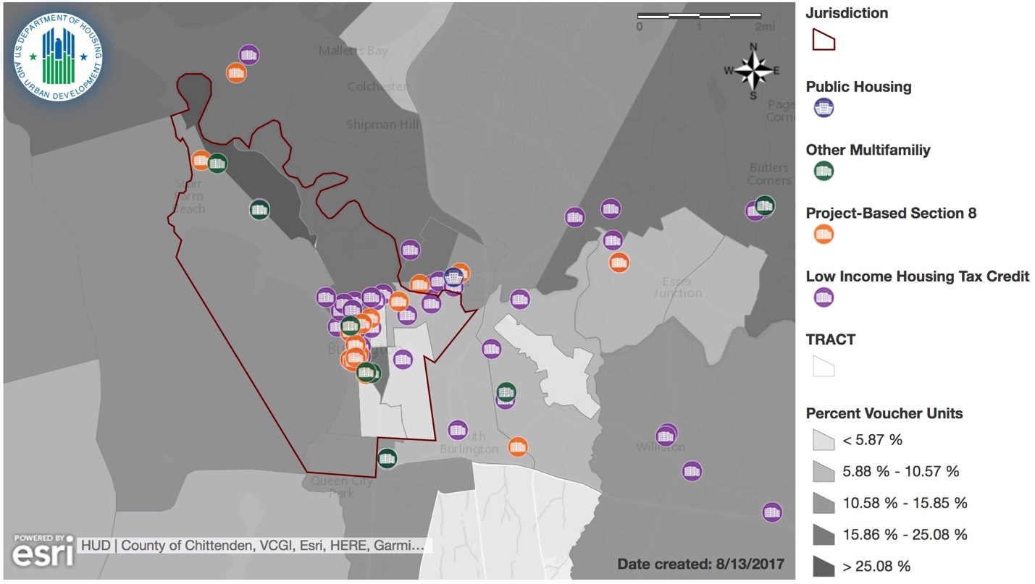
Describe patterns in the geographic location of publicly supported housing by program category (public housing, project-based Section 8, Other Multifamily Assisted developments, HCV, and LIHTC) in relation to previously discussed segregated areas and R/ECAPs in the jurisdiction and region.
According to Map 16, a concentration of publicly supported units is located in the urban core of Burlington and a concentration of voucher units is located in the northeast corner of the jurisdiction.

Describe patterns in the geographic location for publicly supported housing that primarily serves families with children, elderly persons, or persons with disabilities in relation to previously discussed segregated areas or R/ECAPs in the jurisdiction and region.
Multifamily units are more dispersed in the jurisdiction. Thirty-five percent of households with children utilize the HCV Program and 50% of those in the HCV program are in 2 or 3+ bedroom units.
The two BHA developments with units containing numerous bedrooms (4-5) are in located in Burlington’s New North End (Franklin Square) and Burlington’s Old North End (Riverside). Franklin Square has five 4-bedroom units and two 5-bedroom units; Riverside Apartments has five 4-bedroom units and one 5-bedroom unit. These thirteen units are primarily occupied by large minority refugee families. Because other developments do not have four and five bedrooms, these families are housed in these two developments with the unintended consequence of clustering of families. It should be noted, however, that both of these development are served by public transportation, have a number of amenities nearby, and have excellent schools.
How does the demographic composition of occupants of publicly supported housing in R/ECAPS compare to the demographic composition of occupants of publicly supported housing outside of R/ECAPs in the jurisdiction and region?
There are no R/ECAPS in the jurisdiction or the Region.
Do any developments of public housing, properties converted under the RAD, and LIHTC developments have a significantly different demographic composition, in terms of protected class, than other developments of the same category for the jurisdiction? Describe how these developments differ.

There are several developments in the Jurisdiction which have a significantly higher proportion of those in protected classes and are more likely to be in family households.

For example, in Bobbin Mill Apartments, there are 16% Black households and 20% Asian households. In Franklin Square, 34% of the households are Black and 23% Asian; therefore more than 50% of the residents are people of color. In fact, in Franklin Square, 34% of the households speak a language other than English at home, indicating a high number of refugee families in this development. A similar profile exists in the Riverside family development – 34% Black, 25% Asian and 70% speak a language other than English at home. Over all, nearly 24% of the residents of Burlington Housing Authority properties speak a language other than English at home as compared to only 3% of their voucher holders.

There is also a significant number of properties housing over 50% of the residents with disabilities; these properties include Decker Towers at 84%, 105 East Allen at 67% and Champlain at 84%. Details can be seen in the table below.
Half of BHA residents living in owned or managed properties have a disability compared to almost 60% of voucher holders.

BHA Property | No Disability | Disability
103 East Allen | 0 | 0
105 East Allen | 33% | 67%
693-711 Riverside Avenue | 43% | 57%
Bobbin Mill Apartments | 53% | 47%
Duggan Row House | 64% | 36%
Elderly - Champlain | 23% | 77%
Elderly - Decker | 16% | 84%
Family - Franklin | 79% | 21%
Family - Hillside | 84% | 16%
Family - Riverside | 77% | 23%
KSNRC/Maple St Apartments | 50% | 50%
Lake Champlain Apartments | 74% | 26%
Peterson Place Apartments | 73% | 27%
South Square Apartments | 63% | 37%
South St. Paul Apartments | 76% | 24%
Wharf Lane Apartments | 49% | 51%
TOTAL – BHA Properties | 50% | 50%
TOTAL - Section 8 Vouchers | 41% | 59%
GRAND TOTAL | 43% | 57%

Within the Region, the following developments stand out with a higher proportion of protected classes:
Elm and Franklin Street Apartments have 28% Black and 36% Asian populations.
Of the Voucher holders who can reside in both the Jurisdiction and the Region, over 60% have a disability. According to the HUD provided data in Table 22, 8.66% Blacks hold project based Section 8 vouchers in the Region as well as 8% Blacks in the Housing Choice Voucher program.
Provide additional relevant information, if any, about occupancy, by protected class, in other types of publicly supported housing for the jurisdiction and region.
The percentages of non-White persons living in Burlington Housing Authority owned and managed buildings (over 30%) as well as voucher holders (almost 15%) are much greater the population in Burlington and the Burlington/South Burlington MSA.
BHA Residents and Voucher Holders: Race by Percent
 | White | Black | Native American | Asian | Pacific Islander
BHA Residents | 68.97% | 15.18% | 1.69% | 12.31% | 2.53%
BHA Voucher Holders | 85.86% | 9.64% | 2.25% | 3.80% | 0.64%

Housing units with more than 3 bedrooms are limited in the City, and often large houses are rented to groups of college students who can pay significantly higher rent than large families.
The two Burlington Housing Authority developments with units containing numerous bedrooms (4-5) are in located in Burlington’s New North End (Franklin Square) and Burlington’s Old North End (Riverside). Franklin Square has five 4-bedroom units and two 5-bedroom units; Riverside Apartments has five 4-bedroom units and one 5-bedroom unit. These thirteen units are primarily occupied by large minority refugee families. Because other developments do not have four and five bedrooms, these families are housed in these two developments with the unintended consequence of clustering of families. It should be noted, however, that both of these development are served by public transportation, have a number of amenities nearby, and have excellent schools.
Of the 592 units available at BHA, 32 or 5.4% are accessible. This is significantly less than 50% of the population of those with disabilities.
Residents of Burlington Housing Authority (BHA) properties are more likely to speak a non-English and non-Spanish language (23.7%) as compared to voucher holders (3.37%). English is overwhelmingly spoken by voucher holders (96.52%).
Within our community survey, 57 respondents 57 Respondents indicated that they had used a Section 8 housing voucher in the last five years. Of that group, 89% said their neighborhood cleanliness was fair, good, or excellent. 68% said the condition or streets/sidewalks was fair, good, or excellent. 95% said access to public transit was fair, good, or excellent. 37% said availability of housing was poor. 26% said job availability in their neighborhood was poor. 70% said neighborhood safety was fair, good, or excellent. 91% said it was easy to access parks, playgrounds, or other green spaces. 65% said they were somewhat or very satisfied with their current housing. Of the 2% who claimed they had difficult unsing a housing choice voucher the most cited reason was not being able to find a one bedroom within the price range. Other reasons included finding a quality 3 bedroom unit difficult, landlords not wanting to rent to Section 8, past offenses and lack of references and quality apartments.

Compare the demographics of occupants of developments in the jurisdiction, for each category of publicly supported housing (public housing, project-based Section 8, Other Multifamily Assisted developments, properties converted under RAD, and LIHTC) to the demographic composition of the areas in which they are located. For the jurisdiction, describe whether developments that are primarily occupied by one race/ethnicity are located in areas occupied largely by the same race/ethnicity. Describe any differences for housing that primarily serves families with children, elderly persons, or persons with disabilities.
The percentages of non-White persons living in BHA owned and managed buildings (over 30%) as well as voucher holders (almost 15%) are much greater the population in Burlington.
BHA Residents and Voucher Holders: Race by Percent
 | White | Black | Native American | Asian | Pacific Islander
BHA Residents | 68.97% | 15.18% | 1.69% | 12.31% | 2.53%
BHA Voucher Holders | 85.86% | 9.64% | 2.25% | 3.80% | 0.64%

BHA residents and voucher holders are more likely to be female; this is especially true for voucher holders (68% female versus 43% male). For BHA residents, 55% are female and 45% are male. Compare this to the Burlington demographics at 51% female and 49% male demonstrating that female heads of households have a higher rate of poverty than male heads of households.
BHA Residents and Voucher Holders: Gender by Percent
 | Female | Male
BHA Properties | 55% | 45%
Section 8 Vouchers | 68% | 43%
GRAND TOTAL | 65% | 35%

BHA Residents and Voucher Holders: Gender by Number
 | Female | Male
TOTAL – BHA Properties | 326 | 267
TOTAL - Section 8 Vouchers | 1265 | 601
GRAND TOTAL | 1591 | 868

When considering the number of families with children, data shows that BHA is serving a significant number of female-headed households with children – the most vulnerable families in our society.
As one would expect, those living in senior developments do not have children; those living in family developments have children. For vouchers, BHA has a number of specialized vouchers for single people (over age 62 with a disability) thereby further reducing the number of families with children. Our PHA serves 36% of both BHA properties and Section 8 vouchers of families with children compared to the Jurisdiction 46% family population.
BHA Residents and Voucher Holders: Number of Children in Family
 | Number of Children in Family*
 | 0 | 1 | 2 | 3 | 4 | 5 | 6 | 7 | 9
TOTAL – BHA Properties | 414 | 79 | 49 | 25 | 11 | 5 | 7 | 3
TOTAL - Section 8 Vouchers | 1136 | 338 | 217 | 111 | 38 | 17 | 7 | 2 | 1
GRAND TOTAL | 1550 | 417 | 266 | 136 | 49 | 22 | 14 | 5 | 1
*Note: There are no families with 8 children.

Residents of BHA properties are more likely to speak a non-English and non-Spanish language (23.7%) as compared to voucher holders (3.37%). English is overwhelmingly spoken by voucher holders (96.52%). According to the demographics of the Jurisidiction, approximately 5.5 % of the population has limited English Proficiency, a significantly smaller amount than that of the BHA population,
According to data collected from BHA housing applicants, 207 people were identified as possibly having limited English proficiency based on self-reported ability to speak English. The identified households were contacted by mail and in-person by a representative of BHA to determine LEP status. Of the 207 households surveyed, 42 reported speaking English, 143 reported not speaking English, and 22 did not respond to the survey or declined to participate in the interview. Overall, 25 languages other than English were identified as spoken in LEP households.
Of the 143 households that reported having an LEP status, the largest language group was Nepali, spoken by 29 households, reflecting the influx of refugee populations being resettled in Vermont, predominately in Chittenden County. This number represents just 1% of the population that is currently being served by BHA. It should be noted that the 22 households that did not participate in the survey were from 7 different countries with differing primary languages, and are not considered to have had a statistically significant impact on the results by remaining unknown. (Source: BHA Language Access Plan (LAP) for Limited English Proficiency (LEP), August 8, 2014).
The majority of persons served with vouchers are served in the City of Burlington, at 49% and the remainder of those are served in the surrounding communities.
BHA Voucher Holders: Municipality of Residence
Municipality | Number of Voucher Holders | Percent Voucher Holders by Municipality
Burlington | 789 | 42%
Burlington - New North End | 124 | 7%
S. Burlington | 227 | 12%
Winooski | 246 | 13%
Colchester | 183 | 10%
Essex | 171 | 9%
Richmond | 1 | 0%
Shelburne | 40 | 2%
Williston | 68 | 4%
Out of State | 18 | 1%
TOTAL | 1867 | 100%

Table 25: Demographics of Publicly Supported Housing by Program Category in Burlington, VT. Source: APSH.
Table 25: Publicly Supported Housing by Program Category: Units by Number of Bedrooms and Number of Children
 | Burlington, VT Jurisdiction
 | Households in 0-1 Bedroom  Units |  | Households in 2 Bedroom  Units |  | Households in 3+ Bedroom  Units |  | Households with Children
Housing Type | # | % | # | % | # | % | # | %
Public Housing | 0 | 0.00% | 0 | 0.00% | 0 | 0.00% | N/a | N/a
Project-Based Section 8 | 347 | 58.03% | 175 | 29.26% | 62 | 10.37% | 151 | 25.25%
Other Multifamily | 43 | 72.88% | 0 | 0.00% | 0 | 0.00% | 0 | 0.00%
HCV Program | 691 | 48.66% | 430 | 30.28% | 281 | 19.79% | 492 | 34.65%

Burlington/South Burlington Region
- 77% of WHA clients are white only, compared to 94% in the region.
- 9% of WHA clients are Black/African American only compared to 3% in the region.
- 12% of WHA clients are Asian Only, compared to 2% in the region.
- 2% of WHA’s clients are Hispanic or Latin, compared to 1% in the region.

Disparities in Access to Opportunity
Describe any disparities in access to opportunity for residents of publicly supported housing in the jurisdiction and region, including within different program categories (public housing, project-based Section 8, Other Multifamily Assisted Developments, HCV, and LIHTC) and between types (housing primarily serving families with children, elderly persons, and persons with disabilities) of publicly supported housing.

Burlington

Residents in Burlington have access to sufficient public transportation except if working on second or third shifts. With the school choice program, there is access to proficient schools. Although there is a low unemployment rate in Burlington, often low wage jobs are those that are available thereby limiting economic opportunities. Additionally, Burlington is home to many nonprofits and this service enriched environment makes it attractive to live in BHA managed properties or use vouchers within the Jurisdiction.

Burlington/South Burlington

For residents of publicly supported housing in the region, once out of the urban core of Burlington/South Burlington/Winooski, access to employment and public transportation becomes limited. Although employment opportunities are widespread in manufacturing in the Region, shift work might preclude public transportation.
The program participant may also describe other information relevant to its assessment of publicly supported housing. Information may include relevant programs, actions, or activities, such as tenant self-sufficiency, place-based investments, or geographic mobility programs.
The Burlington Housing Authority has adopted a comprehensive Communications Policy to ensure that its communication with applicants, program participants, employees, and members of the public with disabilities is productive and effective.

BHA will furnish appropriate auxiliary aids and services, where necessary, to afford individuals with disabilities, including individuals with hearing or visual disabilities or individuals with limited English proficiency, an equal opportunity to participate in and enjoy the benefits of the programs and services of the BHA.

Examples of auxiliary aids and services include: staff assistance with the completion of applications; telecommunication services or qualified sign language interpreters for persons with hearing impairments; large print, brailled, orally delivered or taped materials for persons with visual impairments; and interpreters or written materials in the appropriate language for persons with limited English proficiency.

Admissions policies, preferences, and housing designations (including grounds for denial of admission, eviction, and subsidy termination)
According to BHA’s Administrative Plan for the Section 8 Housing Choice Voucher Program, admissions may not be based on [Section 982.202(B)]:
- Where the family lives prior to admission to the program;
- Where the family will live with assistance under the program;
- Discrimination because members of the family are unwed parents, recipients of public assistance, or children born out of wedlock;
- Discrimination because a family includes children; or
- Whether a family decides to participate in a family self-sufficiency program.

No applicant for the Housing Choice Voucher Program who has been a victim of domestic violence, dating violence, or stalking shall be denied admission into the program if they are otherwise qualified.

Affirmative marketing plan
BHA’s jurisdiction does not include any R/ECAPs or areas with an undue concentration of poverty. However, BHA works closely with Section 8 Housing Choice Voucher holders to ensure that they have access to housing throughout the jurisdiction, including areas of Burlington and surrounding communities which are of higher income. In particular, BHA has worked closely with the following organizations who own housing in middle and high-income neighborhoods for notification of vacant apartments and referral of voucher holders: Champlain Housing Trust, South Meadow Apartments, Northgate Apartments, and Winchester Place Apartments.
BHA also collaborates with the Champlain Valley Office of Economic Opportunity (CVOEO), a recipient of HUD Fair Housing Program Funds, which conducts a Fair Housing Education and Outreach Initiative. The program educates Section 8 program participants about fair housing law and landlords about their legal obligations. BHA is engaged in ongoing discussions with the Vermont Human Rights Commission regarding fair housing education for Section 8 program participants.
The Burlington Housing Authority has developed a Language Access Plan (LAP) for people with Limited English Proficiency (LEP). The LAP has five main components to aid in identifying LEP persons; this allows those in need of services to be provided meaningful access to BHA programs. For the purposes of this plan, individuals who self-identify as not being able to speak English proficiently, (“less than well”) are considered LEP. The five components are as follows: 1. Identifying LEP persons who need language assistance; 2. Identifying ways in which language assistance could be provided; 3. Training staff; 4. Providing notice to LEP persons (free phone interpretation services, translate BHA postings into the five most commonly spoken languages, outreach efforts); 5. Continued monitoring and updating of the LEP policy.
Meaningful access for person with limited English proficiency (language assistance plans, interpretation assistance, and translation of vital documents)
Generally, BHA is most likely to have direct contact with LEP individuals at the administrative office. For individuals residing in housing managed directly by BHA, there is also a significant likelihood that property managers and maintenance staff will come into contact with LEP individuals while on-site at the properties they oversee and maintain. We therefore focus on training on the administrative office staff, property managers, and maintenance staff.
Many of LEP individuals have contact with BHA once a month to pay their rent at the administrative office. The vast majority reported only needing to contact BHA a few times per year when maintenance issues arose or household information needed to be updated. BHA also handles phone calls as well as face-to-face interactions at the administrative offices on a regular basis. The overwhelming majority of interactions with LEP individuals occur in-person.
BHA provides phone interpretation to all service recipients that request or demonstrate a need for language assistance. Additionally, websites can be utilized to translate some basic written materials. Friends and family members of LEP individuals, as well as local volunteers, often provide interpretation services at meetings and for conversations. The family and/or community members that often accompany LEP individuals do so voluntarily. Therefore, limited LEP measures are reasonable given the resources available to BHA.

Voucher mobility and portability policies and practices

The Burlington Housing Authority has completed conversion of all traditional public housing to RAD. This conversion allows for greater portability of vouchers because those in RAD units can utilize their Section 8 voucher for any approved unit; they can thereby bypass the Section 8 waiting list and have a broad choice in where they find their next home.
In addition, the Burlington Housing Authority has an informal working arrangement with all Vermont Public Housing Authorities for an area-wide rental voucher and certificate exchange program. This allows Public Housing Authorities to absorb Section 8 families moving from one jurisdiction to another. Since 1997, the Vermont State Housing Authority absorbed 63 Certificate/Voucher participants from PHA, and three other PHAs each absorbed one from PHA. In turn, PHA absorbed five families from four other PHAs.
Additionally, the City of Burlington allows both the Winooski Housing Authority and the Vermont State Housing Authority to operate their Section 8 programs within the City of Burlington, thereby increasing rental assistance opportunities for families.

Contributing Factors of Publicly Supported Housing
Consider the listed factors and any other factors affecting the jurisdiction and region. Identify factors that significantly create, contribute to, perpetuate, or increase the severity of fair housing issues related to publicly supported housing, including Segregation, R/ECAPs, Disparities in Access to Opportunity, and Disproportionate Housing Needs. For each contributing factor that is significant, note which fair housing issue(s) the selected contributing factor relates to.
Admissions and occupancy policies and procedures, including preferences in publicly supported housing

Both of the participating housing authorities offer broad admissions preferences and waitlist policies. Reasonable accommodations are reviewed and processed. Housing retention teams work with tenants to remain safely housed. However, a number of respondents during interview and in the survey spoke of long waitlists, lack of vouchers and questionable admission policies. There may be communication issues or a lack of information that this report and further outreach can help to address, particularly when the issues raised do not match the data on voucher availability or the underlying problems.

Community opposition
Recent inquiry into eviction prevention practices of public housing providers, following a serious altercation between the police department and a resident with mental health challenges, resulted in the formation of an Eviction Prevention Committee. This sub-committee of City Council brought together service and housing providers and community public safety officials to identify and evaluate current housing retention services available and discuss current eviction practices. While housing some of the community's most vulnerable residents, clear challenges arise in housing retention, tenant behavior and community response.

Impediments to mobility
Impediments to mobility refers to barriers faced by individuals and families when attempting to move to a neighborhood or are of their choice. With the conversion of public housing units to RAD properties, residents now have the option of moving with their housing voucher to other properties or even perhaps moving out of the Burlington area. However, there appears to be a lack of units priced either in Burlington or the Region at Fair Market Rent level. Private landlords, to increase their returns on investment have opted to price units at market rate levels and due to perpetually low vacancy rates, are able to find renters in college students and higher wage earners

Disability and Access Analysis

Population Profile
How are persons with disabilities geographically dispersed or concentrated in the jurisdiction and region, including R/ECAPs and other segregated areas identified in previous sections?

Burlington
Table 26 shows six types of recorded disabilities, with cognitive difficulty being the most prevalent disability in the Burlington jurisdiction, at 5.97% of the disabled population. Ambulatory difficulty is the second most prevalent disability in the jurisdiction at 5.41%, followed by independent living disability at 4.2%. The proportion of the disabled population experiencing hearing difficulty is 3.09%, self-care difficulty 1.67%, and vision difficulty is the lowest level of recorded disability in Burlington at 1.66%.

Maps 17 and 18 show the distribution of these 6 disability types. Disabled populations appear to be fairly evenly distributed throughout the Burlington area.

Table 26: Disability by Type in Burlington, VT and Burlington-South Burlington Region. Source: ACS.
Table 26: Disability by Type
 | Burlington, VT Jurisdiction |  | Burlington-South Burlington, VT Region
Disability Type | # | % | # | %
Hearing difficulty | 1,251 | 3.09% | 7,161 | 3.58%
Vision difficulty | 670 | 1.66% | 3,183 | 1.59%
Cognitive difficulty | 2,414 | 5.97% | 9,636 | 4.82%
Ambulatory difficulty | 2,189 | 5.41% | 10,599 | 5.30%
Self-care difficulty | 674 | 1.67% | 3,882 | 1.94%
Independent living difficulty | 1,700 | 4.20% | 7,794 | 3.90%

Burlington-South Burlington Region
At the regional level, ambulatory difficulty is the most prevalent recorded disability at 5.3% of the disabled population. Cognitive difficulty is the second most prevalent at 4.82%, followed by independent living difficulty at 3.9%, hearing difficulty at 3.58%, self-care difficulty at 1.94%, and vision difficulty is the least prevalent disability in the region at 1.59%.

Disabled populations appear to cluster around more developed areas, such as Burlington, most likely due to the amenities for disabled people provided in developed areas.

Map 17: Dot density map showing distribution of people with hearing, vision, and cognitive disabilities in the Burlington, VT area.
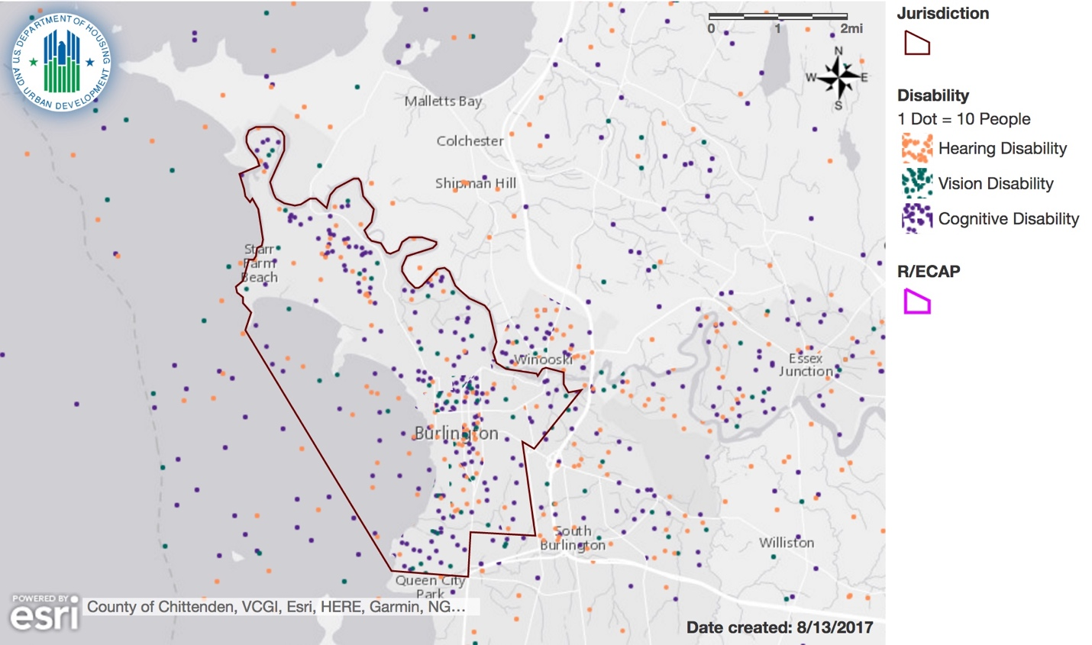

Map 18: Dot density map showing distribution of people with ambulatory, self-care, and independent living disabilities in Burlington, VT area.
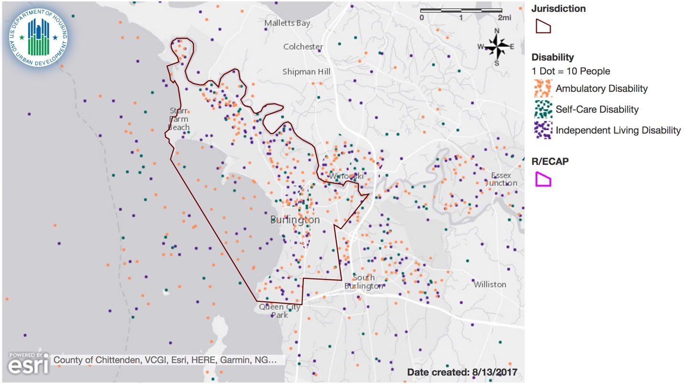

Describe whether these geographic patterns vary for persons with each type of disability or for persons with disabilities in different age ranges for the jurisdiction and region.
There does not appear to be any major geographic patterns for individual disability types. This is true for both the Burlington, VT jurisdiction as well as for the greater region. The region has slightly higher percentage of the disabled population falling into the 5-17 and 65+ age groups when compared to the jurisdiction, and slightly lower percentage falling into the 18-164 age group (see table 27). However, the difference in percentage points is less than 1% across all of the age groups, and therefore do not represent drastic differences between the Burlington jurisdiction and the greater region.
Table 27: Disability by Age Group in Burlington, VT and Burlington-South Burlington Region. Source: ACS.
Table 27: Disability by Age Group
 | Burlington, VT Jurisdiction |  | Burlington-South Burlington, VT Region
Age of People with Disabilities | # | % | # | %
age 5-17 with Disabilities | 317 | 0.78% | 1,801 | 0.90%
age 18-64 with Disabilities | 2,888 | 7.14% | 12,766 | 6.39%
age 65+ with Disabilities | 1,501 | 3.71% | 8,430 | 4.22%

Housing Accessibility
Describe whether the jurisdiction and region have sufficient affordable, accessible housing in a range of unit sizes.

Burlington
Project-based section 8 housing in Burlington has 131 people with a disability, or roughly 21.91% of their population. Other multifamily units has 23 people, or 38.98% of their population. The HCV program has 35.42 of the population with some type of disability, or roughly 503 people (Table 28).
Based on waiting lists and usage, BHA assesses there are sufficient units to accommodate those with disabilities. However, based on survey comments, population and interviews, there is a perceived larger and unfilled need.

Burlington/South Burlington Region

According to the HUD provided data, over 21,000 individuals with disabilities reside in the Burlington-South Burlington Region. With 1248 individuals with disabilities utilizing programs in the region, representing 6% of the disabled population. It does not appear there is sufficient resources in the Region.

Table 28: Disability by Publicly Supported Housing Program Category in Burlington, VT and Burlington-South Burlington Region. Source: ACS.
Table 28: Disability by Publicly Supported Housing Program Category
Burlington, VT Jurisdiction | People with a Disability
 | # | %
Public Housing | N/a | N/a
Project-Based Section 8 | 131 | 21.91%
Other Multifamily | 23 | 38.98%
HCV Program | 503 | 35.42%
Burlington-South Burlington, VT Region
Public Housing | N/a | N/a
Project-Based Section 8 | 131 | 21.91%
Other Multifamily | 23 | 38.98%
HCV Program | 1,094 | 31.31%

Describe the areas where affordable accessible housing units are located in the jurisdiction and region. Do they align with R/ECAPs or other areas that are segregated?
As we mentioned previously, and as we saw in Map 16 publicly supported housing units are concentrated in the urban core of Burlington and a concentration of voucher units located in the northeast corner of the jurisdiction. Although we there are no R/ECAPs in the Burlington region, and segregation is low overall, we have identified tracts 4 and 5 as being areas with signs of increased segregation relative to other areas. It does appear that a large number of affordable public housing options are located in and around census tracts 4 and 5.
To what extent are persons with different disabilities able to access and live in the different categories of publicly supported housing in the jurisdiction and region?
As we can see by the sheer number of persons with disability accessing public housing options, they have a good extent of access to these options within the Burlington jurisdiction. However, the number of ADA accessible units within publicly supported housing is low compared to the overall population of those who identify as disabled within the PHA units.

Integration of Persons with Disabilities Living in Institutions or Other Segregated Settings
To what extent do persons with disabilities in or from the jurisdiction or region reside in segregated or integrated settings?
Overall, persons with disabilities are relatively equally dispersed throughout the Burlington jurisdiction and region as a whole.
Describe the range of options for persons with disabilities to access affordable housing and supportive services in the jurisdiction and region.
Burlington
Within the City of Burlington, there are a range of options for persons with disabilities to access affordable housing. For all new affordable housing developments built by our nonprofit providers, there are the required number of ADA compliant units available for those with physical disabilities. Within publicly supported housing, as noted by the demographics in Table 28, 22% access project-based Section 8 vouchers, 39% access other multifamily programs and 35% access Housing Choice Vouchers. Three properties in Burlington are available for seniors and persons with disabilities at Champlain Apartments, Decker Towers and South Square Apartments. Supportive services are accessible through a number of agencies depending on the presenting disability including Champlain Community Services, Howard Center, Vermont Department of Disabilities, Aging and Independent Living.

Burlington/South Burlington Region

Within the Region, there are also a range of options for persons with disabilities to access affordable housing. Our nonprofit developers, both constructing within the Region and managing properties within the Region, rent ADA compliant units as well as units to those with Section 8 Vouchers and Shelter plus Care vouchers. The Winooski Housing Authority manages three properties in Winooski that offers housing to senior or disabled families. The Vermont State Housing Authority manages three properties in Franklin County that offers housing to seniors or disabled in families and one property in Chittenden County.
Supportive services are accessible through a number of agencies depending on the presenting disability including Northwestern Counseling and Support Services, Champlain Community Services, Vermont Association for the Blind and Visually Impaired and Vermont Department of Disabilities, Aging and Independent Living.

Disparities in Access to Opportunity
To what extent are persons with disabilities able to access the following in the jurisdiction and

Government services
The City of Burlington has an ADA policy and has issued a resolution that all City services, programs and facilities and employment opportunities are accessible to persons with disabilities. Services include but are not limited to language access, hearing impairment and/or accessible written materials.
During a recent review of the City’s ADA Title I and II compliance, it was recommended and implemented two ADA Coordinators; one employee of the Human Resources Department serves as the City’s ADA Coordinator for Title I (Employment Issues) and another City employee is appointed to serve as the ADA Coordinator for Title II (program, services and activities accessibility.
The City is also committed to providing proper access to services, facilities, and employment opportunities. For accessibility information or alternative formats, the Human Resources Department is available to assist.
Government facilities
The City of Burlington follows the 2010 ADA Standards and the Americans with Disabilities Act Accessibility Guidelines. In 1996, the Vermont legislature passed Act 187 that was intended to eliminate portions of Vermont law that did not meet or exceed the requirements of ADA. Portions of Vermont law that already exceeded ADA were retained. Access to all government buildings is available to persons with disabilities. Parking facilities for government facilities contain the number of spaces required.
The City has also invested Community Development Block Grant funds over the past 5 years in accessibility projects for public facilities. These projects included an elevator for a Level 3 Nursing Home facility, accessible doors for a Senior Center; accessibility features for our FoodShelf and our federally qualified health clinic.
Public infrastructure, such as sidewalks, pedestrian crossings, pedestrian signals
In 2014, the City conducted an assessment of all 127 miles of sidewalk. The assessment included an inventory and map of the City’s sidewalk network and pedestrian signal infrastructure; identification of areas that are not ADA-compliant and development of an ADA transition plan; and a method to prioritize projects and annual capital funding plan. The detailed plan outlines repairs and improvements to curb ramps, sidewalks (with connections to elementary schools, transit stops, neighborhood activity centers, parks, downtown, senior centers, medical or social services all scoring has a high priority) and increasing pedestrian push buttons.
The City’s Park, Recreation and Waterfront Department is in the process of designing Vermont’s first universally accessible playground at Oakledge Park. This accessible playground will continue to enhance and expand opportunities for children with disabilities. The Community Sailing Center also offers programs for children with disabilities to participate and learn about sailing on Lake Champlain.

Transportation
Green Mountain Transit is equipped for those with disabilities. This is most effective within the urban core of Chittenden County as bus service in the rural areas of the Region becomes less frequent. Also SSTA is more available for disabled residents in Burlington and South Burlington. With over 50 vehicles in their fleet, over 30 are lift-equipped for wheelchairs. SSTA provides an average of 600-700 rides per day and coordinates transportation service to many area human service agencies. Specific taxi cab companies offer wheelchair accessible taxi service as well.

Proficient schools and educational programs
The City of Burlington is in compliance with Federal law, including Section 504 of the 1973 Rehabilitation Act and the provisions of Title IX of the Education Amendments of 1972. In addition, the State of Vermont has three Acts in support of students all students including Act 157 that schools develop a comprehensive educational support system (ESS) with the capacity to provide a range of social, academic and behavioral supports and Act 264 which allows for the creation of an advisory board and State and Local Interagency Teams to assist in the provision of care for children and adolescents with severe emotional disturbances.
In Burlington Schools, there are 729 students or 18.8% with an Individual Education Program (IEP). 69% of all students on IEPs required some type of behavioral interventions based on disability category. 24% of total Burlington students are identified as having a disability and on a plan (IEP or 504 Plan). Additionally, there are 81 students with IEPs who are served in the Early Education Program.
The Burlington School District is committed to providing excellent and equitable education for all students. The District believes that each student deserves the opportunity to learn from a comprehensive curriculum with a diverse population of peers socioeconomically similar to that of the District as a whole. In the Burlington district, there are both neighborhood and magnet school options; magnet schools offer a specialized curriculum designed to attract applicants from through out the City.

Jobs
Vermont Association of Business, Industry and Rehabilitation, (VABIR), is a statewide private non-profit agency working to assist Vermonters, who face barriers to employment, in finding gainful employment. Established in 1979, this organization provides a link between job-seekers including persons with disabilities and employers. They also provide education and awareness working with individuals who have disabilities; arrange free accessibility surveys for businesses and consumers; job assessment for accommodations which will assist employees in performing their job; help employers strategize ways to retain employees who become disabled while in their employ; and consult with an employer on job descriptions, interview techniques, and other employment areas in which disability issues arise.
The City of Burlington is an Equal Opportunity Employer and also supports the accommodation provisions of the American Disabilities Act which protects persons with a disability who apply for a position. The City understands that reasonable accommodations may be necessary to enable those with disabilities to perform their jobs. Candidates or employees requesting accommodations should contact Human Resources at 802-865- 7145.
Describe the processes that exist in the jurisdiction and region for persons with disabilities to request and obtain reasonable accommodations and accessibility modifications to address the barriers discussed above.
A number of processes exist and are described specifically under the public housing sections.
The Department of Planning and Zoning provides a Design Review Guide for removing barriers to access for businesses and housing. All public meetings are advertised to include the City’s commitment to providing proper access to services, facilities, and employment opportunities. For accessibility information or alternative formats, persons are requested to contact Human Resources Department at 802-865-7145.
For transportation needs, persons can call specific taxi companies to request special accommodations, make a scheduled pick up with SSTA or ride one of the public Green Mountain Transit buses.
The City’s ADA Coordinator may receive complaints or grievances regarding access.
The City also recognizes the importance of making the website accessible and arrangements can be made to meet specific needs as requested.
Describe any difficulties in achieving homeownership experienced by persons with disabilities and by persons with different types of disabilities in the jurisdiction and region.
For both the Jurisdiction and the Region, we consulted a statewide agency who works with persons with disabilities, the Vermont Center for Independent Living. . The primary difficulty faced by those with disabilities in achieving homeownership is financial; many receive Social Security or Social Security Disability Income and because housing costs in the jurisdiction and the region are so high, disabled clients do not believe they have enough to purchase a home. In fact, since rents are so high, paying for a mortgage seems out of the question to them.
Another difficulty in achieving homeownership concerns accessibility issues. Most existing houses are not accessible for those peers with physical disabilities. In addition to the purchase cost, a disabled person would face the cost of making modifications to the house. Examples of common modifications include building a ramp, modifying the bathroom, or kitchen. Modifications are not only expensive but time-consuming and could cause the person’s housing situation to be in limbo for an extended period of time.
Lastly, some persons with disabilities express concern about their inability to properly maintain the outside of their property and trying to find dependable live-in caregivers.
These are the most common difficulties for persons with disabilities to achieving homeownership in the Jurisdiction and the Region.

Disproportionate Housing Needs
Describe any disproportionate housing needs experienced by persons with disabilities and by persons with certain types of disabilities in the jurisdiction and region.
Persons with disabilities face cost burden issues along with other protected classes. According to the American Community Survey 2011-2015, of the population 20-64 years who fall below the poverty level, 16% have a disability. Those below poverty level are more likely to be cost burdened – paying more than 30 or 50% of their income to housing. Housing costs in the City are already higher for most households; those with limited income on disability or minimally employed face higher cost burdens
Recognizing the importance of promoting self-sufficiency and independent living opportunities, the City recognizes the need to make homes accessible or accommodating based on disability. Based upon the information provided in Table 26, providing accessibility modifications would represent the highest housing need. The City of Burlington administers an Accessibility Modification Program with CDBG funds, often in partnership with the Vermont Center for Independent Living, to address these issues. Supportive services, homesharing and congregate meal sites/senior programs can and do assist those with independent living difficulties.
Under the Publicly Supported Housing section, accommodations for those with disabilities is discussed in detail.

Additional Information
Beyond the HUD-provided data, provide additional relevant information, if any, about disability and access issues in the jurisdiction and region affecting groups with other protected characteristics.
During an interview with participants on the Mayor’s Committee on Accessibility, participants were adamant about making changes to the City’s marketplaces and storefronts to make them more accessible to individuals with disabilities. In addition, members discussed experiences and challenges regarding integration/segregation of disabled populations, as well as the over-institutionalization and medicalization of living arrangements and transportation for those with disabilities, both mental and physical.

A concern from a major housing agency in the area is that private landlords are not willing to make accommodations for persons with disabilities. Vermont Center for Independent Living expressed concerns regarding transportation for those with disabilities. Although the public transportation system, Green Mountain Transit is equipped for those with disabilities, it was suggested GMT could do a better job encouraging usage. This is only effective within the urban core of Chittenden County as bus service in the rural areas of the Region becomes less frequent. Also SSTA is more available for disabled residents in Burlington and South Burlington. With over 50 vehicles in their fleet, over 30 are lift-equipped for wheelchairs. SSTA provides an average of 600-700 rides per day and coordinates transportation service to many area human service agencies.

The program participant may also describe other information relevant to its assessment of disability and access issues.
Almost 19% of the respondents to our Housing and Neighborhood Survey identified themselves or someone in their household as having a disability. This percentage is significantly larger than the 11% disabled population in the City of Burlington. In addition, 32 of our respondents noted finding units that accommodated a disability limited the housing options to consider.
Regarding the conditions of streets and sidewalks, 56% of the respondents said the conditions were good or fair; however 21% responded the conditions were poor.
During our community outreach, we spoke in depth to members of the disabled community who identified issues of segregation for the disabled and the close proximity and institutionalize nature of some housing developments. The comment shared, ‘Due to the concentrated nature of the living situations, autonomy has been degraded.”

Contributing Factors to Disability and Access Issues
Consider the listed factors and any other factors affecting the jurisdiction and region. Identify factors that significantly create, contribute to, perpetuate, or increase the severity of disability and access issues and the fair housing issues, which are Segregation, RECAPs, Disparities in Access to Opportunity, and Disproportionate Housing Needs. For each contributing factor, note which fair housing issue(s) the selected contributing factor relates to.

- Inaccessible public or private infrastructure – Accessibility issues may be related to sidewalks, pedestrian crossings, lack of ramps or lack of audible pedestrian signals.

- Lack of affordable, accessible housing in range of unit sizes – Accessible housing includes housing that allows individuals with disabilities equal opportunity to be housed in an affordable and safe dwelling. Affordable is defined as not spending more than 30% of the individual’s income on housing costs.

- Lack of assistance for housing accessibility modifications – Modifications refer to structural changes made to existing premises, occupied or to be occupied by a person with a disability. Housing accessibility modifications can include structural changes to interiors and exteriors of dwellings and to common and public use areas. Under the Fair Housing Act, landlords are required by fair housing laws to permit certain reasonable modifications to a housing unit, but are not required to pay for the modification unless the housing provider is a recipient of Federal financial assistance and therefore subject to Section 504 of the Rehabilitation Act or is covered by the Americans with Disabilities Act (in such cases the recipient must pay for the structural modification as a reasonable accommodation for an individual with disabilities). However, the cost of these modifications can be prohibitively expensive.
- Lack of affordable, integrated housing for individuals who need supportive services – Not only did our survey and interview participants mention the lack of affordable housing but also a perception of a high proportion of those with disabilities in the managed multi-family properties.

Fair Housing Enforcement, Outreach Capacity, and Resources

Fair Housing Enforcement, Outreach Capacity and Resource Analysis
List and summarize any of the following that have not been resolved:
- A charge or letter of finding from HUD concerning a violation of a civil rights-related law;
- A cause determination from a substantially equivalent state or local fair housing agency concerning a violation of a state or local fair housing law;
- Any voluntary compliance agreements, conciliation agreements, or settlement agreements entered into with HUD or the Department of Justice;
- A letter of findings issued by or lawsuit filed or joined by the Department of Justice alleging a pattern or practice or systemic violation of a fair housing or civil rights law;
- A claim under the False Claims Act related to fair housing, nondiscrimination, or civil rights generally, including an alleged failure to affirmatively further fair housing; or
- A pending administrative complaints or lawsuits against the locality alleging fair housing violations or discrimination.

According to the Vermont Human Rights Commission, as the State Fair Housing Assistance Program, there are been no cause cases from any of the counties of the Region in the last two years. There have been no voluntary compliance agreements, conciliation agreements, or settlement agreements entered into with HUD or the Department of Justice; nor or letter of findings issued by or lawsuit filed or joined by the Department of Justice alleging a pattern or practice or systemic violation of a fair housing or civil rights law. There has been no letter of findings issued by or lawsuit filed or joined by the Department of Justice alleging a pattern or practice or systemic violation of a fair housing or civil rights law. The Commission has no jurisdiction to bring claims other than under the VT Fair Housing and Public Accommodations Act. The Commission will not comment or even acknowledge whether there are pending cases as they are confidential unless or until there is a reasonable grounds finding by the commission.

Our community survey asked respondents if they thought they were treated differently when they were looking for housing. Thirteen percent said yes and the number one reason was race and then age. Other reasons included familial status, Section 8 usage and gender.

Describe any state or local fair housing laws. What characteristics are protected under each law?
Vermont’s Fair Housing and Public Accommodations Act (FHPA), 9 V.S.A. §4500 et seq., prohibits discrimination on every bases barred by the federal Fair Housing Act plus these additional bases:
- Age
- Marital status
- Sexual orientation
- Gender Identity
- Receipt of public assistance

The FHPA also bars land use decisions based on the income of the people who will occupy housing.

Burlington’s Housing Discrimination ordinance, Chapter 18, Article IV, 18-200 et seq., bars discrimination in housing against a person because of that person’s:
- Handicap;
- Reliance upon aids such as attendants, dog guides or other specially trained animals, wheelchairs, or similar appliances or devices;
- Intent to occupy a rental unit with one or more minor children;
- Receipt of public assistance;
- sexual preference;
- age; or
- gender.

Identify any local and regional agencies and organizations that provide fair housing information, outreach, and enforcement, including their capacity and the resources available to them.
a. The Vermont Human Rights Commission (HRC) is a state commission of five commissioners appointed by the governor. The HRC has an executive director, three law examiners, and an executive staff assistant. The HRC receives a FHAP grant from HUD and investigates charges of housing discrimination referred to it by HUD or filed directly by the complainant at the HRC. http://hrc.vermont.gov/about-us

b. Vermont Legal Aid (VLA) is a nonprofit, statewide, civil legal services program that provides legal advice and representation in civil matters. VLA receives a FHIP (Fair Housing Initiatives Program) grant from HUD which funds the Housing Discrimination Law Project. The HDLP is staffed by a director attorney, a testing coordinator, and a staff attorney as well as shared clerical, web, and management support. The HDLP gives fair housing complainants legal advice, drafts pro se documents, and represents plaintiffs in federal and state court and before HUD and the HRC. The testing coordinator conducts both complaint-based and audit/systemic fair housing testing. The HDLP also advocate with state and local officials for inclusionary zoning and affordable housing in high opportunity areas. The HDLP writes legal information and forms about housing discrimination content to the www.vtlawhelp.org website and provides housing discrimination training to VLA and Law Line advocates. https://vtlawhelp.org/discriminationfair-housing

c. Legal Services Law Line of Vermont (Law Line), is a nonprofit, statewide, civil legal services program. Law Line provides quick advice and ongoing pro se advice and document writing for people representing themselves in court or in various administrative fora including at the HRC. Law Line also coordinates landlord-tenant legal clinics in three courts. They manage www.vtlawhelp.org together with VLA.

d. The Fair Housing Project of the Champlain Valley Office of Economic Opportunity (FHP) is an education and outreach oriented program that focuses primarily on systemic policy and practices which tend to limit fair housing choice by people in federal and state protected classes. The FHP works with state agencies, municipal agencies and boards, such as local and regional planning commissions and other nonprofit organizations to promote policy changes such as zoning by-law adjustments which tend to “Affirmatively Further Fair Housing.” Increasing community inclusiveness, housing affordability, and enhanced fair housing opportunity throughout the state is the primary goal of the FHP.

The FHP is currently funded almost exclusively by a HUD Education and Outreach (EOI) grant. The FHP is working with organizational partners on a statewide campaign called, “Building a Vibrant Inclusive Vermont.” This campaign is committed to public education and outreach that changes “hearts and minds” as well as public policies. In this current project the FHP’s core partners include: City of Burlington Community & Economic Development Office (CEDO); Champlain Housing Trust (CHT)
Chittenden County Regional Planning Commission (CCRPC); Lamoille Regional Planning Commission (LRPC); Two Rivers-Ottauquechee Regional Commission (TRORC).

Additional Information
Provide relevant information, if any, about fair housing enforcement, outreach capacity, and resources in the jurisdiction and region.
VLA regularly conducts outreach and updates its website, www.vtlawhelp.org. VLA provides fair housing education through six outreach/education events annually, media interviews, newsletter articles and sharing information via Facebook.

The Champlain Valley Office of Economic Opportunity’s FHP, based in Burlington, conducts education and outreach activities through the state of Vermont but has a somewhat higher focus on Chittenden County. In addition to sponsoring annual activities and outreach during April’s Fair Housing Month, CVOEO hosts a quarterly television show, coordinates themed art exhibits, distributes fair housing guides and hosts outreach luncheons to realtors.
The Vermont Human Rights Commission (HRC) continues to lead proactive outreach and education efforts to the public. Efforts included a public service announcements on local broadcasting stations. Efforts are expected to continue during FY17 due to additional grant funding from HUD.

Fair Housing Enforcement, Outreach Capacity, and Resources Contributing Factors
Consider the listed factors and any other factors affecting the jurisdiction and region. Identify factors that significantly create, contribute to, perpetuate, or increase the severity of fair housing enforcement, outreach capacity, and resources and the fair housing issues, which are Segregation, RECAPs, Disparities in Access to Opportunity, and Disproportionate Housing Needs. For each significant contributing factor, note which fair housing issue(s) the selected contributing factor impacts.
- Lack of local private fair housing outreach and enforcement
Although Burlington is home to two agencies who conduct fair housing outreach and enforcement, both programs are based solely on grants to operate. Vermont Legal Aid does not have sufficient resources to conduct testing, bring enforcement actions, or conduct training and outreach. VLA’s current FHIP grant ends in February, 2018. The HUD FHIP grant is the only grant funding HDLP’s work.

- Lack of local public fair housing enforcement
There is no city agency dedicated to enforcing the Fair Housing Act or the State or local fair housing laws.
- Other
The most important course of action for Burlington in the realm of AFFH and inclusion is to continue, and consider enhancing, those policies and practices that have tended to help Burlington to proactively affirmatively further fair housing, such as the City’s inclusionary zoning bylaws. Exploring ways of possibly including some more units of affordable housing in certain high property value areas of the City could be worth some thought and study going forward.

Winooski Housing Authority Inserts

This section is only to be completed when a PHA with 1,250 or fewer combined public housing units and housing choice vouchers partners with a Local Government, when the Local Government is the lead entity in the joint or regional Assessment of Fair Housing. A collaborating PHA’s analysis of fair housing issues in its Assessment of Fair Housing may either be conducted by using this section or sections V.A.-E. of the Assessment Tool for its service area and region, along with all other sections in this Assessment Tool, and as directed by the questions and instructions

Winooski Insert

Demographics
Winooski's population has increased 10 percent during the past 15 years, to 7,130 people. The median age dropped from 32.9 to 30.5 between 2000 and 2015. Refugees from the Congo, Somalia, Nepal and Bhutan are among the refugee arrivals over the last decade. About 14.5 percent of Winooski residents are foreign-born, compared to 4.3 percent in Vermont overall.

Segregation/Integration
As WHA is in the same CBSA as the Local Government acting as the lead entity for collaboration, the following information applies to WHA’s service area.

In the greater Burlington-South Burlington region, racial/ethnic dissimilarity between Non-White and White populations, as well as Hispanic and White populations show low levels of segregation. Dissimilarity between Black and White Populations are, for the first time, considered to be showing “moderate” segregation. The same is true for segregation between Asian or Pacific Islander and White populations.

As we see within Burlington, the greater Burlington-South Burlington region, including Winooski, also shows the highest level of segregation between Asian or Pacific Islander populations, and the lowest segregation levels between Hispanic and White Populations. Dissimilarity is higher overall in the Burlington-South Burlington region when compared to the Burlington jurisdiction.

Burlington-South Burlington Region Dissimilarity Trends
Again, refer to figure 16 for a visualization of table 13 data in the Burlington-South Burlington region. The region has also experienced a steady increase in segregation between non-white and white populations since 1990, yet remains in the “low” category. It is expected that a large increase in dissimilarity between 2010 and 2015 at the regional level will be reported. Winooski, similar to Burlington, is home to refugees. This increase should be watched closely in the next decennial census for verification.

R/ECAPs

As WHA is in the same CBSA as the Local Government acting as the lead entity for collaboration, it is noted that the service area has no R/CAPS.

Disparities in Access to Opportunity

Describe any disparities in access to the following opportunities for households in the service area (and region, if applicable), based on protected class:

Educational Opportunities
Mostly due to a burgeoning refugee community, Winooski's is the only "majority-minority" school district in the state. About 73 percent of the district's students qualify for free and reduced lunch.

Employment Opportunities
The Vermont Student Assistance Corporation is based in Winooski. Community College of Vermont has a large presence in the city as well. There are numerous restaurants, pubs, micro-breweries and small businesses.
The labor market engagement index within the greater Burlington-South Burlington region shows, overall, slightly higher access to labor markets when compared to the Burlington jurisdiction. Asian or Pacific Islanders have the highest level of labor market access at the regional level, with 81.4 index points. The Native American population, however, has much lower access to labor markets, with 67.01 index points. The disparity in labor market access between these two groups is higher than that found within Burlington, showing a difference of 14.39 index points.
Interestingly, while Asian or Pacific Islanders experience the highest level of labor market access at the regional level, they have the lowest job proximity according to the jobs proximity index, with 52.76 index points. Showing a similar but not quite as dramatic of a reversal, the Native American population had the lowest labor market index rating, but has the second highest jobs proximity index rating, at 62.38 index points. The Hispanic population at the regional level has the highest proximity to jobs with 63.15 index points.
In the Burlington-South Burlington region, Blacks also have the highest scores on both the Labor Market Engagement Index and Jobs Proximity Index across all races, that is, 82.99 and 55.83, respectively, although there’s not significant variation across the races on these two indices. However, the data does suggest that low-income people in Burlington are closer to jobs than their counterparts in the region, as a whole.

Transportation
Within the past ten years, Winooski’s downtown core has modernized and upgraded its transportation infrastructure. New wide, pedestrian-friendly sidewalks have been constructed to promote vibrancy on the streetscapes. Traffic patterns have been redesigned to promote greater flow. In addition, city-wide bus service is provided by the Chittenden County Transportation Authority.
As WHA is in the same CBSA as the Local Government acting as the lead entity for collaboration, and as the Lead Entity’s answer to this question is also responsive to WHA’s service area.
The region as a whole has generally lower scores for the Transit Index. For the total population of the region, the lowest Transit Index score is the Native American population with a score of 35.72 and the highest score is the Black, non-Hispanic population with 54.91. For the population below the poverty line, the highest score is Asian or Pacific Islanders with 61.94 and the lowest is the Hispanic population with a score of 48.31.

The scores for the Low Transportation Cost Index are generally lower and show greater variance in the region as a whole than it is in Burlington. For the total population, the highest score was 74.47 (Black, non-Hispanic) and the lowest score was 58.60 (Native American). For populations below the poverty line, the highest score was 79.71 for the Asian population and the lowest score was 67.64 for the Hispanic population.

Low Poverty Exposure

As WHA is in the same CBSA as the Local Government acting as the lead entity for collaboration, and as the Lead Entity’s answer to this question is also responsive to WHA’s service area.

Within the Burlington-South Burlington region, there is less exposure to poverty, in general, when compared to poverty levels within Burlington. However, disparity in exposure to poverty among populations based on racial and ethnic differences are slightly higher in the region than compared to the Burlington jurisdiction. Again, the White population experiences the least exposure to poverty with 68.23 index points, and the Black population has the highest exposure to poverty with 52.54 points. Native American, Asian or Pacific Islander, and Hispanic populations’ exposure to poverty fall in between those two groups, with 57.17, 62.69, and 64.34 index points, respectively.

It is important to note however, the poverty rate of Winooski is comparable to Burlington and 25% of the population accesses food stamps.

Environmentally Healthy Neighborhoods

As WHA is in the same CBSA as the Local Government acting as the lead entity for collaboration, and as the Lead Entity’s answer to this question is also responsive to WHA’s service area.
There is more disparity among racial/ethnic groups’ access to environmentally healthy neighborhoods within the greater Burlington-South Burlington region than within the Burlington Jurisdiction. In contrast to Burlington, the Native American population at the regional level has the highest access to environmentally friendly neighborhoods, with 87.49 index points. The white population has the second highest access to environmentally healthy neighborhoods, with 85.45 index points. The Black population, in a complete reversal from the Burlington jurisdiction, has the lowest access to environmentally health areas with 72.33 index points. Overall disparity is moderate regionally, spanning 13.12 index points.
With the closure of Winooski’s outdoor municipal pool, an important recreational/wellness resource has been lost. The city is working on addressing this challenge. In addition, given Winooski’s long history in manufacturing, some sites have issues with moderate levels of soils contamination.

Disproportionate Housing Needs

Describe which protected class groups in the PHA’s service area (and region, if applicable) experience higher rates of housing problems (housing cost burden, severe housing cost burden, substandard housing conditions, and overcrowding).

According to the most recent census data, the City of Winooski has a very low (2.1%) vacancy rate. The wait for Section 8 Housing Choice Voucher assistance is 3-5 years. The wait for public housing assistance varies by bedroom size and ranges from 6 months to five years.
The Burlington-South Burlington data show us that Asian or Pacific Islander populations have the highest percentage of housing problems when compared to other populations. Similar to Burlington, nonfamily household experience more household problems than households with families.

Within the greater region, Asian or Pacific Islander populations also experience the highest rate of severe household problems, including severe housing cost burden. Like Burlington, nonfamily households experience the highest rate of severe housing cost burden at the regional level.

Contributing Factors of Segregation, R/ECAPs, Disparities in Access to Opportunity, and Disproportionate Housing Needs

Consider the factors listed that are generally applicable to Segregation, R/ECAPs, Disparities in Access to Opportunity, and Disproportionate Housing Needs and any other factors affecting the service area (and region, if applicable). Identify factors that significantly create, contribute to, perpetuate, or increase the severity of one or more fair housing issues. For each contributing factor that is significant, note which fair housing issue(s) the selected contributing factor relates to.

Generally Applicable Contributing Factors (Segregation, R/ECAPs, Disparities in Access to Opportunity, and Disproportionate Housing Needs)

Contributing factors are discussed in the main portion of the Assessment.
Publicly Supported Housing Section

Questions on the location and occupancy of the PHA’s publicly supported housing
- Demographics
Provide demographic information, including protected class groups, on the residents of the PHA and compare these with the demographics of the service area (and region, if applicable).

- 77% of WHA clients are white only, compared to 94% in the region.
- 9% of WHA clients are Black/African American only compared to 3% in the region.
- 12% of WHA clients are Asian Only, compared to 2% in the region.
- 2% of WHA’s clients are Hispanic or Latin, compared to 1% in the region.

- Segregation and R/ECAPs

i. Describe the location of the PHAs properties in relation to areas of segregation and R/ECAPs in the service area.

-Winooski Housing Authority’s properties are located in the city of Winooski, comprised of one (1) square mile within the CBSA. Based on the HUD provided data, it appears none of WHA properties are located in areas of segregation and R/ECAPs in the service area.

ii. Describe the location of the PHA’s Housing Choice vouchers in relation to areas of segregation and R/ECAPS in the service area (and region, if applicable).
Based on the HUD provided data, it appears none of WHA’s vouchers are located in areas of segregation and R/ECAPs in the service area.

iii If there are R/ECAPs, describe and differences in the demographics, including by protected class group, of PHA assisted households who live in R/ECAPS versus those who live outside of R/ECAPs in the service area.
-N/A
iv. Describe the demographics, by protected class group, of each of the PHA’s publicly supported developments.

- Spring Gardens Apartments: two disabled individuals (4%).
- Elm and Franklin Street Apartments: five disabled individuals (7%), 21 Black (28%), 27 Asian (36%) and 4 Hispanic (5%).
- Senior Tower: three disabled individuals (5%), 1 Black (1%), 1 Asian (1%).
- The Terrace: two disabled individuals (4%).

- Disparities in Access to Opportunity
Any disparities are discussed in the main portion of this Assessment.

- Disproportionate Housing Needs
  - Compare the demographics, including by protected class group, of the PHA’s assisted households to households in the service area with disproportionate housing needs in the service area (and region, if applicable).
- 77% of WHA clients are white only, in the region, 34.99% of this cohort have disproportionate housing needs.
- 9% of WHA clients are Black/African American only, in the region, 58.43% of this cohort have disproportionate housing needs.
- 12% of WHA clients are Asian Only, in the region, 64.95% of this cohort have disproportionate housing needs.
- 2% of WHA’s clients are Hispanic or Latin, in the region, 44.94% of this cohort have disproportionate housing needs.

  - Compare the needs of families with children in the PHA’s service area (and region, if applicable) for housing units with two, and three or more bedrooms, with the PHA’s available stock of assisted units.

-There are 15,054 families with children requiring housing units with two and three or more bedrooms in WHA’s region with disproportionate housing needs. WHA has a stock of 75 two and three or more units with none currently vacant and available.

- Policies and Practices
Describe any policies and practices of the PHA and how they relate to fair housing choice including:
*Access with Persons with disabilities
-Reasonable accommodations requests are reviewed when made, Section 504 reviews are conducted on an annual basis to ensure program access.
* Admissions policies, preferences, and housing designations (including grounds for denial of admission, evection and subsidy termination.)
-WHA’s Admissions and Continued Occupancy Policy and Section 8 Administrative Plan contain fair housing elements relative to the above.
* Affirmative Marketing Plan
-WHA’s Admissions and Continued Occupancy policy contains an affirmative fair housing marketing element.
* Meaningful Access for persons with limited English proficiency.
-WHA’s Admissions and Continued Occupancy Policy and Section 8 Administrative Plan contain elements to ensure meaningful Access for persons with limited English proficiency.
*Voucher mobility and portability policies and practices.
-WHA’s Admissions and Continued Occupancy policy includes Voucher mobility and portability policies and practices.

- Questions on other categories of publicly supported housing

Describe other publicly supported housing programs, if any, in the PHA’s service area. Identify the location by category of publicly supported housing in relation to areas of segregation and R/ECAPs and the demographics of the households of each category of publicly supported housing, by protected class in the service area (and region, if applicable).

As WHA is in the same CBSA as the Local Government acting as the lead entity for collaboration, and as the Lead Entity’s answer to this question is also responsive to WHA’s service area, please refer to the Lead Entity’s responses to questions V.,C,1(b.)i,ii,iii and iv(A) and (B).

- Contributing Factors of Publicly Supported Housing

Consider the listed factors and any other factors affecting the service area and region. Identify factors that significantly create, contribute to, perpetuate, or increase the severity of fair housing issues related to publicly supported housing, including Segregation, R/ECAPs, Disparities in Access to Opportunities, and Disproportionate Housing Needs. For each contributing factor that is significant, note which fair housing issue(s) the selected contributing factor relates to.

As WHA is in the same CBSA as the Local Government acting as the lead entity for collaboration, and as the Lead Entity’s answer to this question is also responsive to WHA’s service area, please refer to the Lead Entity’s responses to questions V.,C,(3).

V(F)
Disability and Access (a.b.c.d.)
As WHA is in the same CBSA as the Local Government acting as the lead entity for collaboration, and as the Lead Entity’s answer to this question is also responsive to WHA’s service area, please refer to the Lead Entity’s responses to questions V.,D.1(a)(b), V.,D,2(a)(b)(c), V.,D,3(a), and V.,D,7.

V(F) Fair Housing Enforcement

a. Describe whether the PHA is currently the subject of any enforcement action.
-WHA is not currently the subject of any related fair housing enforcement action involving HUD, the Department of Justice or any other state or local entity.
b. Contributing Factors of Fair Housing Enforcement.
-As WHA is in the same CBSA as the Local Government acting as the lead entity for collaboration, and as the Lead Entity’s answer to this question is also responsive to WHA’s service area, please refer to the Lead Entity’s response to question V.,E,5.

V(F) Additional PHA information
-N/A

Fair Housing Goals and Priorities

For each fair housing issue, prioritize the identified contributing factors. Justify the prioritization of the contributing factors that will be addressed by the goals set below in the next prompted question. Give the highest priority to those factors that limit or deny fair housing choice or access to opportunity, or negatively impact fair housing or civil rights compliance.
The City of Burlington and its partners, the Burlington and Winooski Housing Authorities performed a thorough review of the Fair Housing Issues within this Assessment. The Fair Housing Issues include Segregation/Integration, Disparities in Access to Opportunity, Disproportionate Housing Needs, Publicly Supported Housing, Disability and Access Issues and Fair Housing Enforcement, Outreach Capacity and Resources. There are no Racial and Ethnic Concentrations of Poverty within the Jurisdiction or Region.
For each Fair Housing Issue, the contributing factors have been identified and prioritized based on degree of impact and ability of the partners to influence or change.

Contributing Factors of Segregation
- Location and type of affordable housing
- Private discrimination

Contributing Factors of R/ECAPS

For similar reasons mentioned earlier, policies that create pockets of homogeneously priced housing will likely increase segregation, which, as overall nonwhite populations grow, could lead to areas within Burlington to become classified as an R/ECAP.

Contributing Factors of Disparities in Access to Opportunity
- Availability, type, frequency, and reliability of public transportation
- Impediments to mobility
- Displacement of residents due to economic pressure - With local private and public investments into low-income census tracts some residents might be forced to relocate as previously low-income housing is renovated and then rented at market rate. Additionally, with renovated older properties, new public infrastructure, private landlords and the market itself may sustain higher rents, displacing current residents.

Contributing Factors of Disproportionate Housing Needs
- Availability of affordable units in a range of sizes
- Lack of affordable housing units - Although 25% of Burlington’s housing stock is made affordable via subsidies, vouchers and other programs, many of our residents find it difficult to find an available unit due to the low vacancy rate.

Contributing Factors of Publicly Supported Housing Location and Occupancy
- Admissions and occupancy policies and procedures, including preferences in publicly supported housing
- Community opposition
- Impediments to mobility

Contributing Factors to Disability and Access
- Lack of affordable, accessible housing in range of unit sizes
- Lack of affordable, integrated housing for individuals who need supportive services
- Lack of assistance for housing accessibility modifications
- Inaccessible public or private infrastructure
Contributing Factors to Fair Housing Enforcement, Outreach Capacity and Resources
- Lack of local public fair housing outreach enforcement
- Need for expanded policies for inclusion

The most important course of action for Burlington in the realm of AFFH and inclusion is to continue, and consider enhancing, those policies and practices that have tended to help Burlington to proactively affirmatively further fair housing, such as the City’s inclusionary zoning bylaws. Exploring ways of possibly including some more units of affordable housing in certain high property value areas of the City could be worth some thought and study going forward.

For each fair housing issue with significant contributing factors identified in the previous AFH prompt, set one or more goals. Explain how each goal is designed to overcome the identified contributing factor and related fair housing issue(s). For goals designed to overcome more than one fair housing issue, explain how the goal will overcome each issue and the related contributing factors. For each goal, identify metrics and milestones for determining what fair housing results will be achieved, and indicate the timeframe for achievement.

Goal | Contributing Factors | Fair Housing Issues | Metrics, Milestones, and Timeframe for Achievement | Responsible Program Participant(s)
Increase Affordable Housing Options- Neighborhood Stabilization Plan | Impediments to Mobility  Lack of affordable units | Protected classes lack neighborhood options due to market | RFP – 8.17  Plan review -11.17  Council review - 1.18  Implementation -  2018-2020 | CEDO  CDNR  Planning & Zoning  Community Partners
Discussion:
Create a neighborhood plan to convert residential units used for student housing by private landlords to individual/family households.
Goal | Contributing Factors | Fair Housing Issues | Metrics, Milestones, and Timeframe for Achievement | Responsible Program Participant(s)
Increase affordable housing opportunities – new construction  Cambrian Rise  Burlington City Center  Inclusionary Zoning Units | Location and type of affordable housing  Availability of affordable units in range of sizes  Lack of affordable units  Lack of affordable, accessible units in range of sizes  Lack of affordable, integrated housing for individuals who need supportive services  Private discrimination | Disproportionate Housing Needs  Disability and Access  Segregation | Prioritize federal/local resources for new affordable housing construction –annually  Assist Champlain Housing Trust with the construction of 74 affordable units (6 PSH) at Cambrian Rise. Construct/Lease 2018-2019  Assist Cathedral Square with construction of 76 senior/special needs units at Cambrian Rise construction/lease 2019-2020  Assist developer with construction of approx. 55 IZ units in Burlington City Center const/lease 2018-2020  Provide assistance to for profit developers for IZ compliance as needed approx. 5 units annually | CEDO  Champlain Housing Trust  Cathedral Square  Don Sinex  For Profit Developers  CEDO
Discussion:
The City of Burlington continues to prioritize the provision of safe, decent and affordable housing within its Housing Action Plan as well as its Five Year Consolidated Plan. To that end, federal resources such as CDBG and HOME, along with municipal resources of the City of Burlington Housing Trust Fund are allocated to nonprofit developers for the construction of deeply subsidized affordable units. The City also enforces an Inclusionary Zoning Ordinance which produces several IZ units annually and will produce additional units with the construction of the mixed use Burlington City Center. An increase of units provides access to protected classes in new neighborhoods, close to transportation, with supportive services and close to amenities.
Goal | Contributing Factors | Fair Housing Issues | Metrics, Milestones, and Timeframe for Achievement | Responsible Program Participant(s)
Increase Affordable Housing Opportunities  Create over 1,700 new well-managed student housing beds | Lack of affordable units  Location of affordable units and types  Private Discrimination | Student housing in jurisdiction displaces low/mod residents and protected classes  Disproportionate housing needs | Eagles Landing – 314 new student beds - opening 2018 | Champlain College/CEDO  UVM
Discussion:
In the last two years, the University of Vermont and Champlain College have each built new on campus housing for about 600 students, representing the completion of one-third of the Mayor’s 5-year goal of housing half of off-campus undergraduate students in new, well-managed student housing to better balance quality of life issues in the City’s historic neighborhoods. The City continues discussions with both UVM and Champlain regarding options for the remainder of the goal. Champlain College is committed through its master plan to house 300 more students on campus, and the City is working with UVM to design a public process to identify appropriate locations for 800 additional students in the coming years.
Goal | Contributing Factors | Fair Housing Issues | Metrics, Milestones, and Timeframe for Achievement | Responsible Program Participant(s)
Increase Affordable Housing Opportunities  Review for improvements City’s Inclusionary Zoning Ordinance | Location/type of affordable housing  Private discrimination | Segregation/Integration | Work Group to begin 9.17  Report to Council/Mayor 4.18  Plan to implement changes/improvements  9.18-2019 | CEDO/CDNR
Discussion:
Following adoption of Burlington’s Housing Action Plan in October 2015, the City has moved forward with implementing a number of initiatives to help reduce the cost of housing for all Burlington residents and more broadly, support affordable housing.
Specifically, in January 2017, a draft evaluation report of Burlington’s Inclusionary Zoning (IZ) ordinance was completed. Since then, the Burlington City Council adopted a resolution to establish an Inclusionary Zoning Working Group (IZWG), whose composition will include for-profit and not-for-profit developers and affordable housing advocates, as well as representation from the City Council, Planning Commission and other city departments.
The purpose and goals of the IZWG are to review the IZ draft report’s recommendations, identify pros and cons, evaluate financial feasibility, identify any data/information gaps and propose a timeline for implementation, among others. The IZWG has also been tasked with gathering public input on the draft report’s recommendations before the final report is presented to the City Council.

Goal |  |  | Contributing Factors |  |  | Fair Housing Issues |  | Metrics, Milestones, and Timeframe for Achievement |  | Responsible Program Participant(s)
Maintain/ Preserve affordable housing units  North Avenue Coop  BRHIP  Pearl Union SRO  Lead Remediation/Healthy Homes – rental  Expiring Subsidized Units |  |  | Lack of affordable units  Location and type of units  Displacement of residents due to economic pressures  Inaccessible private infrastructure |  |  | Cost of housing – disproportionate housing needs  Disparities to Access to opportunities |  | Preservation of local mobile home park, 6 abandoned homes 12.17  HTF assistance with infrastructure 2018-2020  Financing, capital investments, rehabilitation of 49 scattered affordable units in the Old North End 2016-2018  Rehabilitation of 14 SRO units for homeless 2017-2018  Remediation of 149 units 2017-2020  Identification of units/funding and non-profit partners to preserve annually as needed |  | CEDO  Champlain Housing Trust/CEDO  Champlain Housing Trust/CEDO  CEDO  CEDO
Discussion: The City of Burlington prioritizes maintaining and preserving affordable housing within the City and allocates federal and local resources to partners to keep housing with expiring subsidies, renovate housing, provide energy efficiencies and lead remediation. It makes economic sense to modernize existing affordable housing at a significantly reduced cost than creating a new unit at about $250,000.
The City helped to facilitate the preservation of affordable housing at the North Avenue Cooperative (formerly known as Farrington’s Mobile Home Park). With CEDO support, Efficiency Vermont & Burlington Electric Department have installed a high efficiency “Vermod” unit as a model home in the North Avenue Cooperative.

Goal |  |  | Contributing Factors |  |  | Fair Housing Issues |  | Metrics, Milestones, and Timeframe for Achievement |  | Responsible Program Participant(s)
Provide housing resources to low income renters, homeowners and increase homeownership opportunities  Housing Improvement Program  Study Homeownership Trends in Burlington  Lead Remediation – owner occupied units  Create new owner occupied housing  Assist senior/disabled with housing options  Study on Accessory Dwelling Units  Section 8 Homeownership Program |  |  | Lack of assistance for housing accessibility modifications  Displacement of residents due to economic pressure  Availability type, frequency of type of public transportation  Impediments to mobility  Private discrimination |  |  | Segregation/Integration  Disparities to Access to Opportunities  Disproportionate Housing Needs  Publicly Supported Housing  Disability and Access |  | Provide emergency repairs/access modifications for 5 low-income homeowners – annually  Collect data on trends in homeownership 2018  Present findings/discuss target goals with CDNR/Council/Mayor 2019  Create targets for increasing homeownership in specific census tracts 2020  Provide 16 owner occupied units with lead remediation by 2020  Cambrian Rise – 30  Homeshare Vermont – 100 per year  Age Well – 40 persons per year  Evaluate the impact of accessory dwelling units and possibility of micro-housing First draft 12.17  CDNR presentation 02.18  Encourage self-sufficiency and homeownership with public housing residents – 3 annually |  | CEDO  CEDO  CDNR/Council/ Mayor  CEDO  Champlain Housing Trust/CEDO  Homeshare Vermont/Age Well/CEDO  CEDO/Planning & Zoning  Burlington Housing Authority/Winooski Housing Authority
Discussion: While the City invests resources in building new housing units and preserving affordable housing, resources also are used to assist low-income/protected class renters to remain in safe, affordable housing. With specific census tracts low in homeownership opportunities, the City will identify homeownership trends and partnerships/programs that can encourage and expand owner-occupied housing for underrepresented minorities. Additionally, the City will continue to assist seniors/disabled with accessory modifications and age in place housing options. Overall, the City will explore other housing options such as ADU’s and homesharing.

Goal |  | Contributing Factors |  |  | Fair Housing Issues |  | Metrics, Milestones, and Timeframe for Achievement |  |  |  | Responsible Program Participant(s)
Increase employment opportunities for protected classes  MicroEnterprise Assistance  Start up in a Day  CDBG Revolving Loan Program  Burlington’s Livable Wage Ordinance  Kaufman – Mayor’s Prize  Burlington City Center  New Housing Developments |  | Lack of affordable units  Location and type of units  Impediments to mobility  Availability, type, frequents, and reliability of public transportation |  |  | Disparities to Access to Opportunities  Disproportionate Housing Needs  Publicly Supported Housing  Disability and Access |  | Staff at CEDO to provide on-going assistance for new and expanding microenterprises with focus on refugee/minority populations – CDBG funded  CDBG to support Women’s Small Business Program – 25 women annually  CEDO to provide specific outreach and track new online support for business start ups for focus on protected classes, use of languages other than English – ongoing  Evaluate program 10.18  CEDO to provide CDBG revolving loan fund assistance with preference to minority and women owned ventures, January 2018 and then on-going while funds are available  CEDO to ensure all contracts originating from the department over $15,000 are certified for the livable wage ordinance and supply information for compliance monitoring – on-going  CEDO to administer more than $300,000 over a two-year period, with priority given to women-and/or minority-and/or immigrant-owned businesses, among others  10.17 – Call for proposals issued to innovative entrepreneur support organizations (to foster growth and development of entrepreneurship in the city)  1.20 - Grant program complete  The City works with for profit developer, utilizes TIF funding for renovation of mall, streets and affordable housing to bring additional jobs to the City. Construction begins 2018 and complete 2019.  New developments bring new/additional opportunities for construction work.2018-2020 |  |  |  | CEDO  Mercy Connections  CEDO  CEDO  CEDO  City Attorney  CEDO  CEDO  For Profit Developer  Non-profit developers
Discussion: Economic development initiatives combine assistance to large businesses and microenterprises to stimulate job creation and retention, policy and planning efforts to enable development, initiatives to educate the workforce to meet local needs, and facilitate large scale development and infrastructure projects to stimulate economic development. But providing access to better jobs, livable wages or business creation/expansion, protected classes have more housing options and access to opportunities.

Goal |  | Contributing Factors |  |  | Fair Housing Issues |  | Metrics, Milestones, and Timeframe for Achievement |  |  |  | Responsible Program Participant(s)
Increase educational opportunities with a focus on protected classes  Sponsor Burlington AmeriCorps Program  Sponsor City of Burlington Internship Program  Support City of Burlington’s My Brother’s Keeper Initiative  Build capacity for Early Learning Initiative |  | Location and type of units  Impediments to mobility  Availability, type, frequents, and reliability of public transportation  Community opposition |  |  | Segregation  Disparities to Access to Opportunities  Disability and Access |  | CEDO AmeriCorps program providing 20+ diverse AmeriCorps members per year for direct service in City departments, school districts and non profits to support youth and community engagement. 2017-2018  150 youth will take part in programming and showed increased school or community engagement 2017-2018  Track higher education outcomes for AmeriCorps members annually.  Apply for new grant 11.17.  Host fall internship program with focus on youth of color 10.17  Host summer internship program with a focus on youth of color 6.18  Track educational outcomes of participants in internship program.  Pathways to College and Career 11.17  Youth Job Fair, Spring 2018  Youth Leadership Council- annually for youth of color  Track internship and employment for youth of color annually  Request for proposals 9.17  Grant Competition Begins 10.17  Advisory Committee Meets 12.17  Advisory Committee Presents Recommendations to Mayor 1.18  Mayor Proposes Slate of Grant Allocations to the City Council 2.18  Capacity Grants under contract and begin to assist agencies 3.18  Track outcomes 3.19 |  |  |  | CEDO  CEDO  CEDO/Champlain College  CEDO/Dept. of Labor/Burlington School District  CEDO  Selected partner
Discussion: Programs that increase educational opportunities for youth of color and other protected classes improve access to opportunities, integration and provide a pathway out of poverty. Since May 2016 the City of Burlington has undertaken a My Brothers Keeper Initiative to provide supports to closing opportunity gaps and pathways to success for youth of color and other underserved youth in the City. The CEDO AmeriCorps program has developed over the years to provide opportunities for underserved community members to gain experience for employability and earn education awards that will be used to pay for education. Additionally AmeriCorps members in the City have supported youth leadership and employability training that last year led to Summer employment for youth of color / underserved youth. The City Hall Internship Program was created to support youth engagement and advancement in professional development. Internships allow youth to real life hands on learning experience and expose young people to professional mentors to help them gain success and knowledge about careers. Since the City Hall Internship Program started 4 years ago, this meaningful program has supported 129 intern participants from diverse backgrounds to valuable professional public service experience and exposure.

Goal | Contributing Factors |  |  | Fair Housing Issues |  |  |  |  | Metrics, Milestones, and Timeframe for Achievement |  |  | Responsible Program Participant(s)
Support Fair Housing Education and Equitable Outreach  Support grant applications for Burlington-based HUD-funded Fair Housing Program for outreach and education  Fair Housing Group  Lead equitable outreach and engagement efforts for CEDO and provide direction/standards to other departments  Support classes for tenants, credit improvement, etc. | Lack of resources for fair housing agencies  Private discrimination  Need for expanded policies for inclusion  Community Opposition |  |  | Discrimination or violations of civil rights law or regulations  Segregation |  |  |  |  | Provide letter of support/match 9.17  Host two outreach events/education panels with landlords and/or realtors -2018-19  Local and state participation – on-going  Complete Citizen Engagement Handbook 1.18  Share best practices and checklists for equitable engagement 2.19  Create materials that are easily accessible and approachable, provide translated materials as needed.  Provide publicity, best practices, information. |  |  | CEDO/Fair Housing Project Partner  CEDO  CEDO/Fair Housing Project Partner  CEDO/ Partners  CEDO  CEDO  CEDO  Partners
Discussion: Burlington has two agencies within the City doing fair housing outreach and education. Both agencies are dependent on grant funding to sustain their important work. Demographics of the City show how diverse our community has become in the past 30 years. However, not all of our new community members feel welcome during standard engagement efforts like neighborhood planning assemblies, City Council meetings and committee meetings or public hearings. Learning to engage diverse populations in non-traditional techniques, while creating safe and inclusive spaces for equitable engagement is critical for the City to reach underserved and underrepresented communities. The very populations who may be facing displacement pressures, segregation, and disproportionate housing needs are those who need to be reached and heard.

