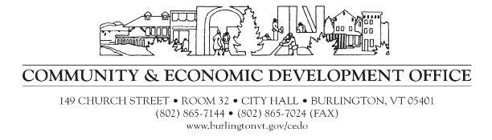

MEMORANDUM

TO: Potential CDBG Applicants
FROM: Christine Curtis, Community Development Specialist I – Grant Support
DATE: January 4th, 2021
RE: Community Development Block Grant (CDBG) NOFA

Attached please find the 2021 Community Development Block Grant Notice of Funding Availability, CDBG Application, and Conflict of Interest Statement.

Each agency is limited to ONE Public Service application per year, and it must fall into the categories for this round. The categories or priorities for Public Services grants this year include Early Childhood Education, Childcare and Youth Services, Health, Housing and Homelessness, and Economic Opportunity. Early Childhood Education, Childcare and Youth Services programs may apply for two-year grants with funding beginning July 1, 2021 and continuing through June 30, 2023. The minimum grant amount for these categories is $10,000, there is no maximum amount. Programs/projects that fall into the categories of Health or Economic Opportunity may apply for one-year grants with a minimum request of $5,000 and no maximum amount. One-year grants must be completed by June 30, 2022. These categories only apply to Public Services projects.

If you are uncertain about what category your program/project falls into, please contact (ccurtis@burlingtonvt.gov), and I will help you decide.

Please be advised that the entire application packet for the competitive selection process is due January 28, 2021 at 4 p.m. CEDO will host a virtual Application Workshop for interested applicants January 21, 2021 (time TBD). Please indicate your interest by emailing ccurtis@burlingtonvt.gov and a Zoom invitation will then be extended to you. Further information about the workshop and the CDBG process can be found on the City website

The application for funding is designed to help you present your information in the best possible way. Do not assume that the Citizen Advisory Board is familiar with your program/project. All the information asked for within the application is needed and used by the community volunteers who will recommend to the Mayor and City Council how to invest our limited CDBG resources.

