Question 1 Addendum.

ALL housing projects (2010 – 2016) including those below the IZ threshold (distribution chart below by Net New Units)

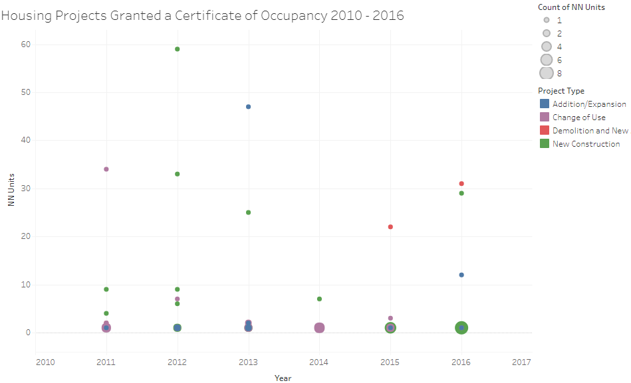
Source: City of Burlington

2. How many of these projects were new construction and adaptive reuse?

(2010 – 2016)
37 New construction projects: 210 units
3 Demo and new build projects: 55 units
32 Renovation/Expansion projects: 135 units

