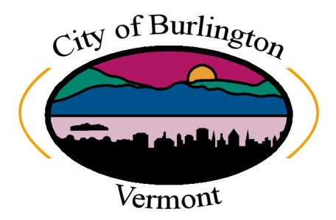 |  | CITY OF BURLINGTON  DEPARTMENT OF PUBLIC WORKS  WATER RESOURCES  235 Penny Lane | P O Box 878 | Burlington, VT 05402  P 802.863.4501 | F 802.864.8233  water-resources@burlingtonvt.gov | www.burlingtonvt.gov/dpw/water
FIRE PROTECTION MAINTENANCE NOTIFICATION

EMAIL FORM TO: water-resources@burlingtonvt.gov
or FAX TO: 802-864-8233

Instructions: If you are conducting work that will impact the quality or flow of Burlington’s Distribution system then you must notify us. Forms should be submitted at least two (2) business days prior to scheduled work or, as soon as possible, in the case of emergency work. We will post the form online so residents who are experiencing disruptions can stay informed.

Section 1: Requestor Section 2: Property Information

Company:  Click here to enter text. | Property Contact:  Click here to enter text.
Contact Name:  Click here to enter text. | Property Address:  Click here to enter text.
Contact Phone #:  Click here to enter text. | Building Name (if applicable):  Click here to enter text.
Contact Email:  Click here to enter text. | Contact Phone #:  Click here to enter text.
Date Submitted:  Click here to enter a date. | Contact Email:  Click here to enter text.

Section 3: Project Information

System(s) Affected:
Click here to enter text.

Reason for Work:
Click here to enter text.
Start Date & Time:
Click here to enter a date. Enter time.

Completion Date & Time:
Click here to enter a date. Enter time.
Onsite Contact Name:
Click here to enter text.

