City of Burlington
March 2014
FINANCIAL STATEMENTS

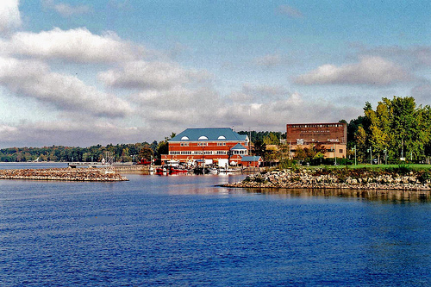

Community and Economic Development Office
The majority of CEDO funding is from reimbursable grants. While currently our revenues are well below the projected amount for this time of year, expenditures are tied to project completion and expenses and are not evenly distributed throughout the calendar year. We have identified shortfalls in projected revenue in the areas of new revenue sources and an indirect cost transfers. We are actively working with the CAO to identify and address these issues in a timely manner.

