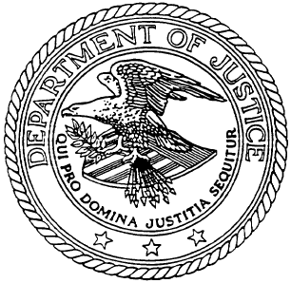
Notice of Provision of Services Under the Americans with Disabilities Act (ADA)

In accordance with the requirements of Title II of the Americans with Disabilities Act of 1990 ("ADA"), the City of Burlington will not discriminate against qualified individuals with disabilities on the basis of disability in its services, programs, or activities.

Employment: The City of Burlington does not discriminate on the basis of disability in its hiring or employment practices and complies with all regulations promulgated by the U.S. Equal Employment Opportunity Commission under Title I of the ADA.

Effective Communication: The City of Burlington will generally, upon request, provide appropriate aids and services leading to effective communication for qualified persons with disabilities so they can participate equally in the City of Burlington’s programs, services, and activities, including qualified sign language interpreters, documents in Braille, and other ways of making information and communications accessible to people who have speech, hearing, or vision impairments.

Modifications to Policies and Procedures: The City of Burlington will make all reasonable modifications to policies and programs to ensure that people with disabilities have an equal opportunity to enjoy all of its programs, services, and activities. For example, individuals with service animals are welcomed in all City of Burlington offices, even where pets are generally prohibited.

Anyone who requires an auxiliary aid or service for effective communication, or a modification of policies or procedures to participate in a program, service, or activity of the City of Burlington, should contact the office of the Title II Burlington ADA Coordinator (contact information listed below) as soon as possible but no later than 48 hours before the scheduled event.

The City of Burlington will not place a surcharge on a particular individual with a disability or any group of individuals with disabilities to cover the cost of providing auxiliary aids/services or reasonable modifications of policy, such as retrieving items from locations that are open to the public but are not accessible to persons who use wheelchairs.

*****

ADA Grievance Procedure Contacts

Title I Grievances (employment, hiring practices):

Human Resources Office
802-540-2505
hr@burlingtonvt.gov

Title II Grievances (services, programs, activities):

Chief Administrative Officer
Clerk/Treasurer’s Office
802-865-7000
kschad@burlingtonvt.gov

General Accessibility Inquiries:

Ethan Fellows
Mayor’s Advisory Committee on Accessibility
efellows@burlingtonvt.gov

Note: The ADA does not require the City of Burlington to take any action that would fundamentally alter the nature of its programs or services, or impose an undue financial or administrative burden.

